Catalog

www.tutuetoile .com
(520)360-0416

Romantic Tutus

Romantic Skirt
These skirts have 4 layers (except the 3-tiered) of heavily gathered tulle. Hooks and bars are included with an instruction sheet for placement and garment care. Please select your fabric from the fabric and color chart on our website.

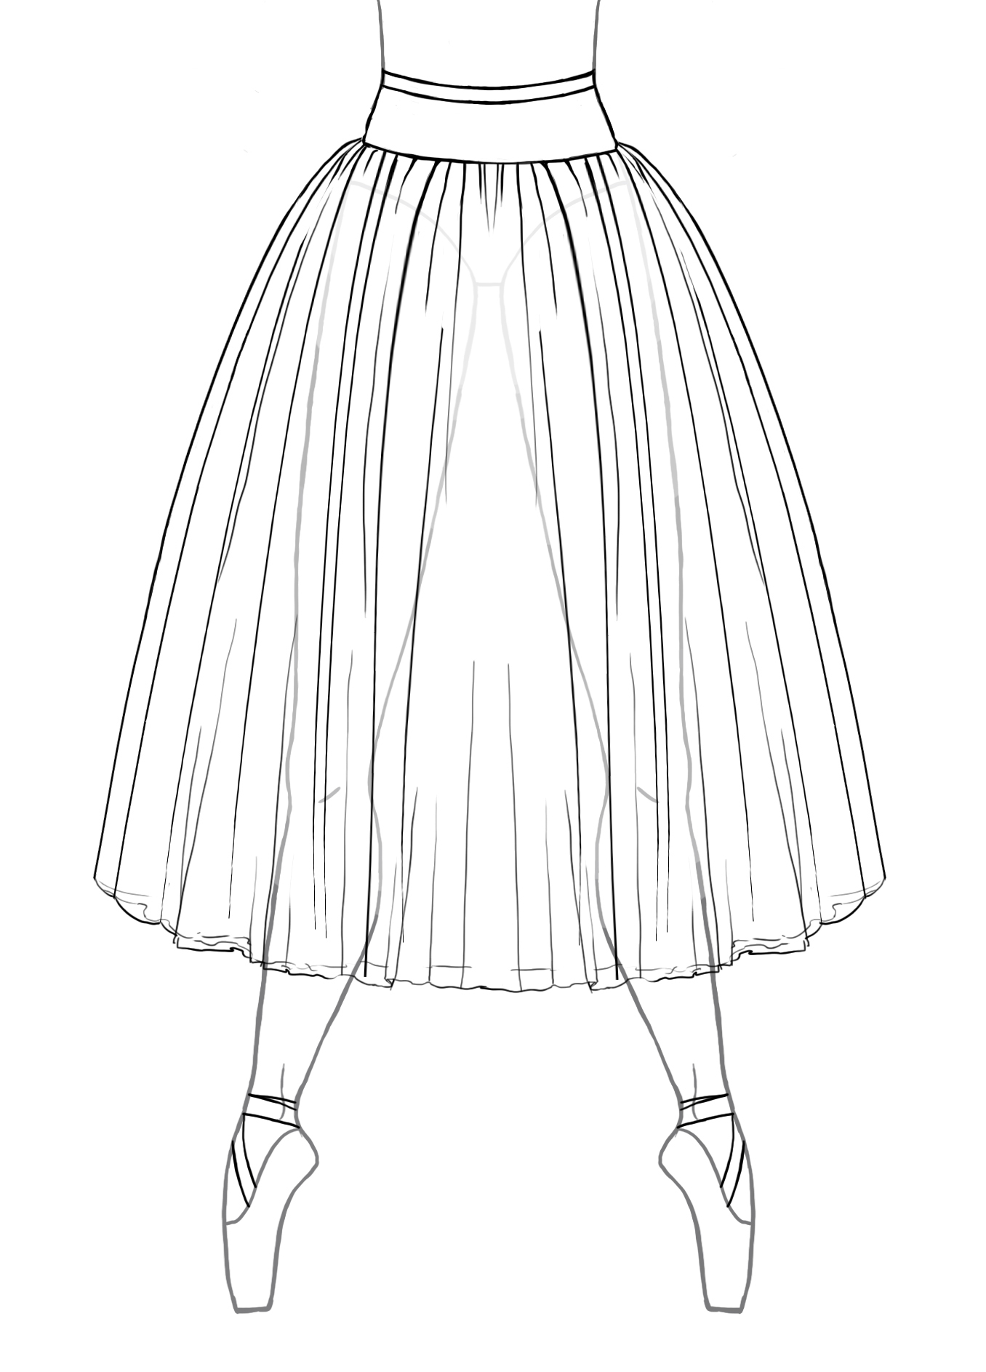#RTS A 22”, 24”, 26”, 28”, 30”, 32”, 34”, 36”, 38”, 40” lengths $160.00

This skirt includes a custom sized basque that is lined with coutil and has a grosgrain waistband with
elastic insets. The tulle on this skirt begins at the high hip. A.K.A., Neo- Romantic

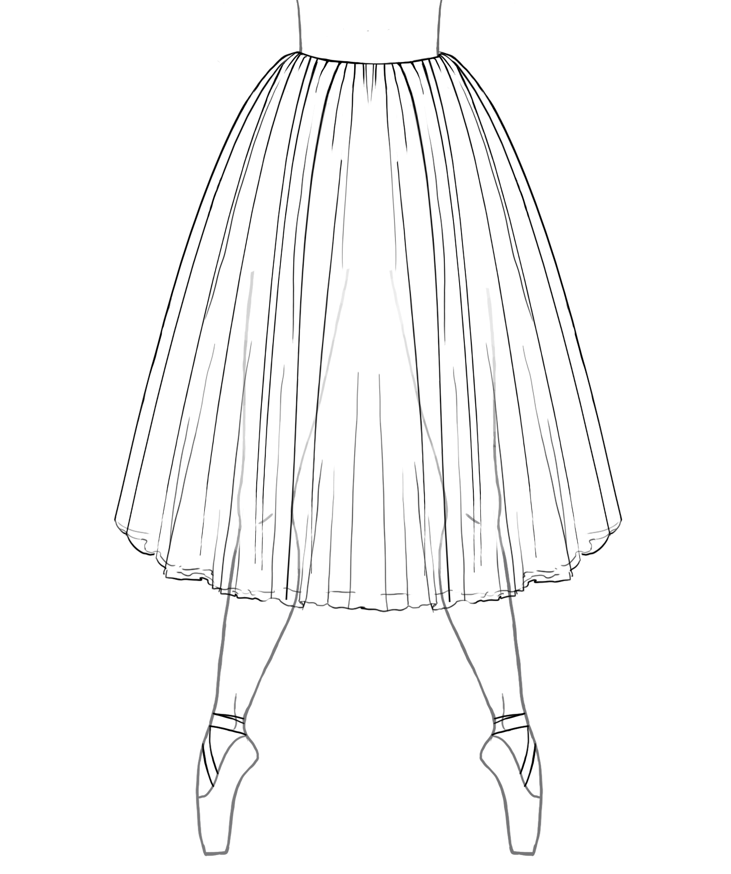#RTS B 22”, 24”, 26”, 28”, 30”, 32”, 34”, 36”, 38”, 40” lengths $150.00

The tulle on this skirt begins at the waist but utilizes a narrow basque that the tulle is stitched on to for
stability.

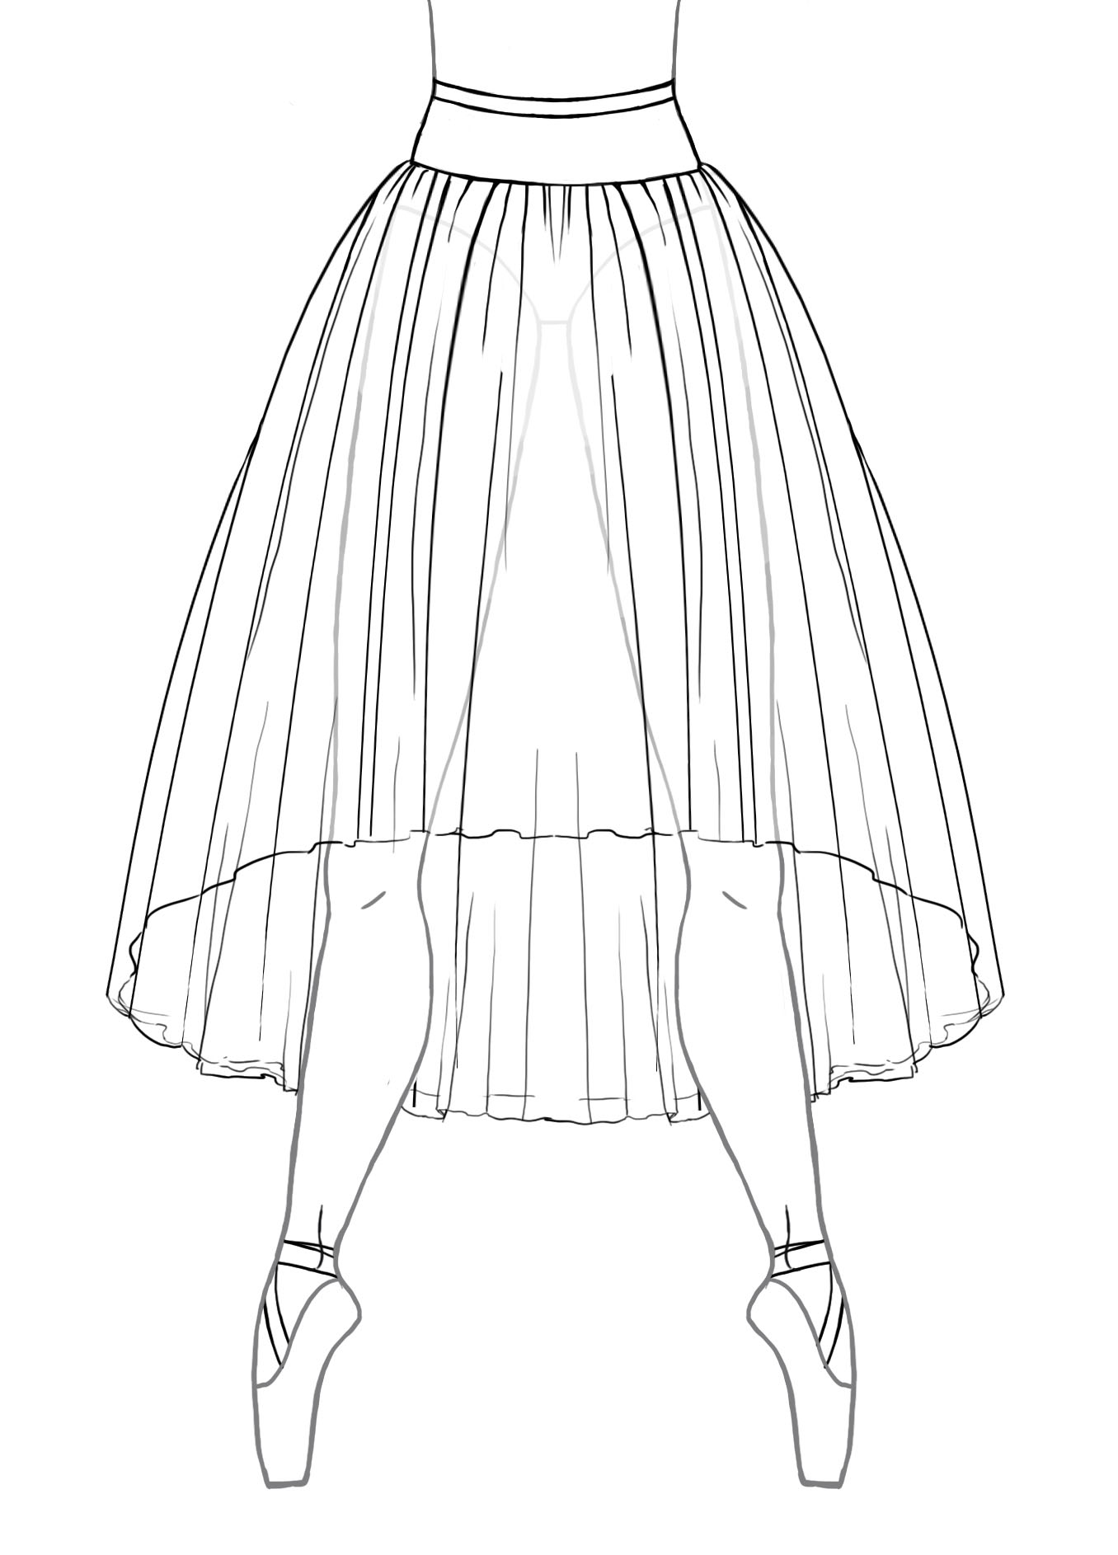#WFS A 22”, 24”, 26”, 28”, 30”, 32”, 34”, 36”, 38”, 40” lengths $195.00

The tulle on this skirt begins at the high hip and has a waterfall hemline.
The increments listed above are the back hemline. The front hemline is 8” shorter.

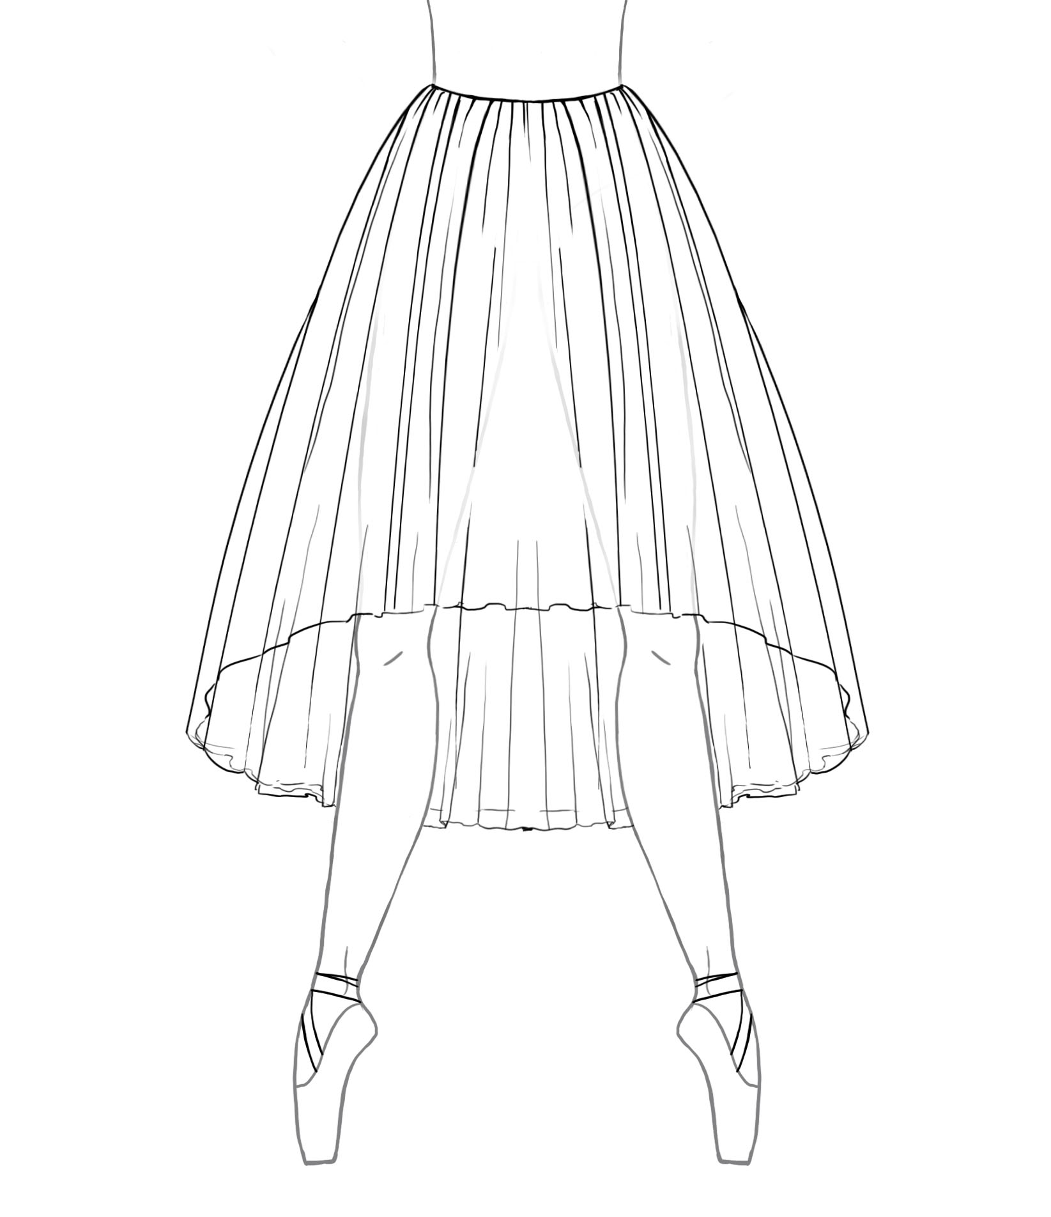#WFS B 22”, 24”, 26”, 28”, 30”, 32”, 34”, 36”, 38”, 40” lengths $185.00

The tulle on this skirt begins at the waist and has a waterfall hemline.
The increments listed above are the back hemline. The front hemline is 8” shorter.

Tutu Etoile Revised 7/19 Prices are subject to change Pg. 1

Romantic Gored Skirt
This skirt has 4 layers (except the 3-tiered) of heavily gathered tulle. Hooks and bars are included with an instruction sheet for placement and garment care. Please select your fabric from the fabric and color chart on our website.

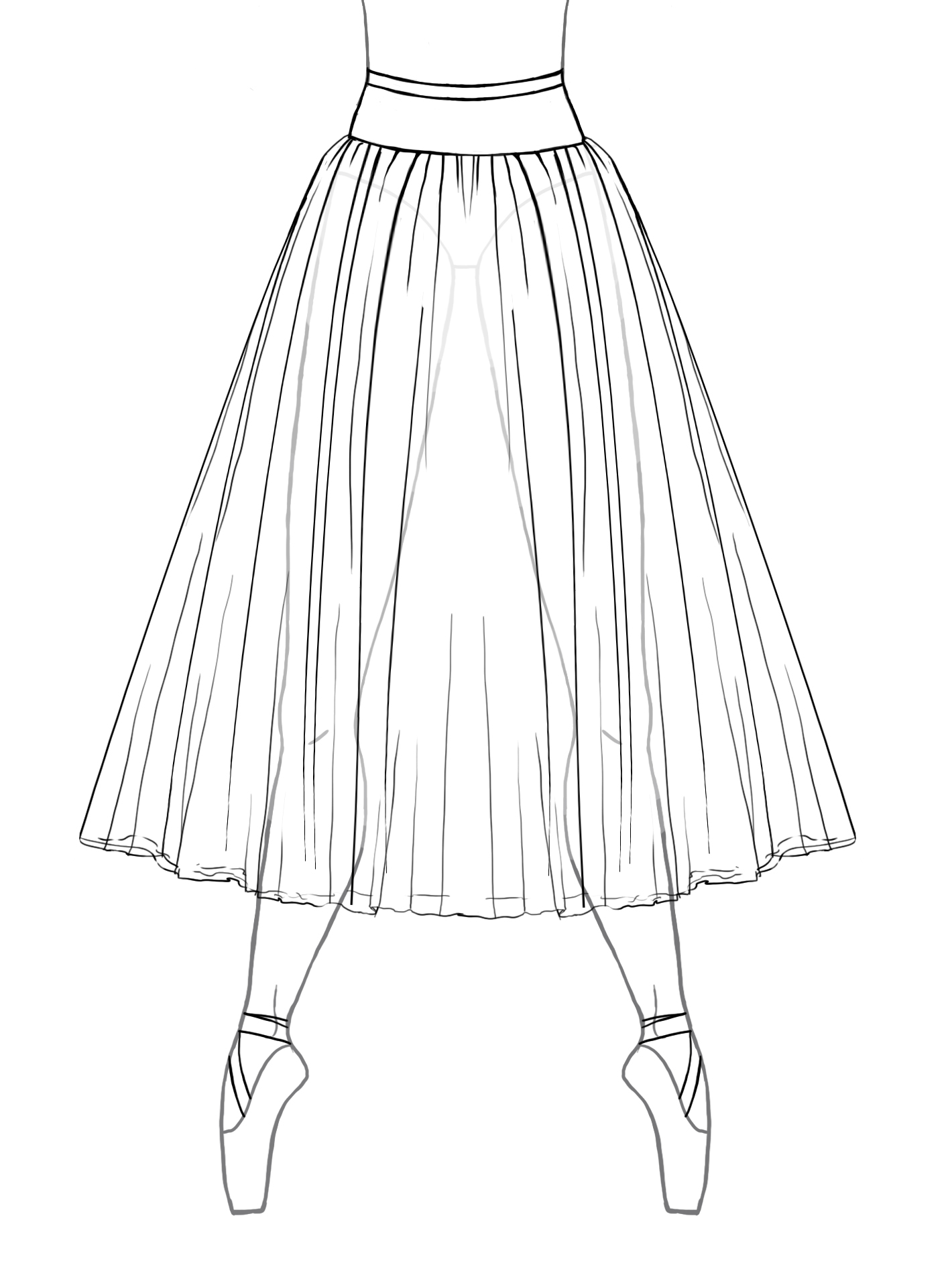 #RGS A 22”, 24”, 26”, 28”, 30”, 32”, 34”, 36”, 38”, 40” lengths $175.00

The tulle panels on this skirt are cut into triangular sections called “Gores” which are stitched together and
gathered beginning at the high hip. The gores create an “A” line shape.

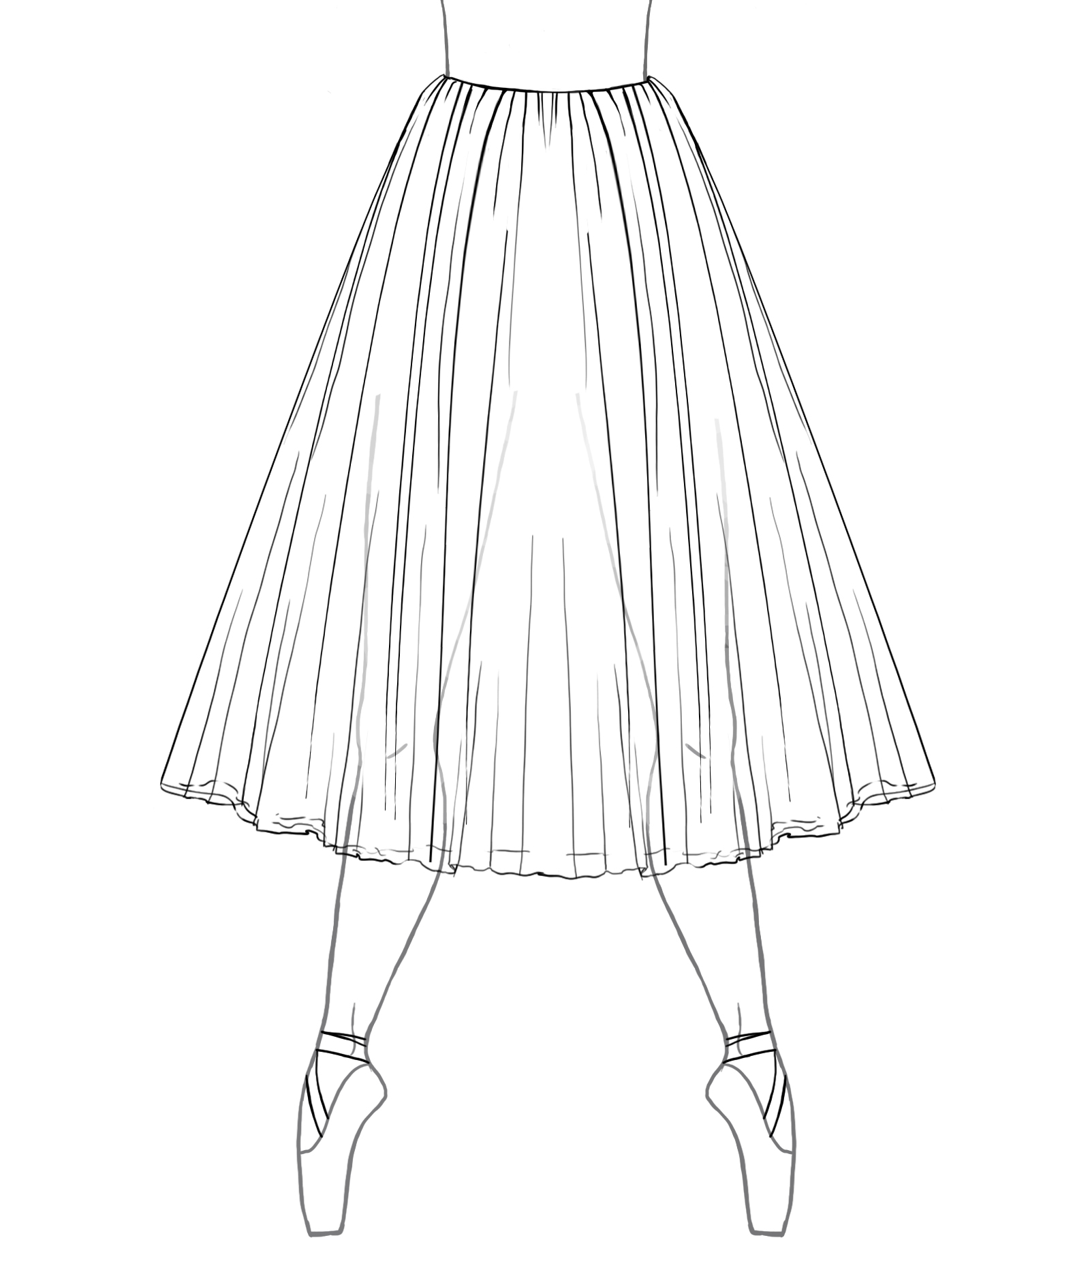 #RGS B 22”, 24”, 26”, 28”, 30”, 32”, 34”, 36”, 38”, 40” lengths $165.00

The tulle panels on this skirt are cut into triangular sections called “Gores” which are stitched together
and gathered beginning at the waist. The gores create an “A” line shape. Each layer of tulle is stitched on
to a narrow basque for stability.

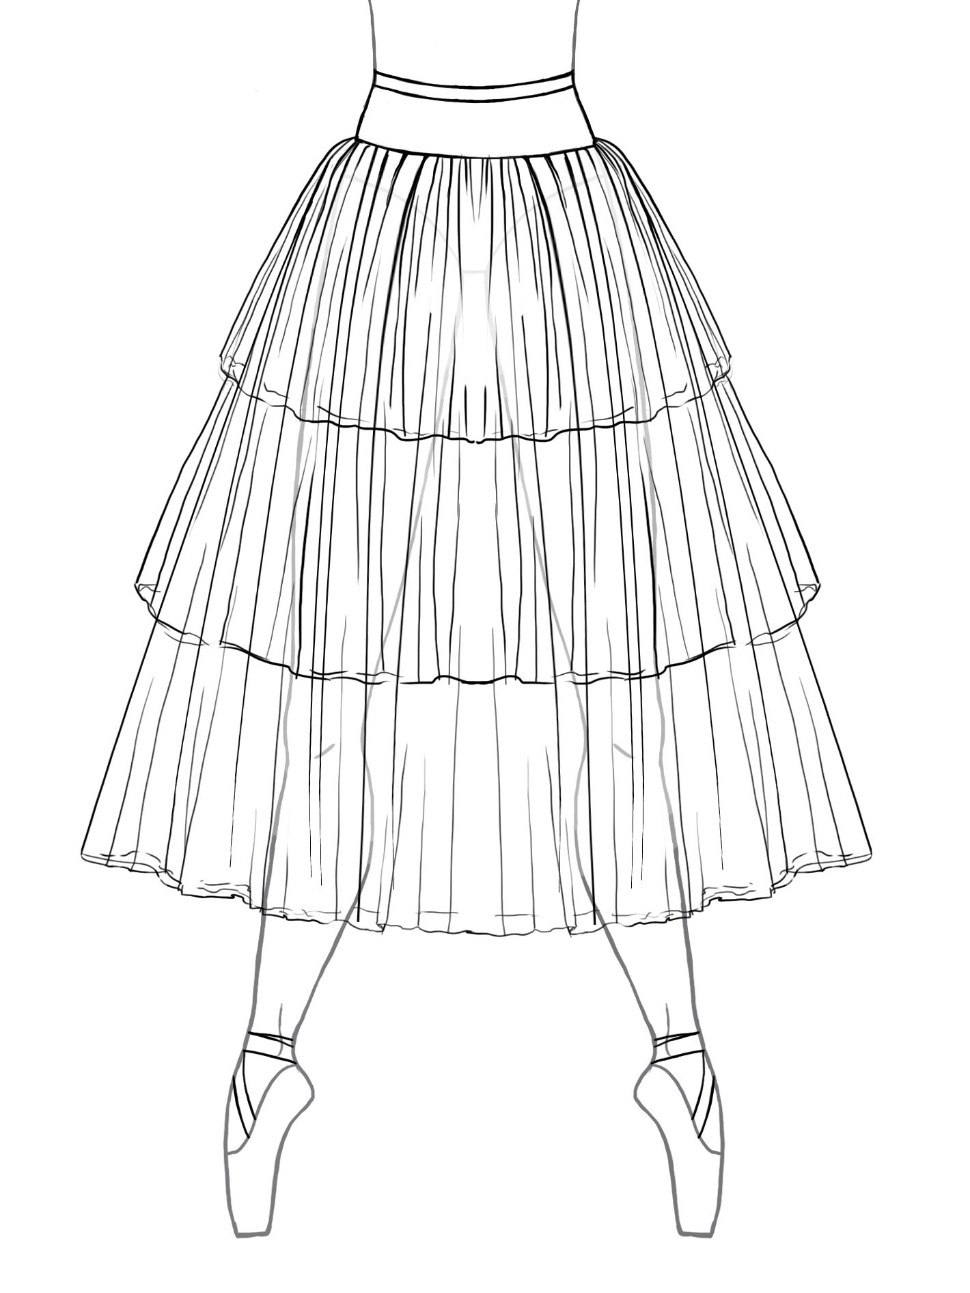 #RG3TS A 22”, 24”, 26”, 28”, 30”, 32”, 34”, 36”, 38”, 40” lengths $175.00

This 3-tiered skirt has panels that are cut into triangular sections called “Gores”, creating an “A” line
skirt. The gores are stitched together and gathered beginning at the high hip.

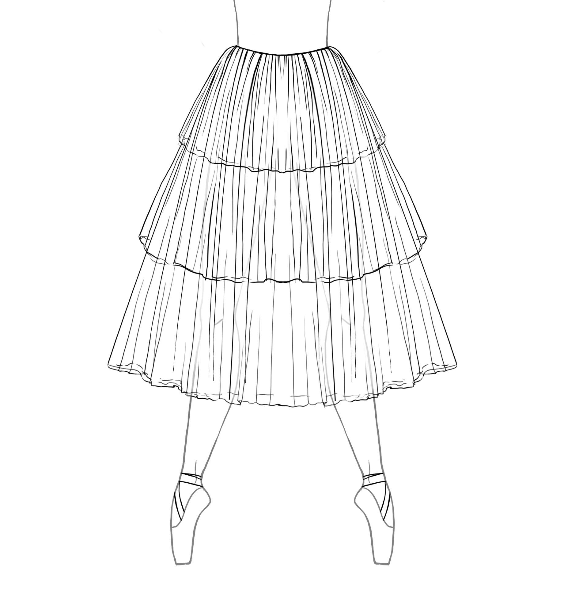#RG3TS B 22”, 24”, 26”, 28”, 30”, 32”, 34”, 36”, 38”, 40” lengths $165.00

This 3-tiered skirt has panels that are cut into triangular sections called “Gores”, creating an “A” line
skirt. The gores begin at the waist and are stitched on to a narrow basque for stability.

Tutu Etoile Revised 07/19 Prices are subject to change Pg. 2

Romantic Performance Tutu (Bodice included)

Our romantic performance tutu includes your choice of 8 skirt styles that include an attached alterable bodice. Our bodices are
lined with coutil and include nude elastic straps. Each skirt (except the 3-tiered) has 4 layers of heavily gathered tulle. The cut of your
bodice is designed to your specifications (see the bodice style selection listed on Pg. 9-10).
Hooks and bars are included with an instruction sheet for placement and garment care. Please select your fabric from the
fabric and color chart on our website.

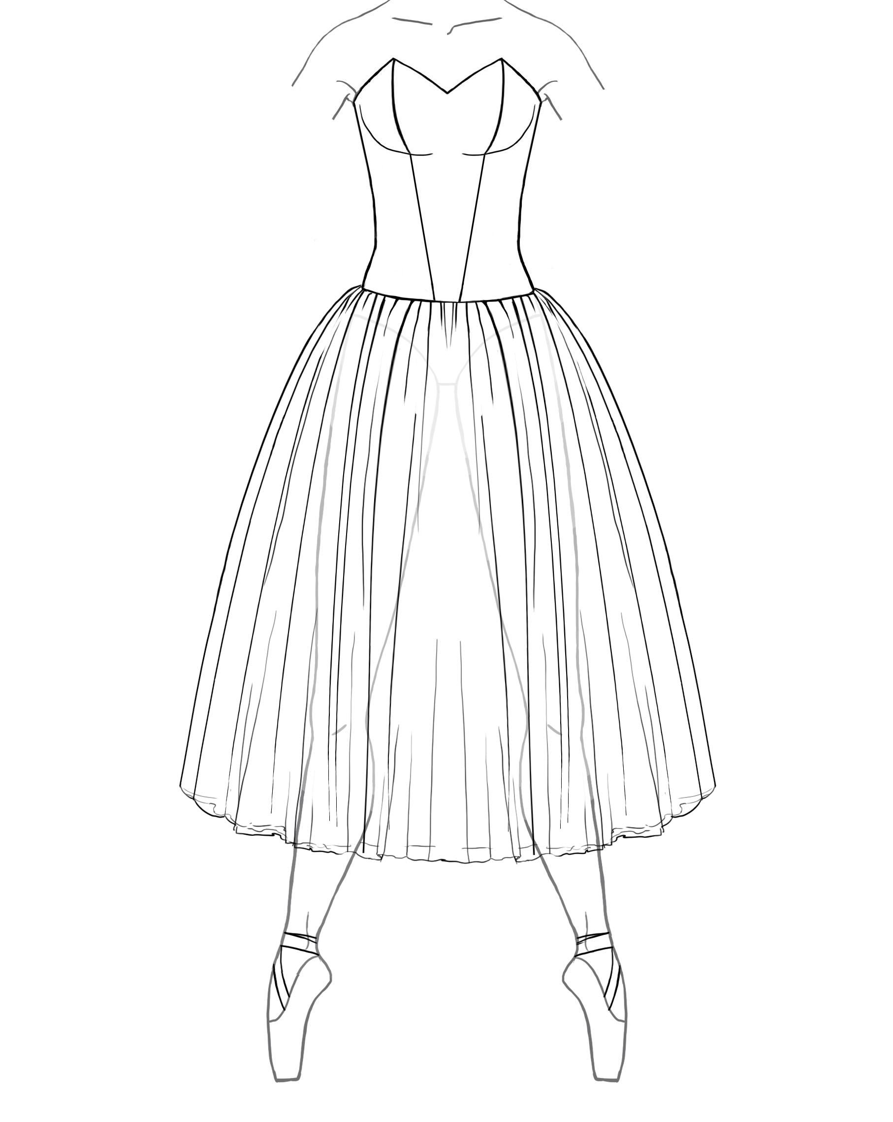 #RPT A 22”, 24”, 26”, 28”, 30”, 32”, 34”, 36”, 38”, 40” lengths. The tulle on this skirt begins at the high hip.

#7 7 panel bodice $380.00 #7b 7 panel bodice w/ built in basque $385.00
#9 9 panel bodice $395.00 #9b 9 panel bodice w/ built in basque $400.00
#11 11 panel bodice $410.00 #11b 11 panel bodice w/ built in basque $415.00
#12 12 panel bodice $425.00 #12b 12 panel bodice w/ built in basque $430.00
#BS Bustier Bodice $440.00 #BS b1 Bustier Bodice w/built in basque $445.00

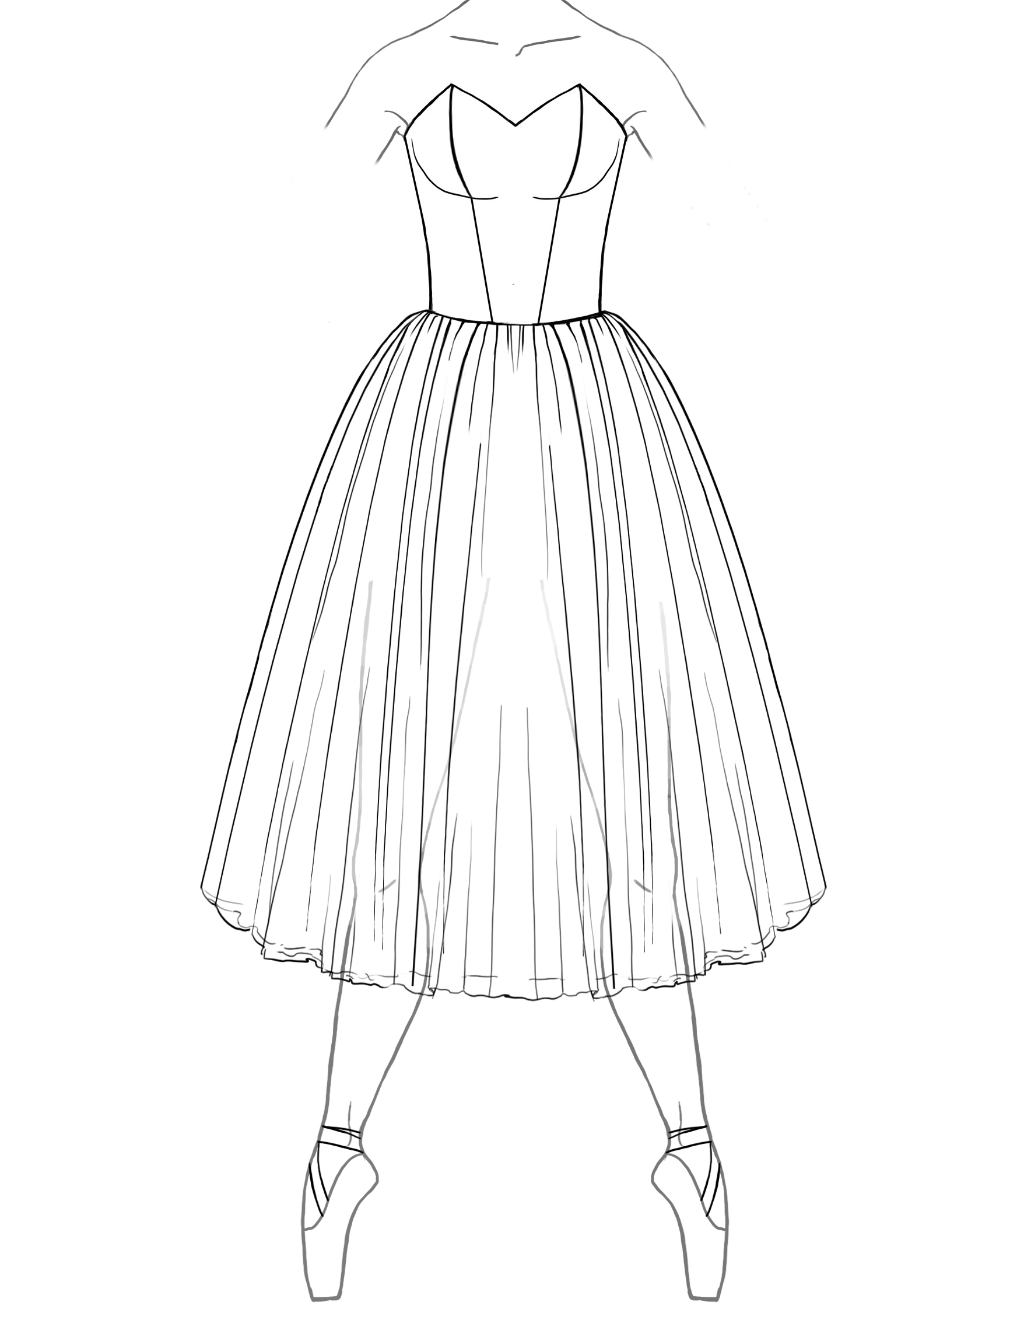 #RPT B 22”, 24”, 26”, 28”, 30”, 32”, 34”, 36”, 38”, 40” lengths. The tulle on this skirt begins at the waist. The
suggested bodice bases for this tutu are, Pointed or Straight.

#7 7 panel bodice $370.00 #9 9 panel bodice $385.00
#11 11 panel bodice $400.00 #12 12 panel bodice $415.00
#BS Bustier bodice $430.00

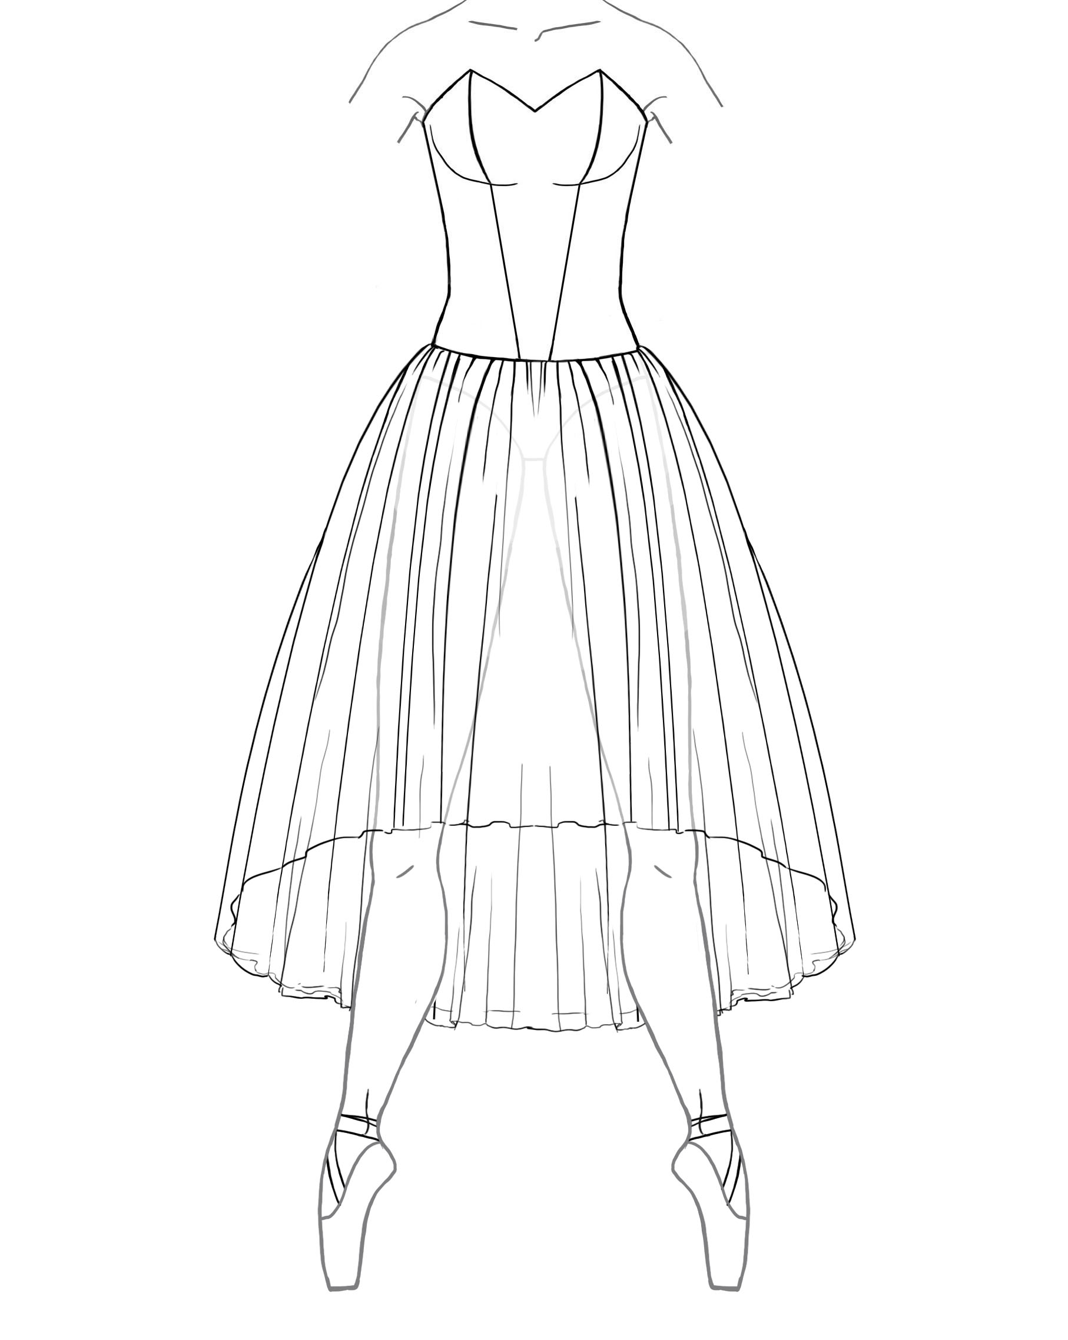 #WFT A 22”, 24”, 26”, 28”, 30”, 32”, 34”, 36”, 38”, 40” lengths. The tulle on this skirt begins at the high hip and
has a waterfall hemline. The increments listed below are the back hemline. The front hemline is 8”
shorter.

#7 7 panel bodice $415.00 #7b 7 panel bodice w/ built in basque $420.00
#9 9 panel bodice $430.00 #9b 9 panel bodice w/ built in basque $435.00
#11 11 panel bodice $445.00 #11b 11 panel bodice w/ built in basque $450.00
#12 12 panel bodice $460.00 #12b 12 panel bodice w/ built in basque $465.00
#BS Bustier Bodice $475.00 #BS b1 Bustier Bodice w/built in basque $480.00

Tutu Etoile Revised 07/19 Prices are subject to change Pg. 3

Romantic Performance Tutu cont.
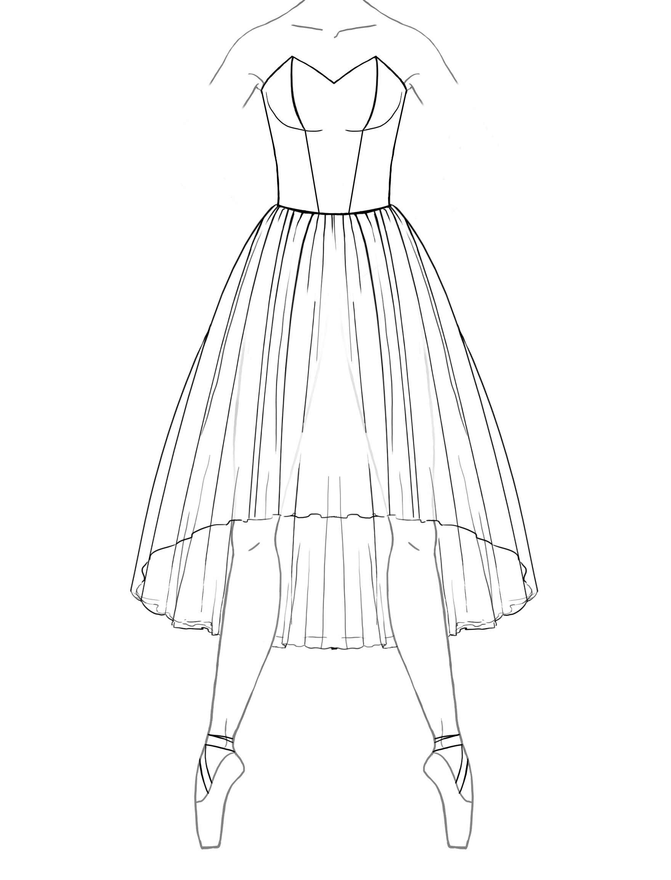#WFT A 22”, 24”, 26”, 28”, 30”, 32”, 34”, 36”, 38”, 40” length. The tulle on this skirt begins at the waist and has a
waterfall hemline. The increments listed below are the back hemline. The front hemline is 8” shorter.

#7 7 panel bodice $405.00 #9 9 panel bodice $420.00
#11 11 panel bodice $435.00 #12 12 panel bodice $440.00
#BS Bustier bodice $455.00

Romantic Gored Tutu (Bodice included)
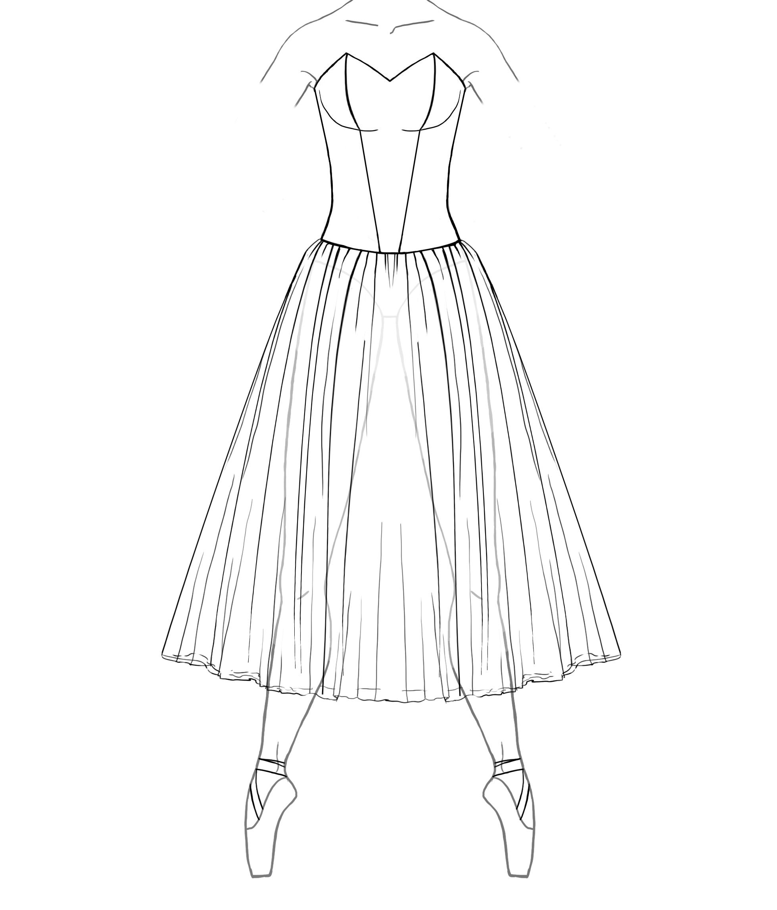#RGT A 22”, 24”, 26”, 28”, 30”, 32”, 34”, 36”, 38”, 40” lengths. The tulle panels on this skirt are cut into
triangular sections called “Gores” which are stitched together and gathered. This cut creates an “A” line
silhouette. Each layer is stitched to a basque beginning at the high hip.

#7 7 panel bodice $395.00 #7b 7 panel bodice w/ built in basque $400.00
#9 9 panel bodice $420.00 #9b 9 panel bodice w/ built in basque $425.00
#11 11 panel bodice $43500 #11b 11 panel bodice w/ built in basque $440.00
#12 12 panel bodice $450.00 #12b 12 panel bodice w/ built in basque $455.00
#BS Bustier bodice $465.00 #BS b1 Bustier bodice w/built in basque $470.00

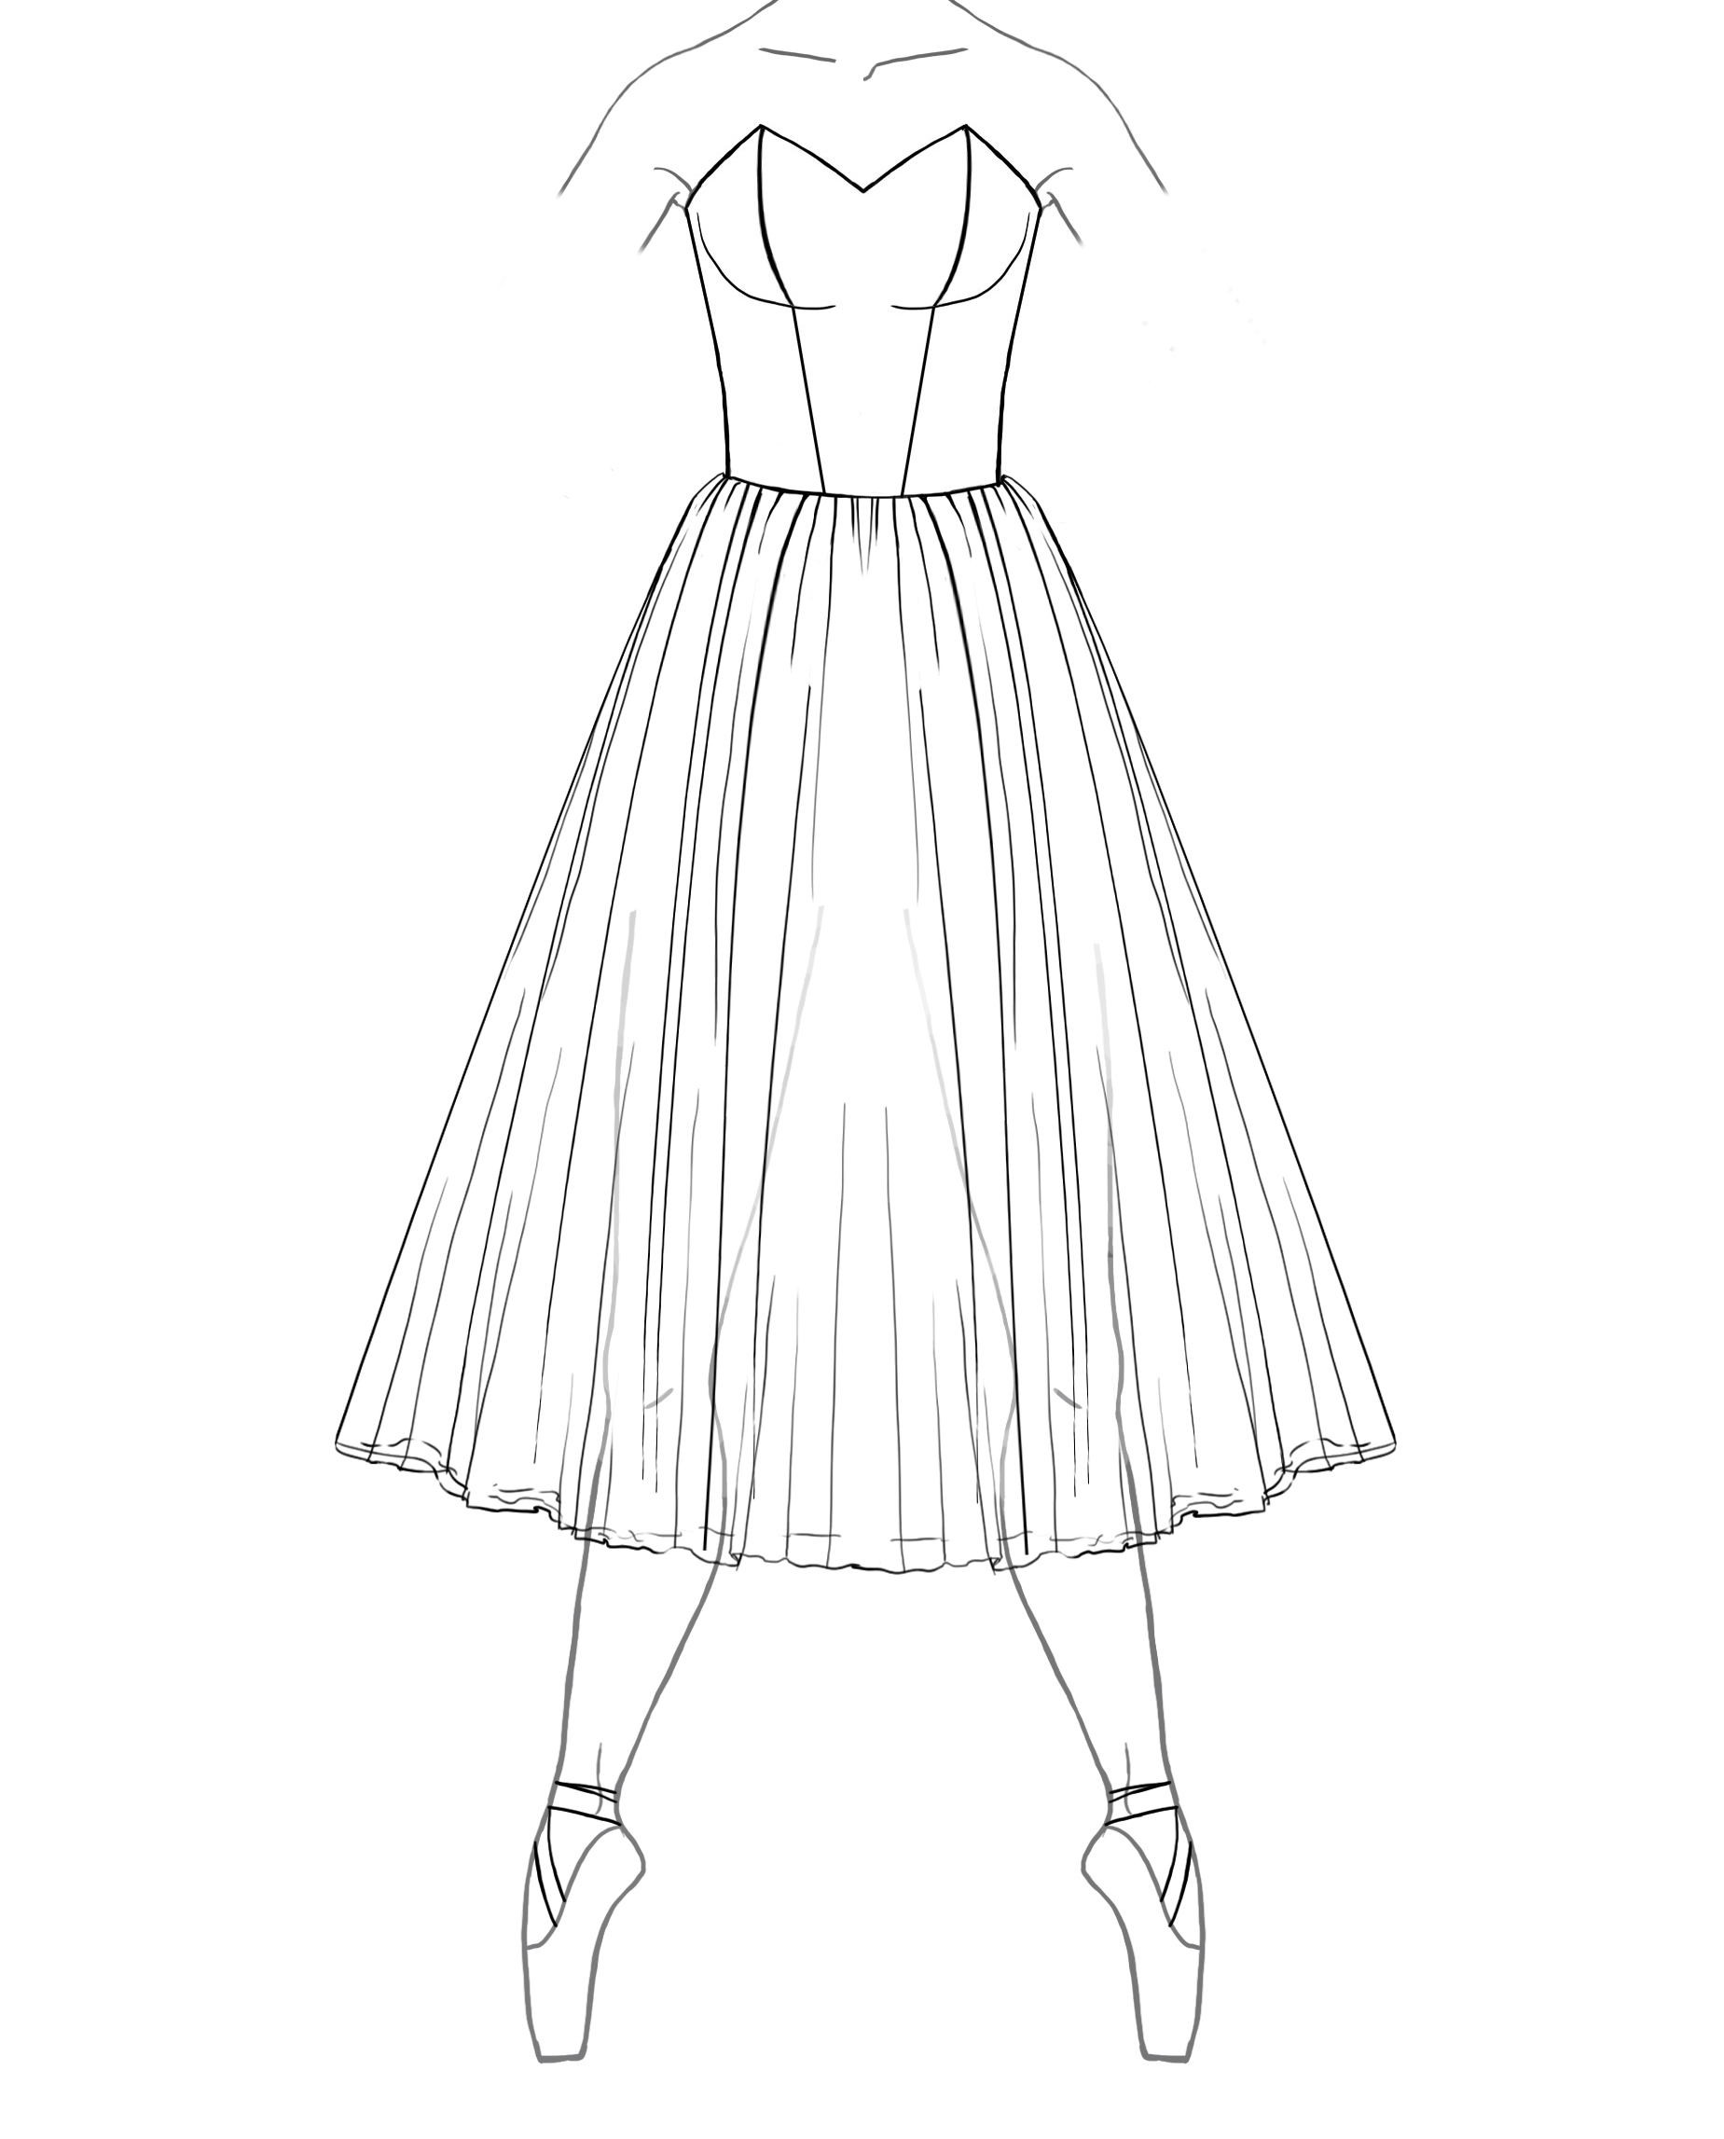#RGT B 22”, 24”, 26”, 28”, 30”, 32”, 34”, 36”, 38”, 40” lengths. The tulle panels on this skirt are cut into
triangular sections called “Gores” which are stitched together and gathered. This cut creates an “A” line
silhouette. Each layer is stitched to a basque beginning at the waist.

#7 7 panel bodice $385.00 #9 9 panel bodice $400.00
#11 11 panel bodice $415.00 #12 12 panel bodice $430.00
#BS Bustier bodice $445.00

Tutu Etoile Revised 07/19 Prices are subject to change Pg. 4

Romantic Gored Tutu cont.

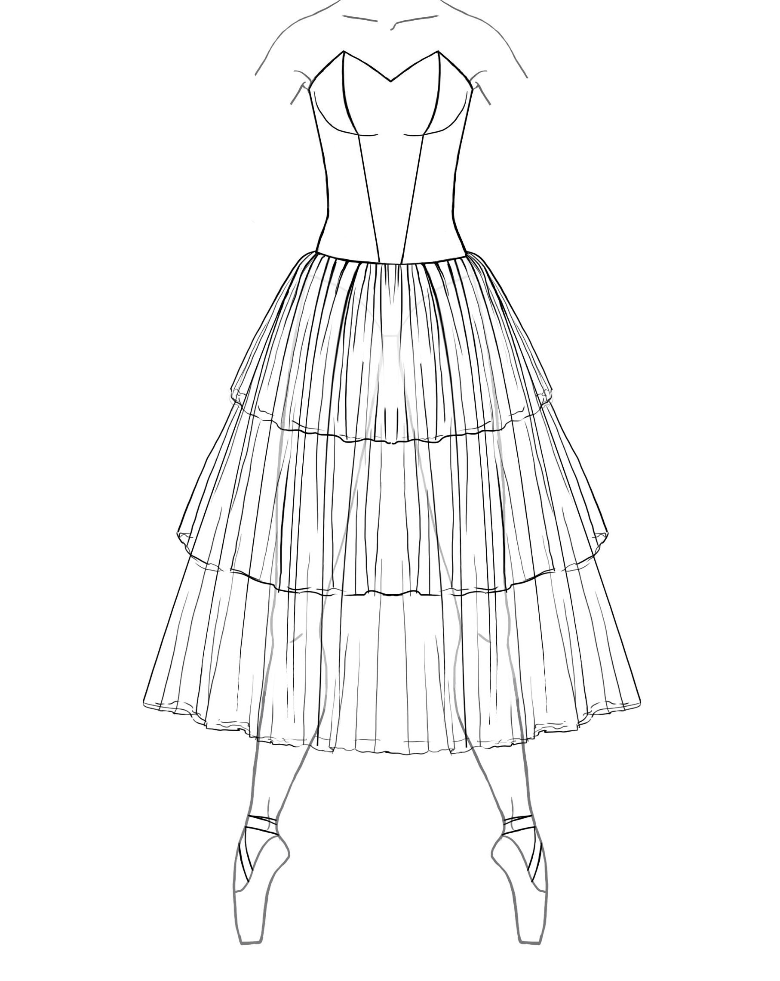#RG3T A 22”, 24”, 26”, 28”, 30”, 32”, 34”, 36”, 38”, 40” lengths. This 3-tiered skirt has panels that are cut into
triangular sections called “Gores” creating an “A” line skirt. The gores are stitched together and
gathered beginning at the high hip.

#7 7 panel bodice $395.00 #7b 7 panel bodice w/ built in basque $400.00
#9 9 panel bodice $410.00 #9b 9 panel bodice w/ built in basque $415.00
#11 11 panel bodice $425.00 #11b 11 panel bodice w/ built in basque $430.00
#12 12 panel bodice $4405.00 #12 12 panel bodice w/ built in basque $445.00
#BS Bustier bodice $455.00 #BS b1 Bustier bodice w/built in basque $460.00

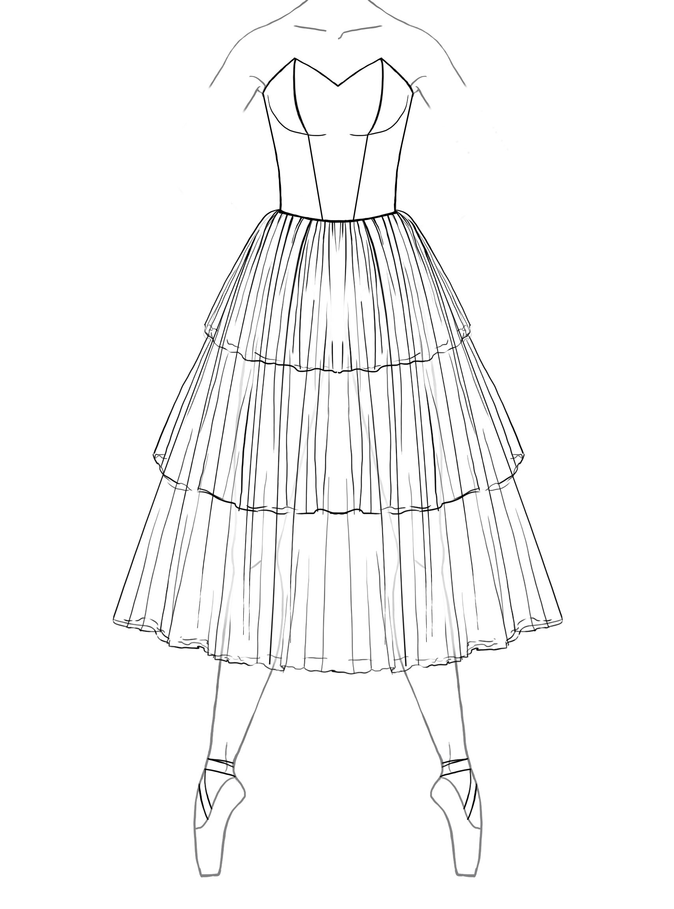#RG3T B 22”, 24”, 26”, 28”, 30”, 32”, 34”, 36”, 38”, 40” lengths. This 3-tiered skirt has panels that are cut into
triangular sections called “Gores” creating an “A” line skirt. The gores are stitched together and
gathered beginning at the waist.

#7 7 panel bodice $385.00 #9 9 panel bodice $400.00
#11 11 panel bodice $415.00 #12 12 panel bodice 430.00
#BS Bustier bodice $445.00

Custom options for all romantic tutus,

Each additional layer of tulle/ net (except gored skirt) $25.00
Each additional layer of gored tulle $35.00
Scalloped or Dagged tulle or net (Styles WF and RB) $25.00
Scalloped or Dagged tulle or net (Styles RG) $40.00
Hand Tacking $35.00
Varying colors of tulle (each layer change) $10.00
Modesty inset for bodices made of souffel $12.50
Spiral boning (all bodices) $30.00

Contrast Piping on Bodice $15.00 - $25.00

Ombre dyed Tulle $55.00

Tutu Etoile Revised 07/19 Prices are subject to change Pg. 5

Classical Tutus

Classical Rehearsal Skirt 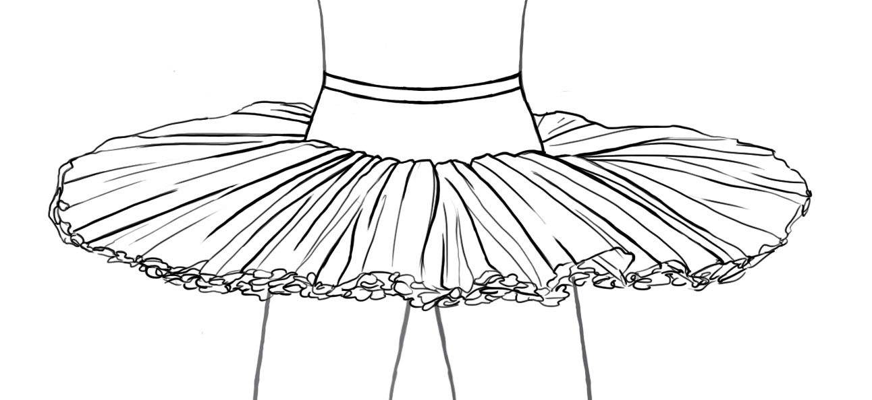 #CRS 13”, 15”& 17” net lengths

This classical rehearsal skirt is hooped, hand tacked with cotton thread and has 10 layers of diamond net heavily gathered
on to a Nylon power net panty and basque. These skirts are not custom sized, please select from the sizes listed below.
Hooks and bars are included with an instruction sheet for placement and garment care.
5% disc. for 8-11 #CRS & 10% disc. for 12 or more #CRS. Must be the same color for discounts to apply.

$210.00 Black or White $215.00 Colors

Sizes; Waist High Hip Low hip Basque depth Half Girth Leg Opening
A 22”- 23” 27”- 28” 32”- 33” 2.5” 22”- 24” 19”
B 24”- 25” 29”- 30” 34”- 35” 3” 23”- 25” 20”
C 26”- 27” 31”- 32” 36”- 37” 3.5” 24”- 26” 21”
D 28”- 29” 33”- 34” 38”- 39 4” 25”- 27“ 22”
E 30”- 31” 35”- 36” 40 “- 41” 4.5 26”- 28” 23”

Classical Skirt #CTS 13”, 15” & 17” net lengths

This classical skirt is hooped and hand tacked in your style choice of English (fluffier) or Russian (Pancake). We offer 2 different hooping wires (soft and stiff). There are 10 layers of diamond net, heavily gathered onto a Nylon power net panty. The basque is lined with coutil and has a grosgrain waistband with elastic insets for comfort. Hooks and bars are included with an instruction sheet for placement and garment care. Please select your fabric from the fabric and color chart on our website.

$250.00 Black or White $255.00 Colors

Inverted skirt 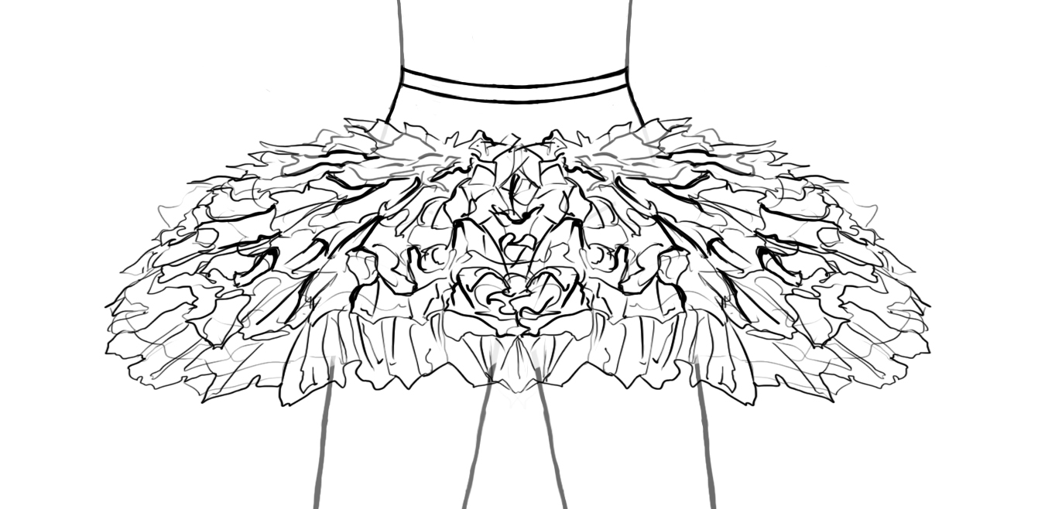 #IT 13”, 15” & 17” net lengths

This inverted classical skirt is hand tacked. We offer 2 different hooping wires (soft and stiff). The 10 layers of diamond net is heavily gathered onto a Nylon power net panty. The basque is lined with coutil and has a grosgrain waistband with elastic insets. Hooks and bars are included with an instruction sheet for placement and garment care. Please select your fabric from the fabric and color chart on our website.

$250.00 Black or White $255.00 Colors

Tutu Etoile Revised 07/19 Prices are subject to change Pg. 6

Classical Tutus cont.

Classical performance Tutu 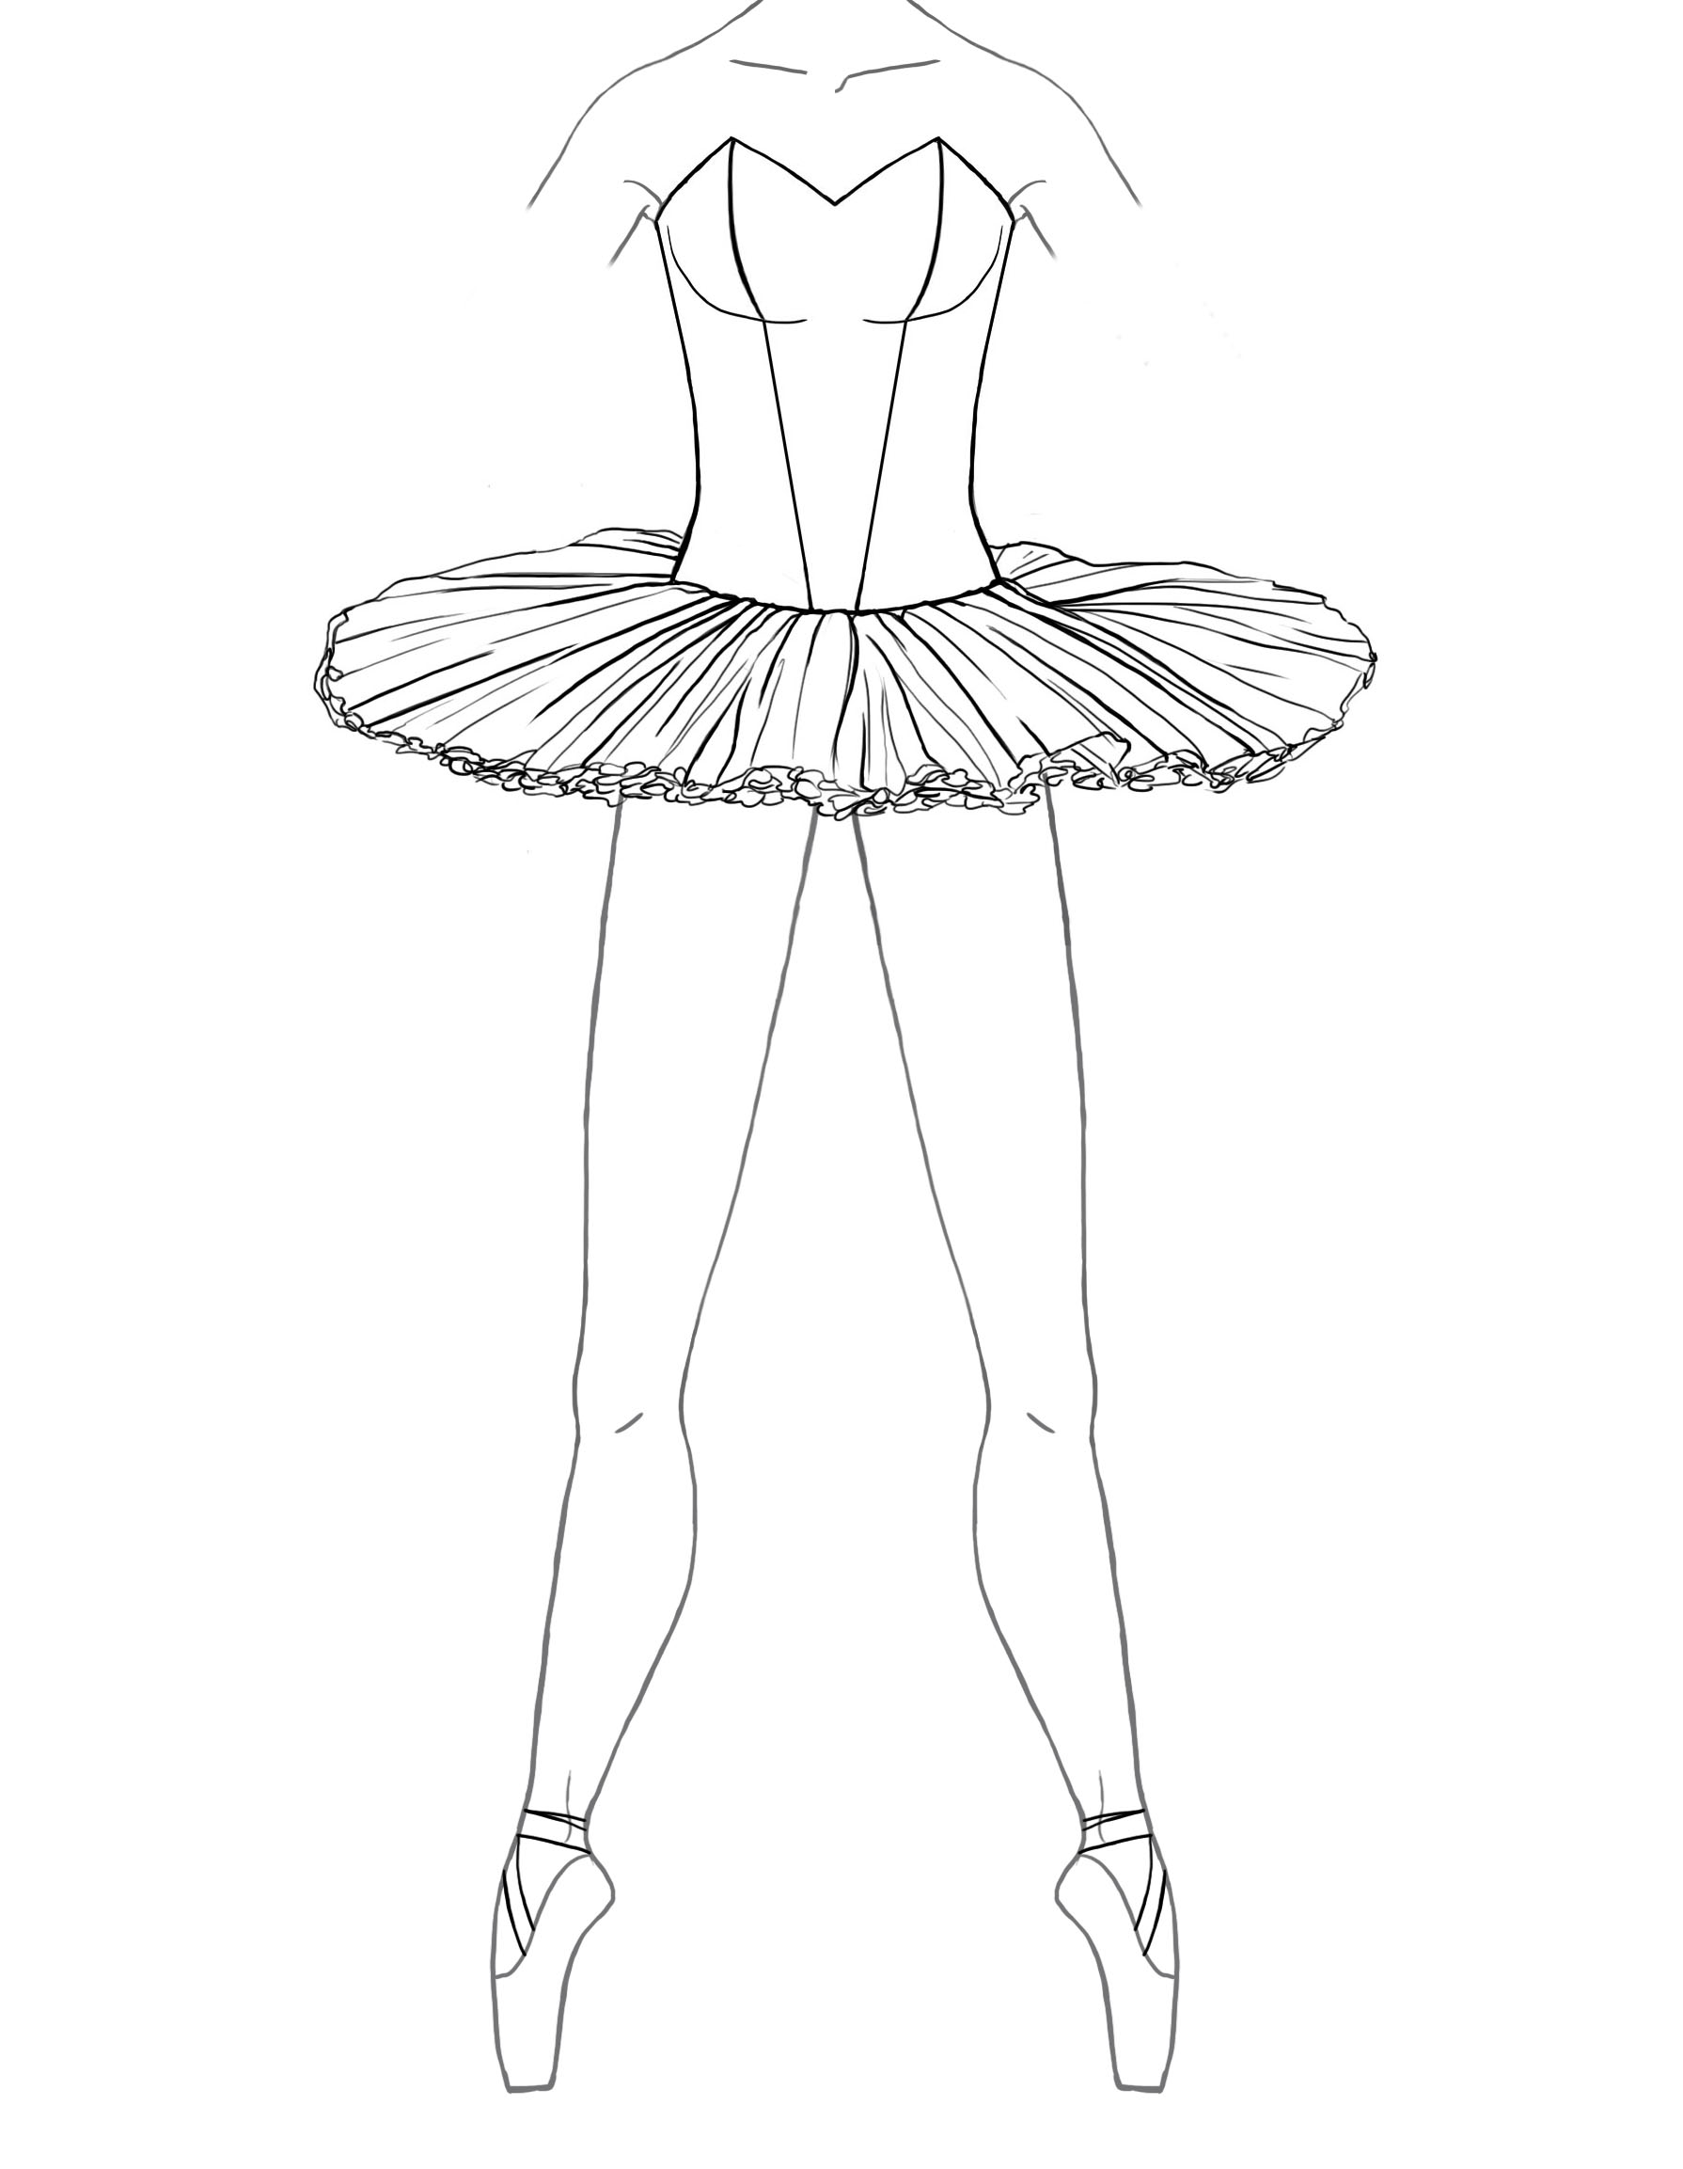#CPT 13”, 15” & 17” net lengths

This classical performance tutu includes an attached, alterable bodice lined with coutil and nude elastic straps. The cut of your bodice is cut to your specifications (see the bodice selection listed on Pg. 9-10). The skirt has the same construction as the classical tutu skirt listed above. Hooks and bars are included with an instruction sheet for placement and garment care. Please select your fabric from the printable fabric and color chart on our website.

#7 7 panel bodice $475.00 #7b 7 panel bodice w/ built in basque $480.00
#9 9 panel bodice $490.00 #9b 9 panel bodice w/ built in basque $495.00
#11 11 panel bodice $500.00 #11b 11 panel bodice w/ built in basque $510.00
#12 12 panel bodice $520.00 #12 12 panel bodice w/ built in basque $525.00
#BS Bustier Bodice $535.00 #BS b1 Bustier Bodice w/built in basque $540.00

Inverted Tutu 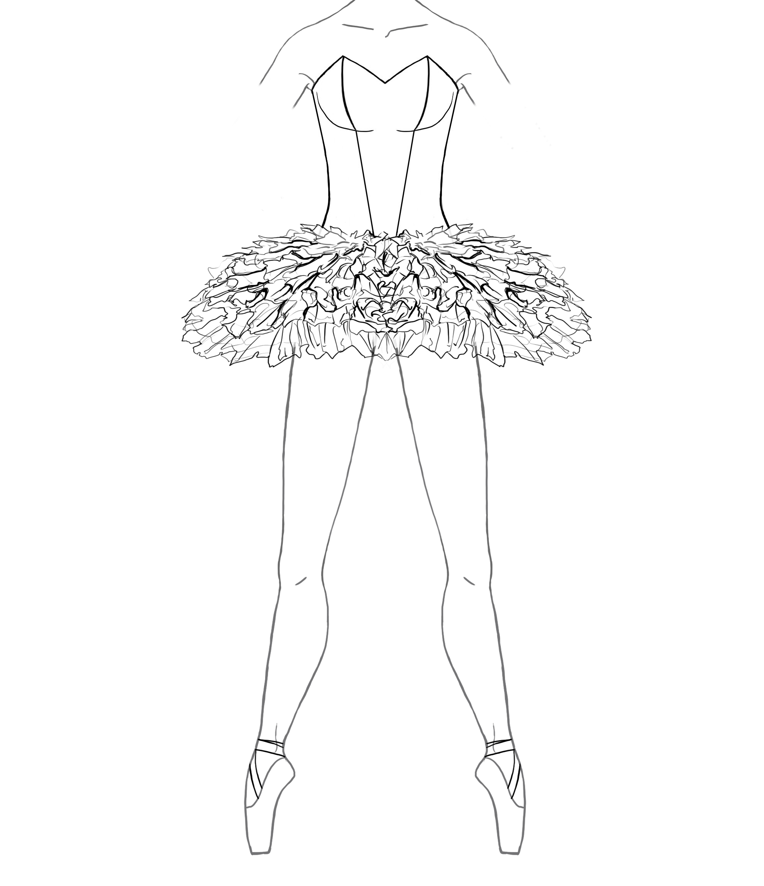#CPIT 13”, 15” & 17” net lengths

#7 7 panel bodice $460.00 #7b 7 panel bodice w/ built in basque $465.00
#9 9 panel bodice $475.00 #9b 9 panel bodice w/ built in basque $480.00
#11 11 panel bodice $490.00 #11b 11 panel bodice w/ built in basque $495.00
#12 12 panel bodice $500.00 #12 12 panel bodice w/ built in basque $510.00
#BS Bustier Bodice $520.00 #BS b1 Bustier Bodice w/built in basque $525.00

Euro (Bell) Tutus

Classical Euro Tutu 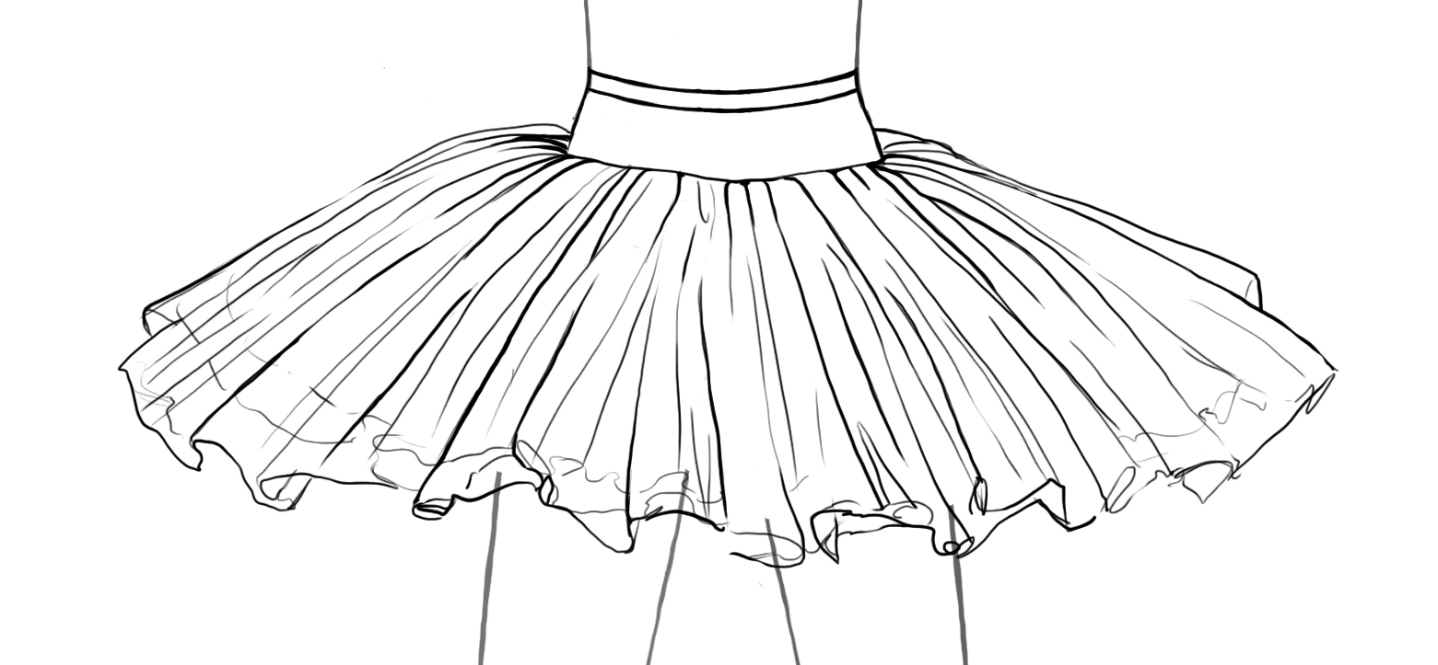 or, Inverted Bell Skirt 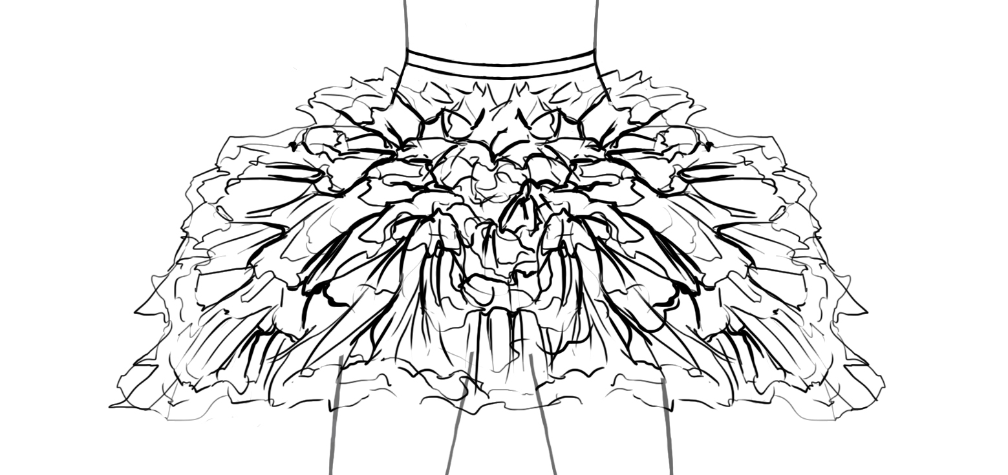
This classical euro (bell) tutu skirt has 7 layers of diamond net or tulle heavily gathered on to a Nylon stretch net panty.
They slightly drape down, having a softer flounce than classical skirts.
The basque is lined with coutil and has a grosgrain waistband with elastic insets. Note: hand tacking is not included on the tulle skirt.
Hooks and bars are included with an instruction sheet for placement and garment care. Please select your fabric from the printable
fabric and color chart on our website.

14”, 16”, 18” tulle lengths (no tacking) #CETST or #IBST $170.00 Black or White $185.00 Colors
14”, 16”, 18” net lengths w/ tacking #CETSN or #IBSN $225.00 Black or White $240.00 Colors

Tutu Etoile Revised 07/19 Prices are subject to change Pg. 7

Euro (Bell) Tutus cont.

Classical Performance Euro Tutu 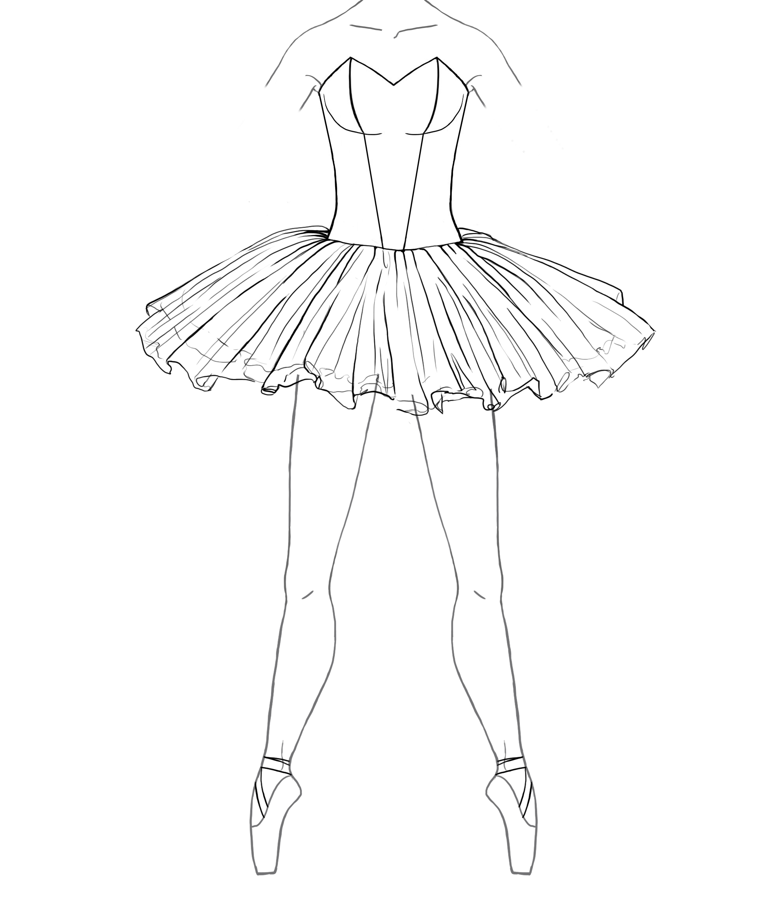
or, Inverted Bell (Bodice included) 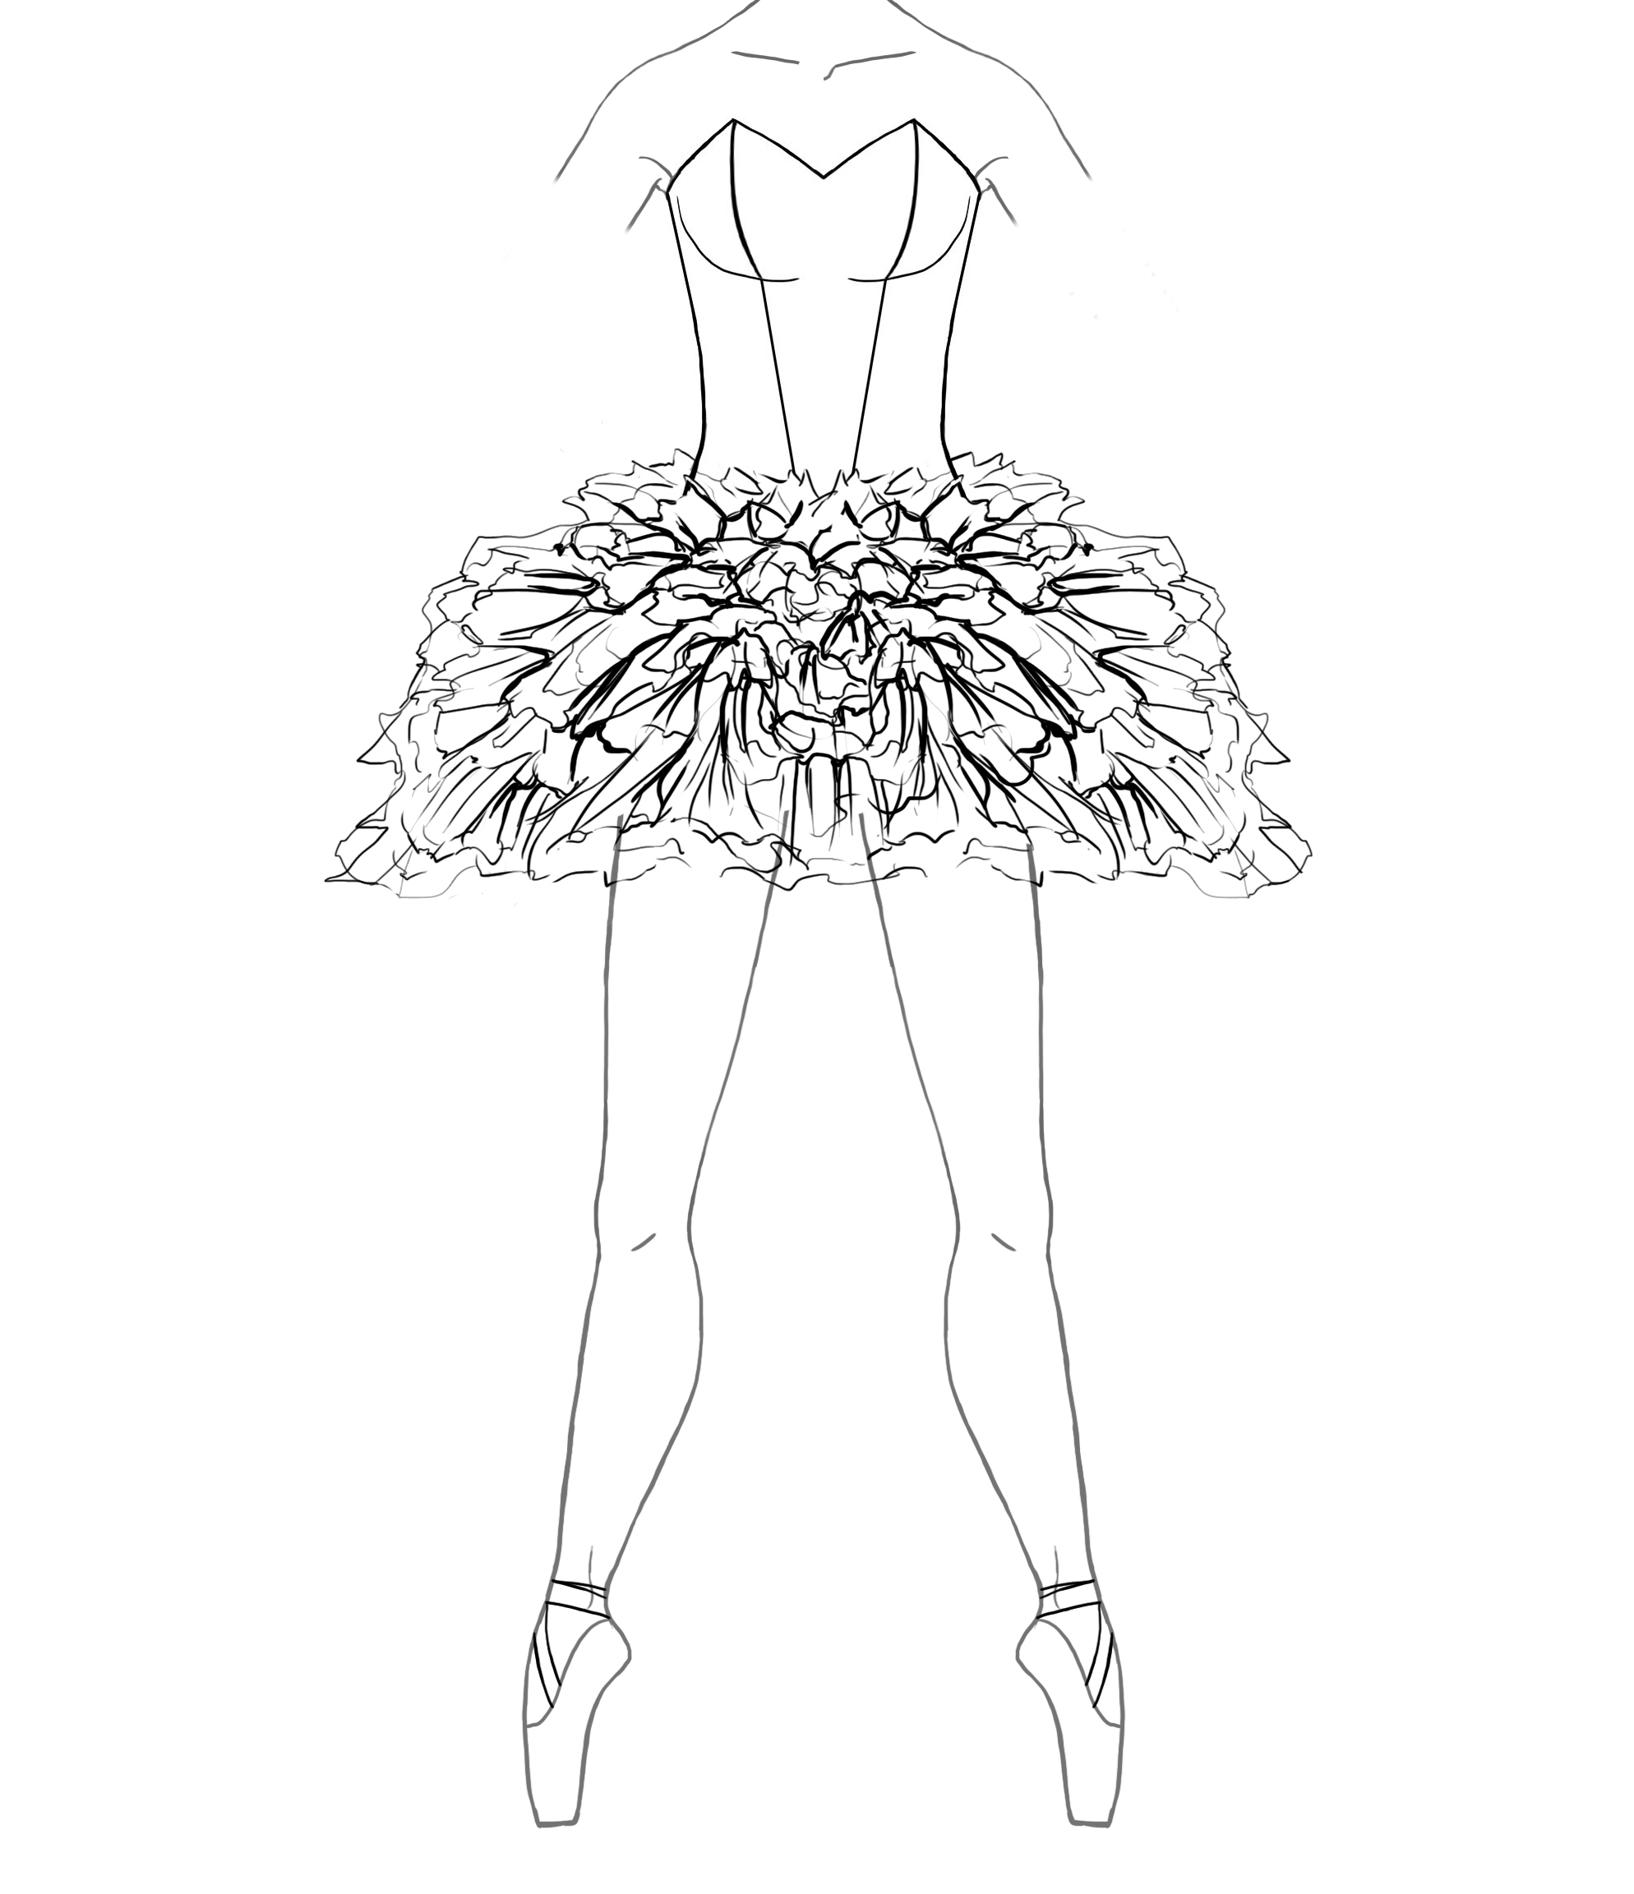
Our classical euro tutu includes an alterable, lined bodice and nude elastic straps. The cut of your bodice is constructed to your specifications (please see following suggestions listed on Pg. 9-10). The skirt has the same construction as the classical euro tutu skirts listed above. Hooks and bars are included with an instruction sheet for placement and garment care. Please select your fabric from the printable fabric and color chart on our website.

14”, 16”, 18” #CPETT #7 7 panel bodice $390.00 #7b 7 panel bodice w/ built in basque $395.00
tulle lengths or #IBETT #9 9 panel bodice $405.00 #9b 9 panel bodice w/ built in basque $410.00
(no tacking) #11 11 panel bodice $420.00 #11b 11 panel bodice w/ built in basque $425.00
#12 12 panel bodice $435.00 #12 12 panel bodice w/ built in basque $440.00
#BS Bustier Bodice $415.00 #BS b1 Bustier Bodice w/built in basque $425.00

14”, 16”, 18” #CPETN #7 7 panel bodice $445.00 #7b 7 panel bodice w/ built in basque $450.00
net lengths or #IBETN #9 9 panel bodice $460.00 #9b 9 panel bodice w/ built in basque $465.00
(w/ tacking) #11 11 panel bodice $475.00 #11b 11 panel bodice w/ built in basque $480.00
#12 12 panel bodice $490.00 #12 12 panel bodice w/ built in basque $495.00
#BS Bustier Bodice $505.00 #BS b1 Bustier Bodice w/built in basque $510.00

Custom options for classical and Euro (Bell) tutus,

Varying colors of tulle or net (each layer) $10.00
Scalloped or dagged net edges on the top 7 layers $40.00
Circular top plate (layer) $12.00
Panty ruffles $25.00
Modesty inset for bodices made of souffel $12.50
Spiral boning (all bodices) $30.00

Contrast Piping on Bodice $15.00 - $25.00

Ombre dyed net $55.00

Custom dyed net (single color) $45.00
Hand Tacking tulle Euro (Bell) $40.00

Tutu Etoile Revised 07/19 Prices are subject to change Pg. 8

Bodices, Sleeves and Wings

Our alterable bodices are lined with coutil, stretch cotton twill or lycra and include nude elastic straps. These bodices can
be purchased separately from our skirts. Hooks and bars are included with an instruction sheet for placement and garment care.
Please select your fabric from the printable fabric and color chart on our website. Additionally, you can send us your fabric. See details
on the color chart.

Bodice Styles

Pointed Base Straight Base W/ Built in Basque

7 Panel Bodice $155.00
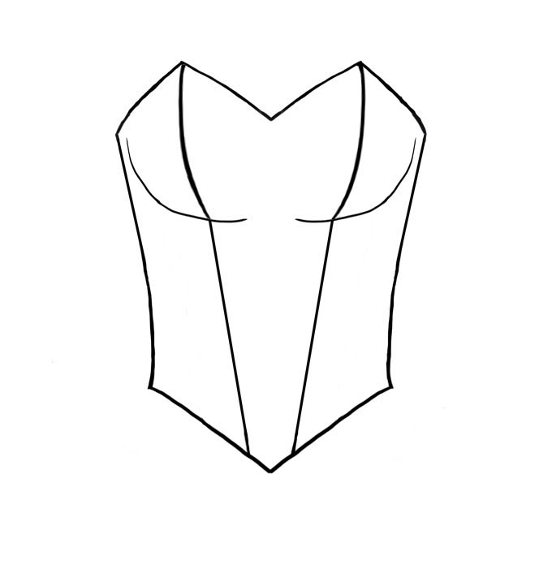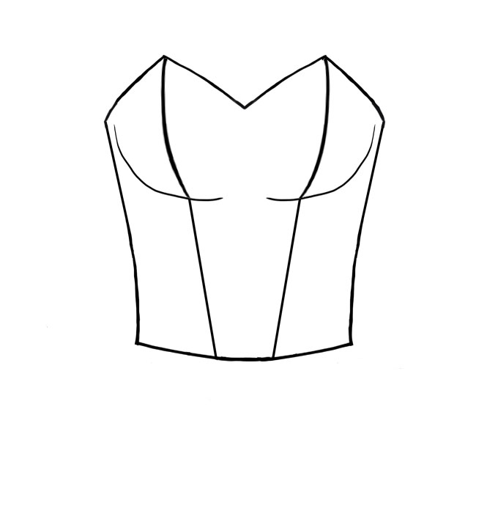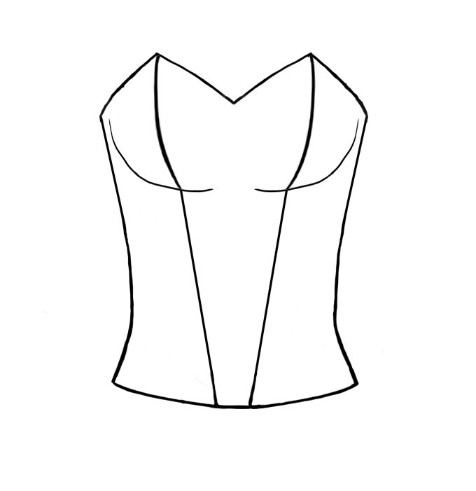
9 Panel Bodice $170.00 & 11 Panel Bodice $185.00
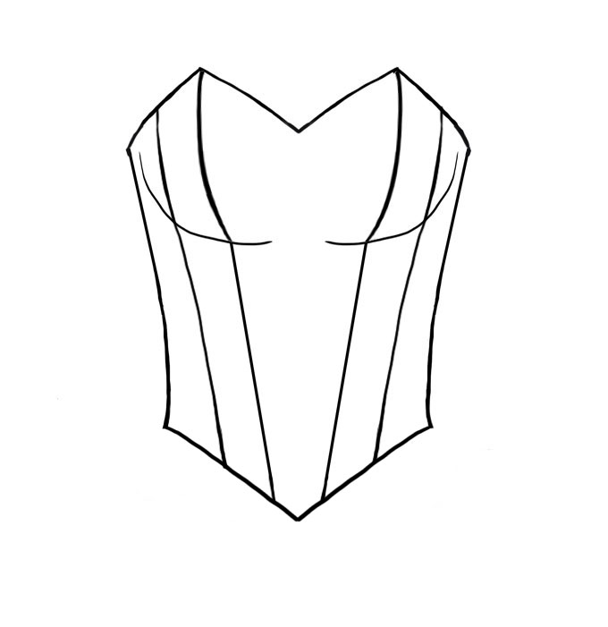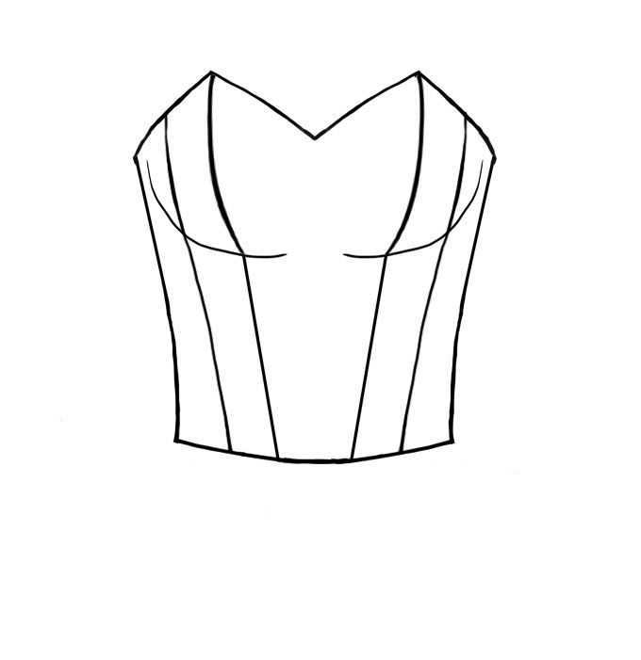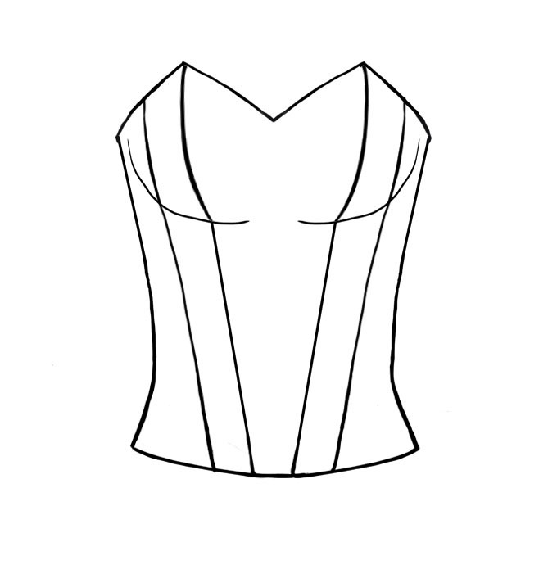

12 Panel Bodice $200.00
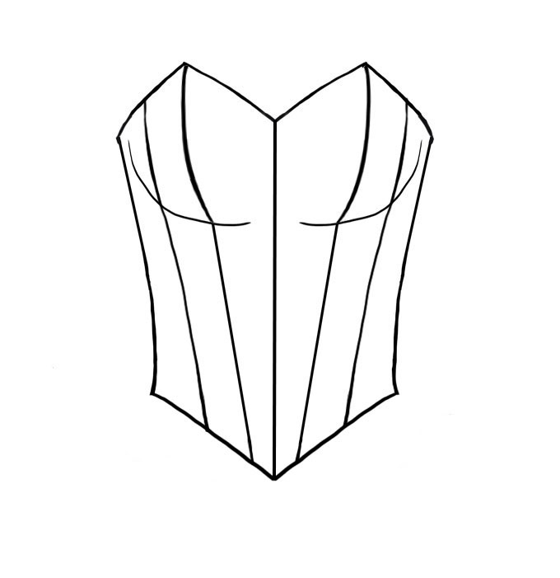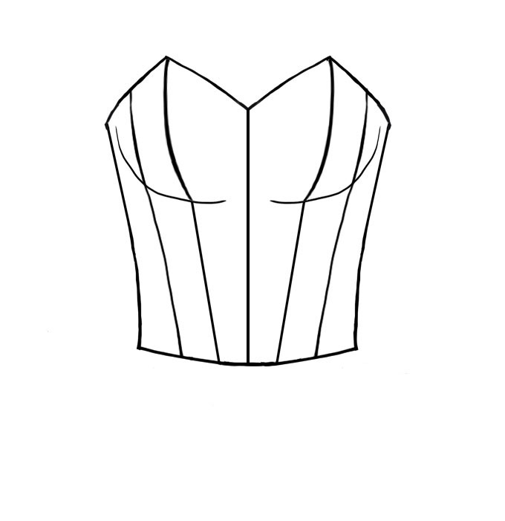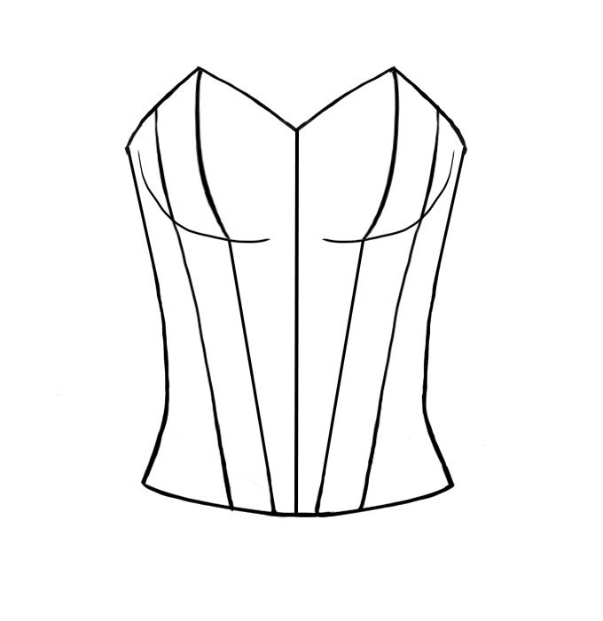

Bustier $215.00
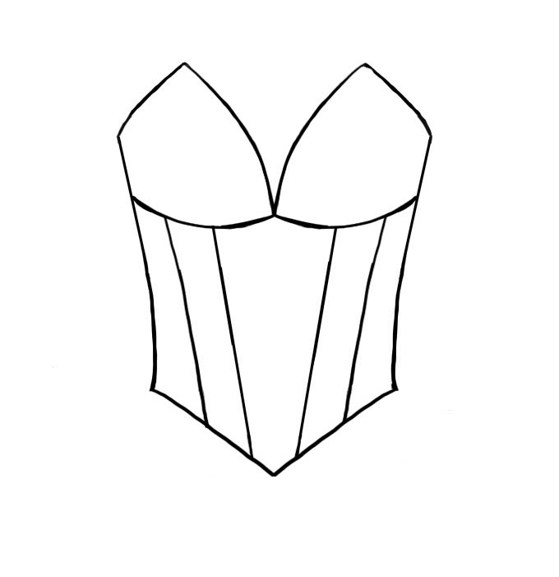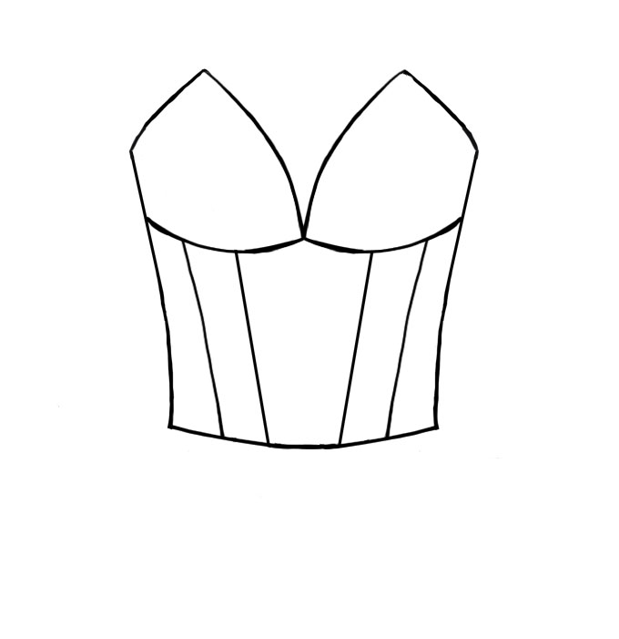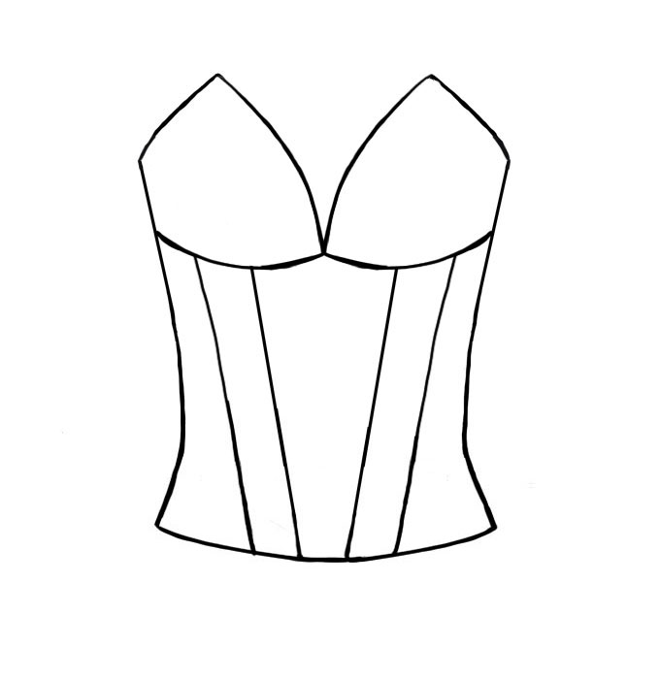

Tutu Etoile Revised 07/19 Prices are subject to change Pg. 9

Necklines

Modest “V” Deep “V” Plunging “V” Scoop Sweetheart
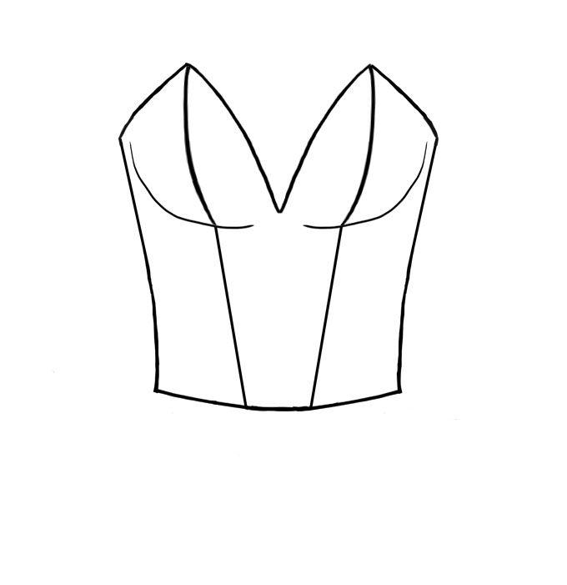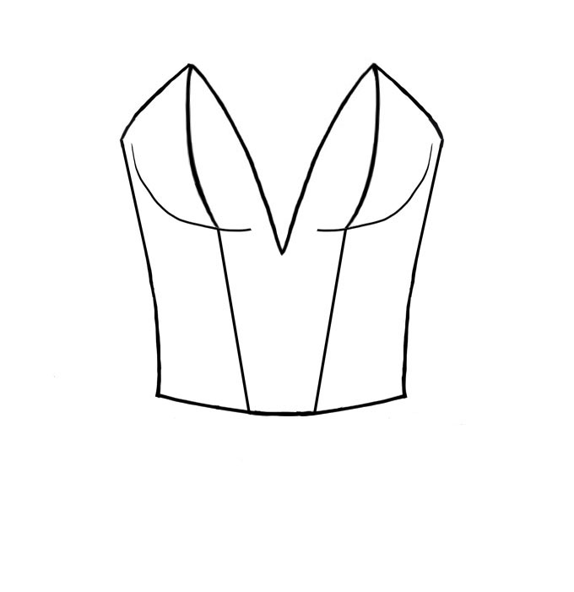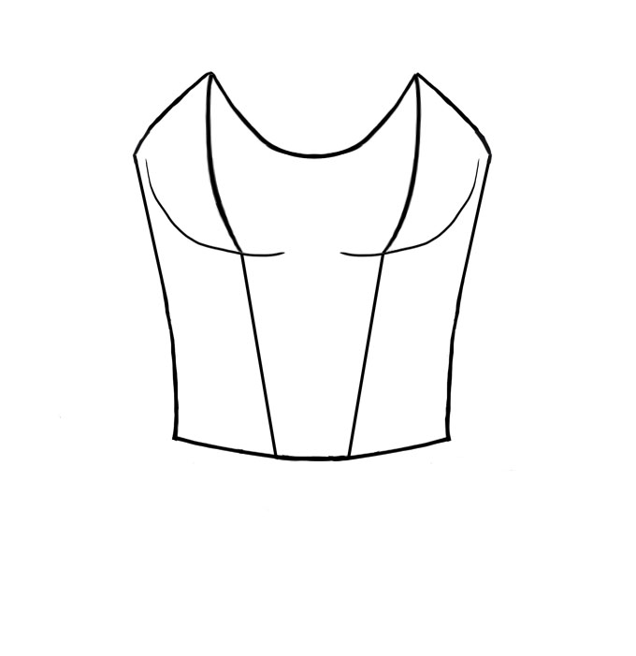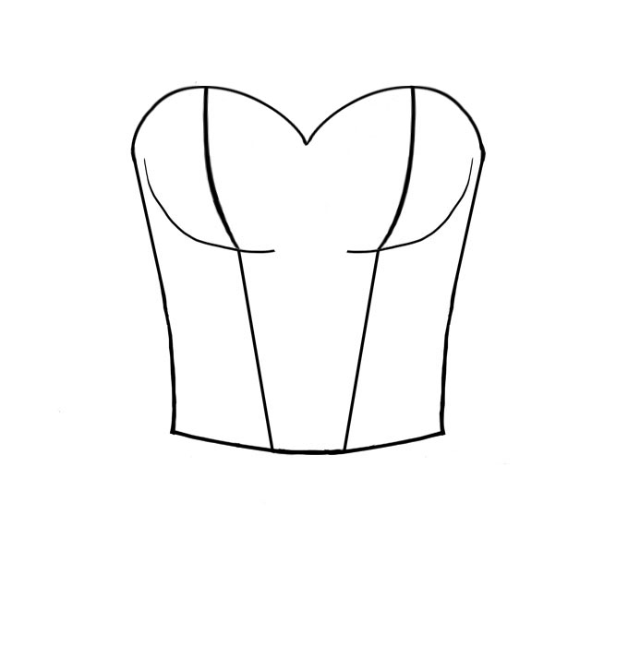

Sweetheart “V” Notched “V” Boat Character
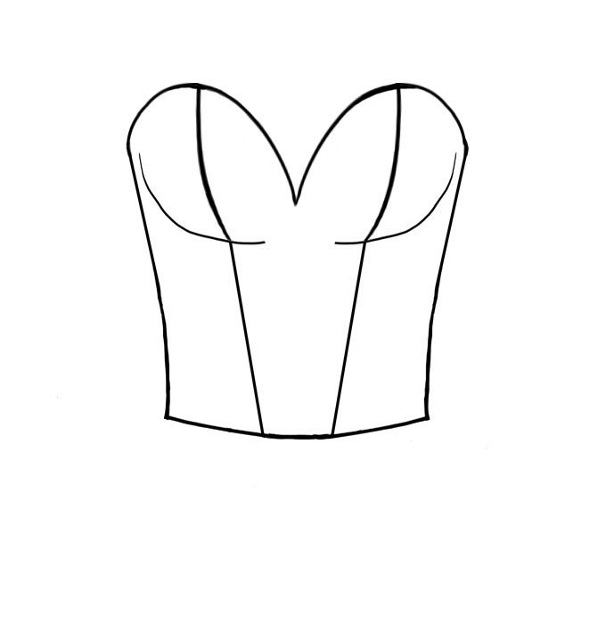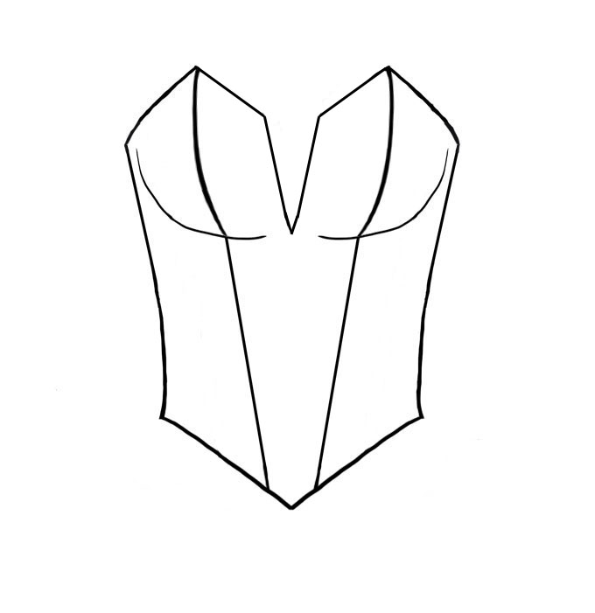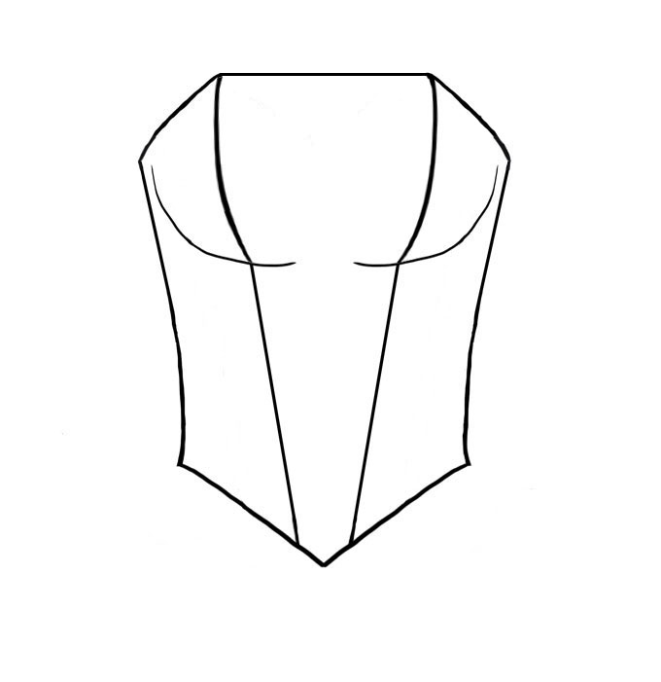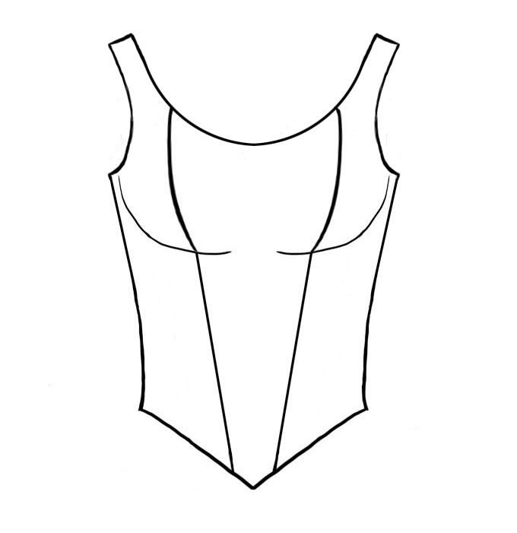

Back Shapes

Scoop Low Scoop “V” Low “V”
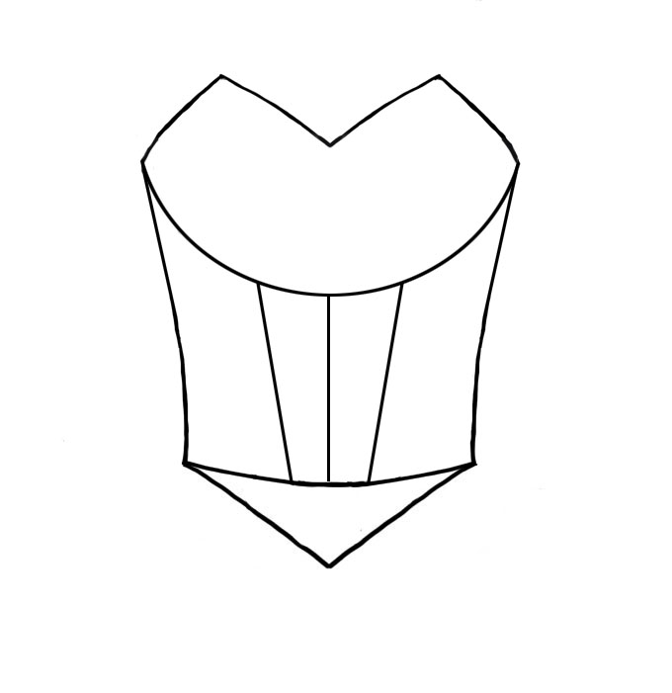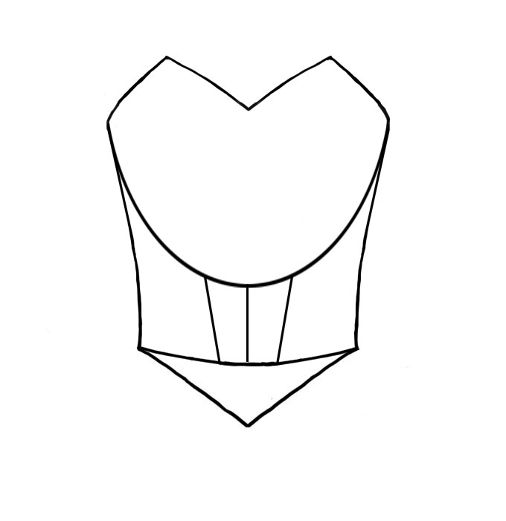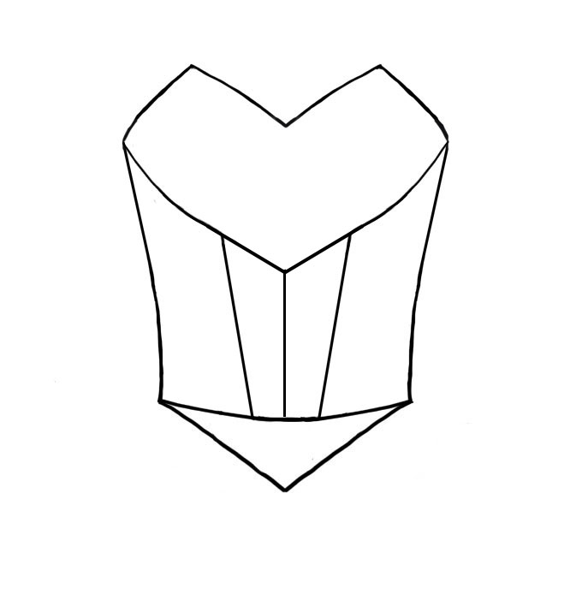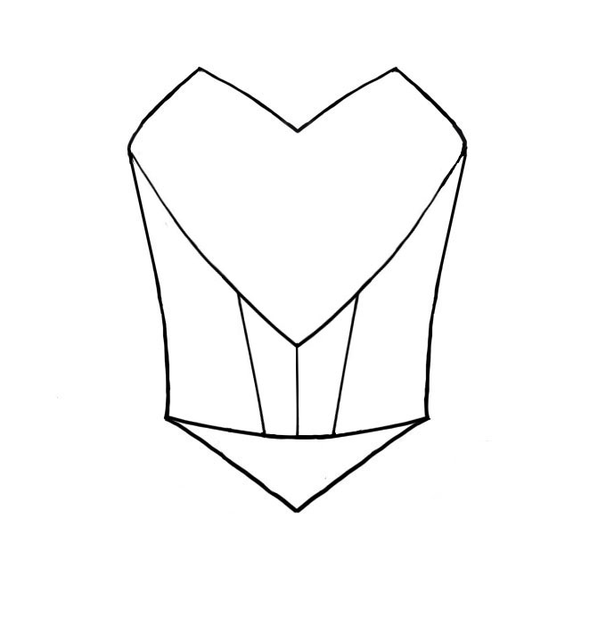

Custom options for bodices

Modesty inset for bodices made of souffel $12.50
Spiral boning (all bodices) $30.00

Contrast Piping on Bodice $15.00 - $25.00

Tutu Etoile Revised 07/19 Prices are subject to change Pg. 10

Sleeves
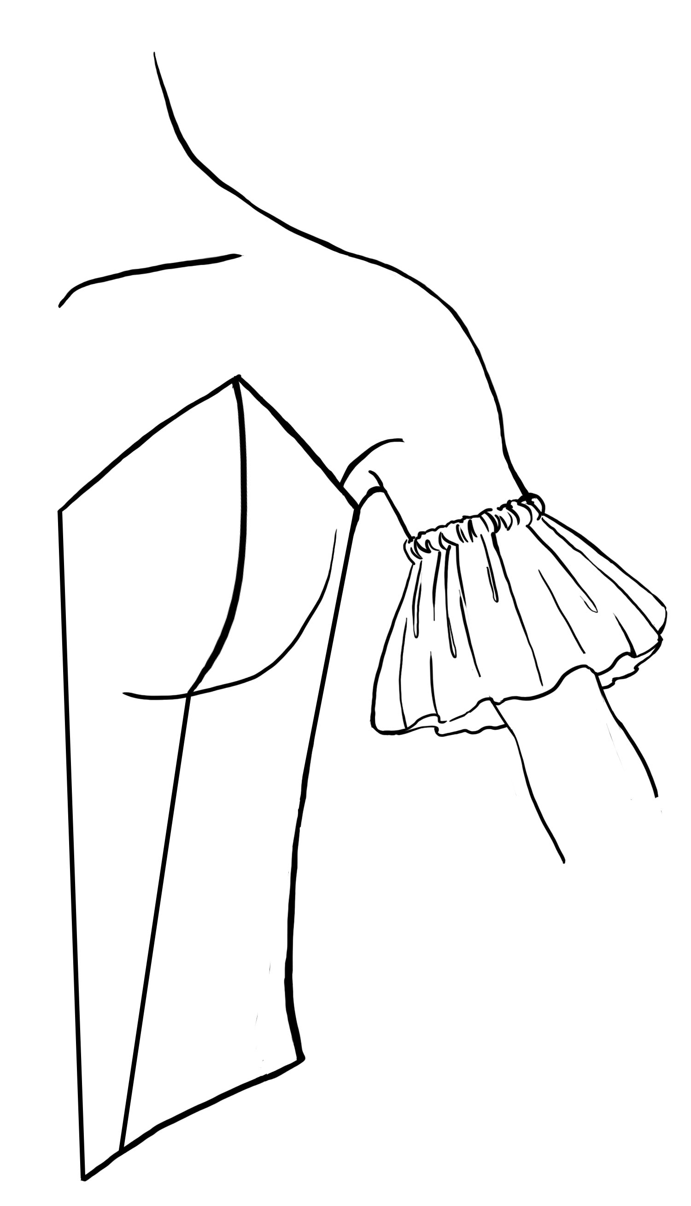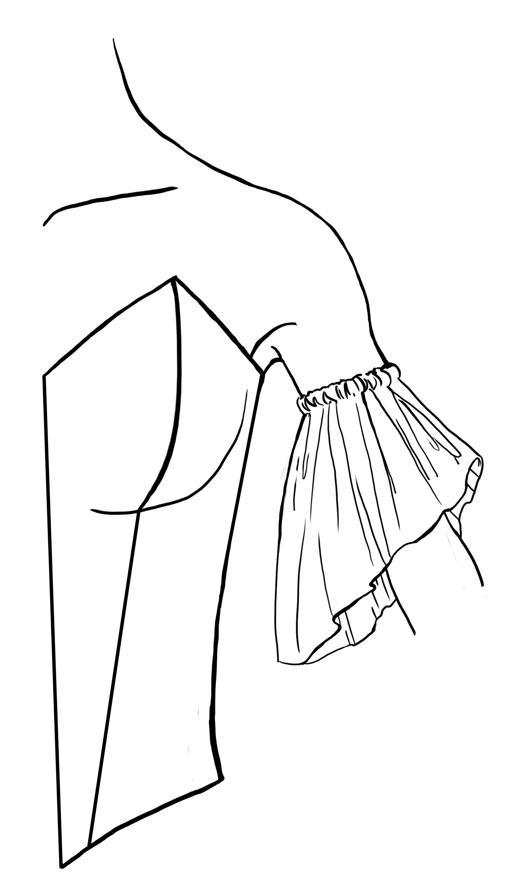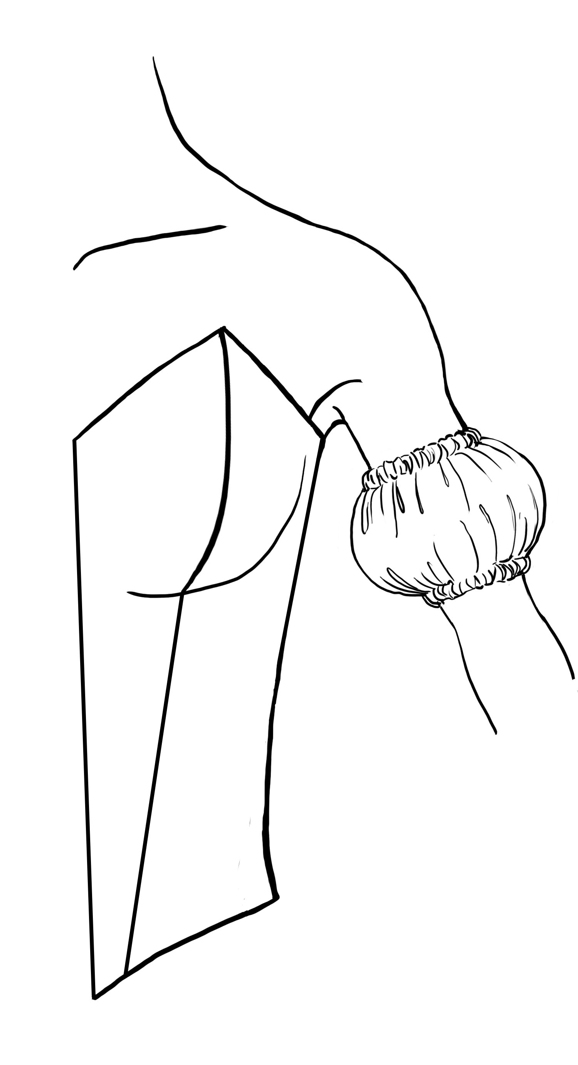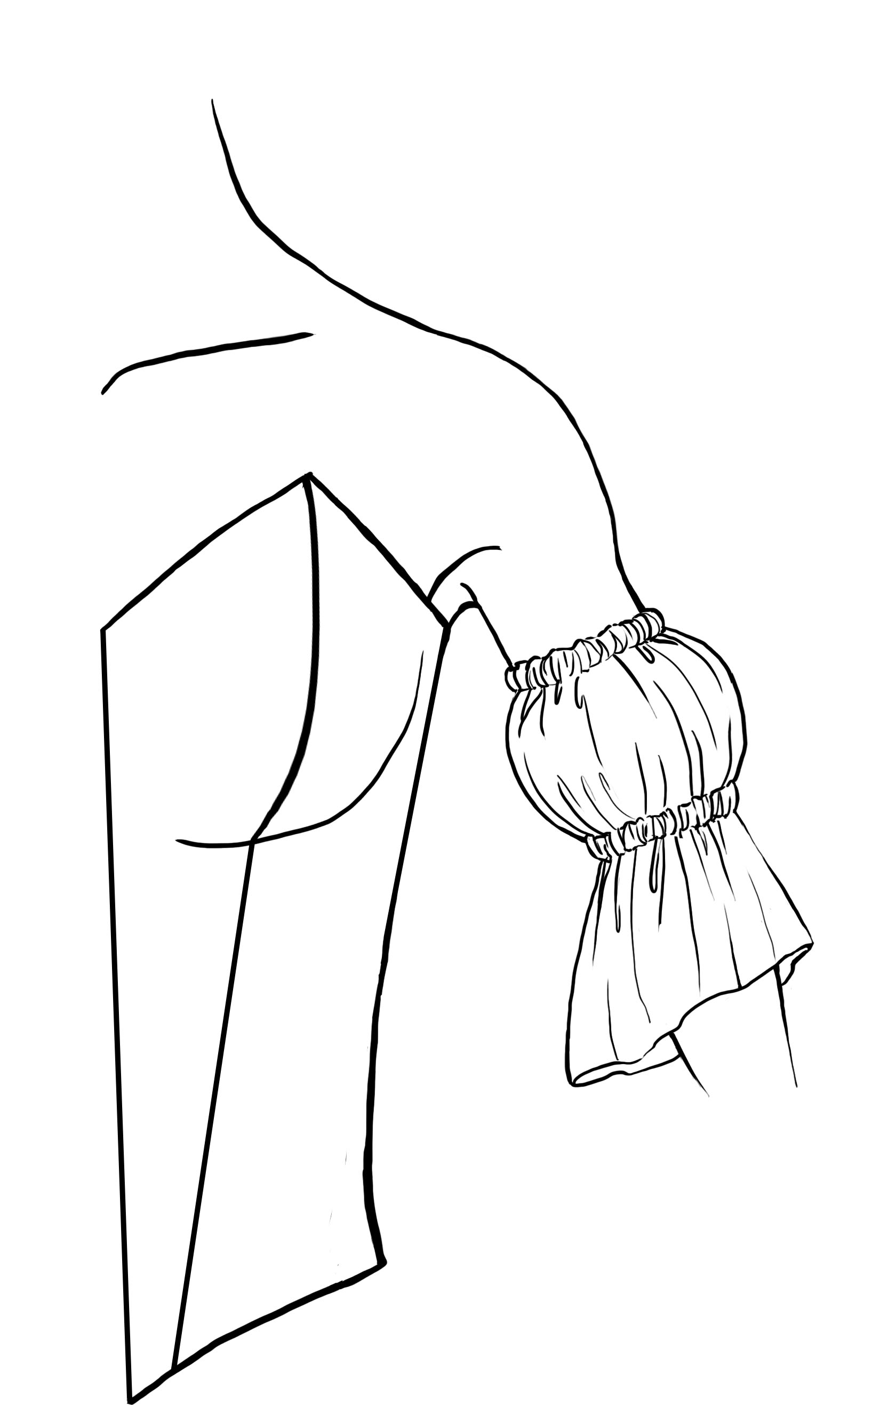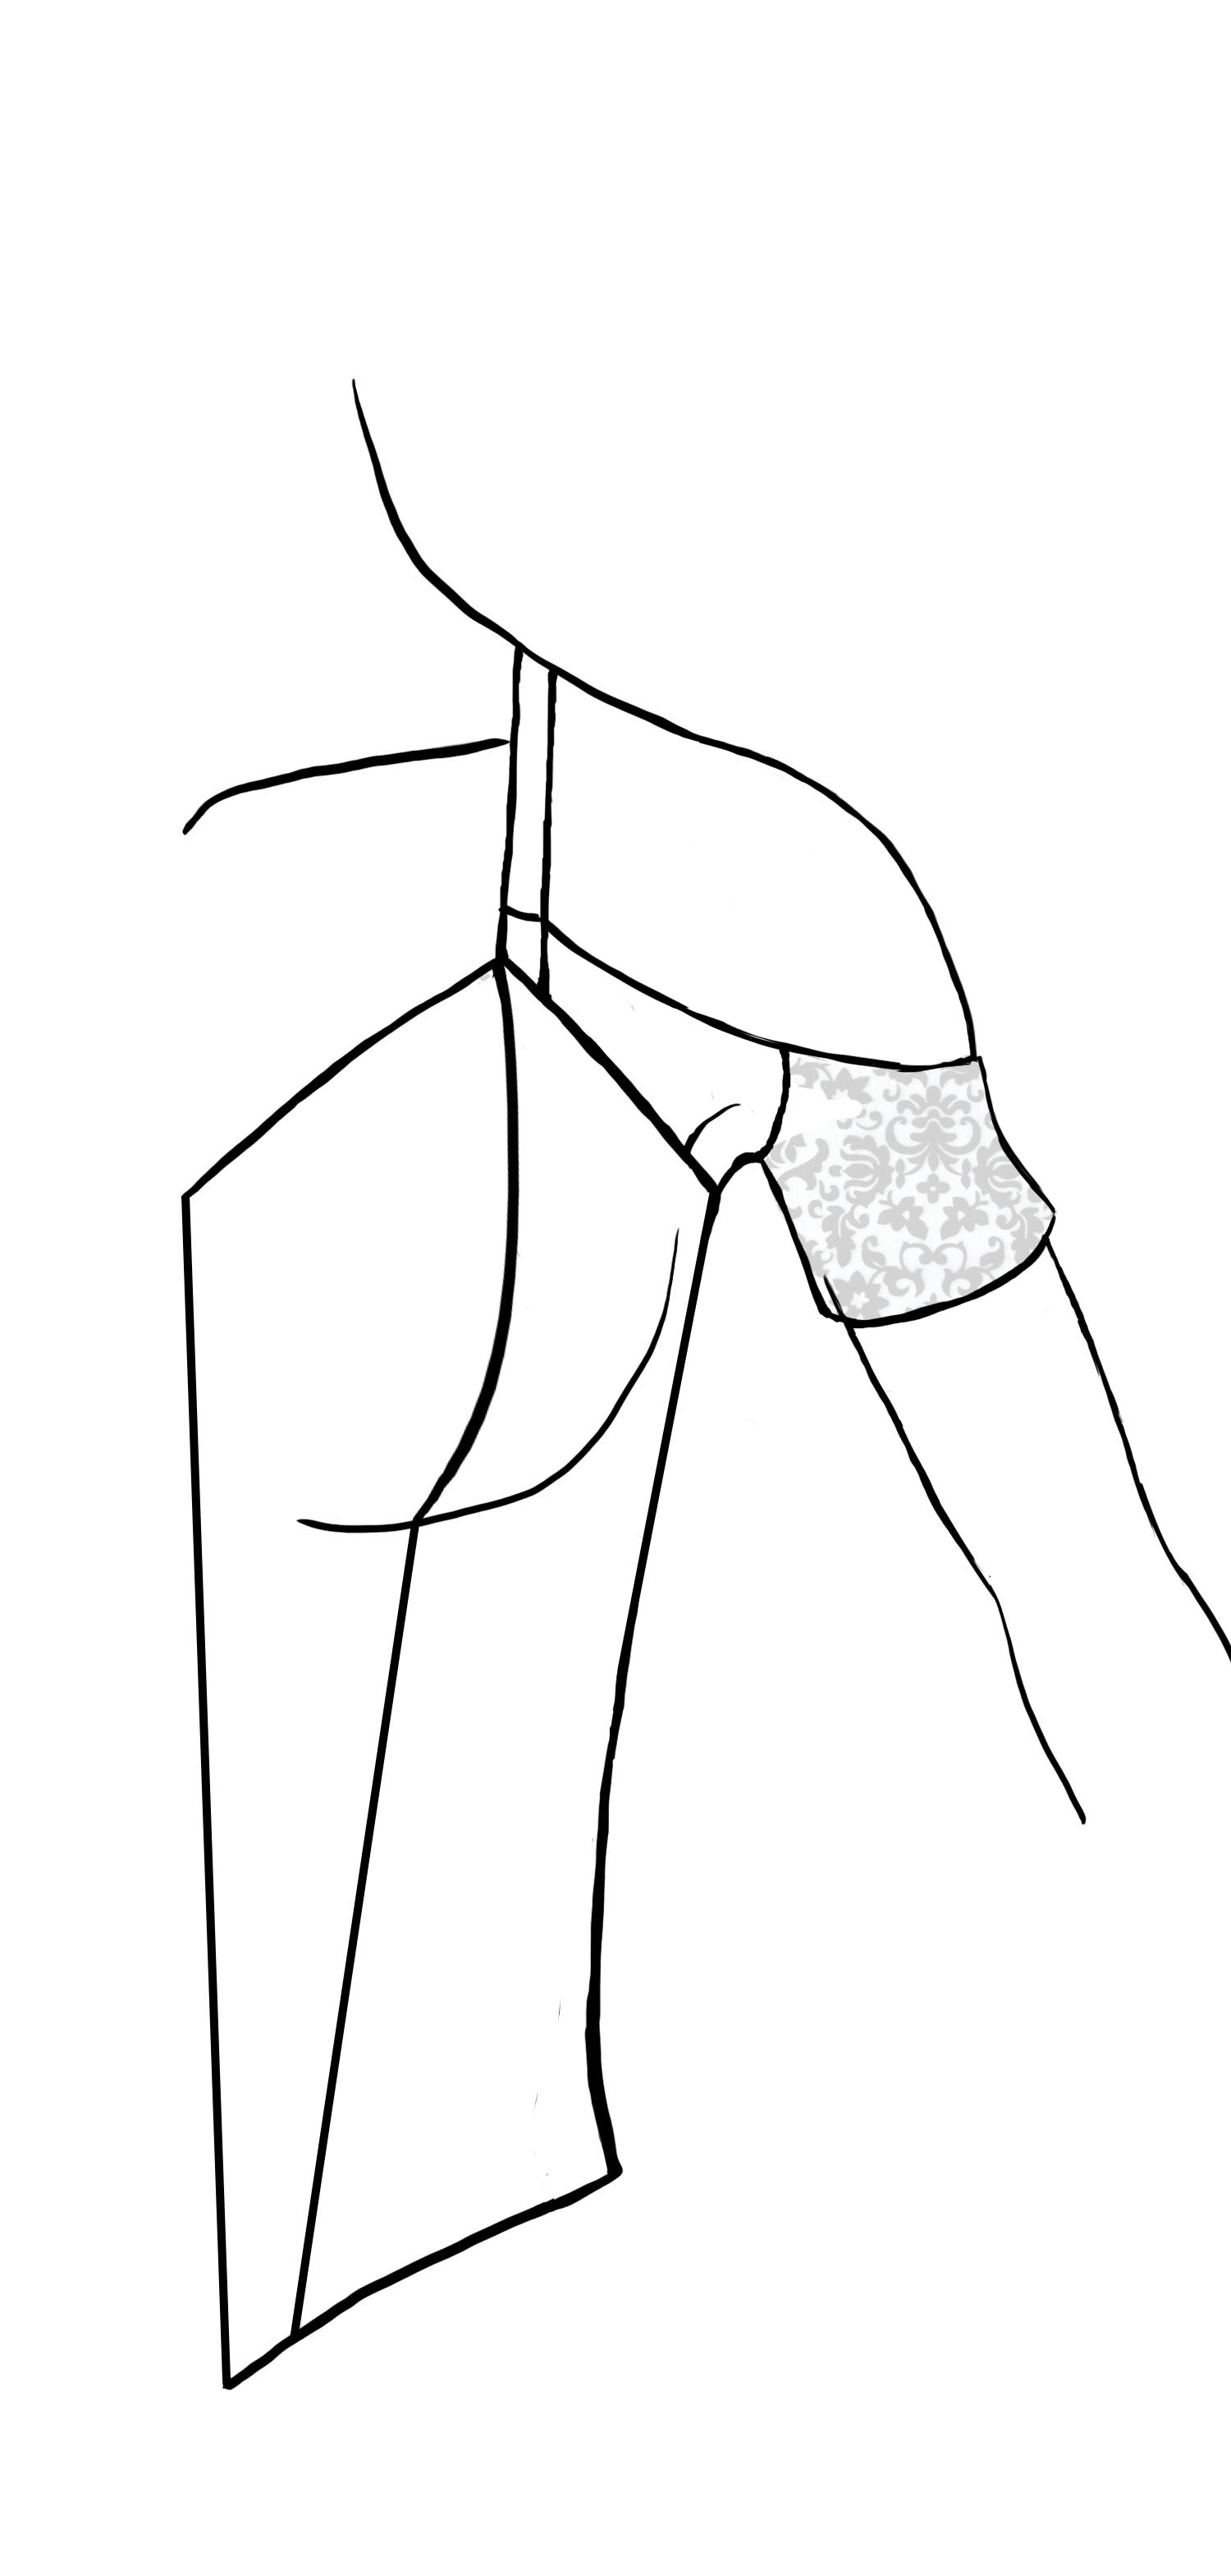
Ruffle Engegant Puff Puff Band
$25.00 $30.00 $30.00 w/ Ruffle $45.00 $30.00
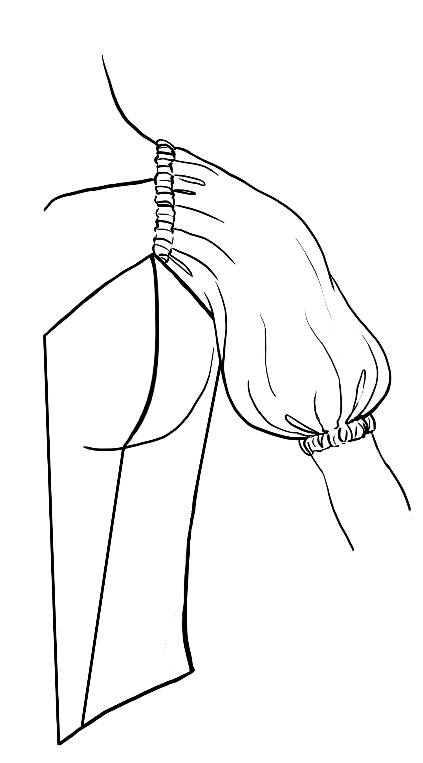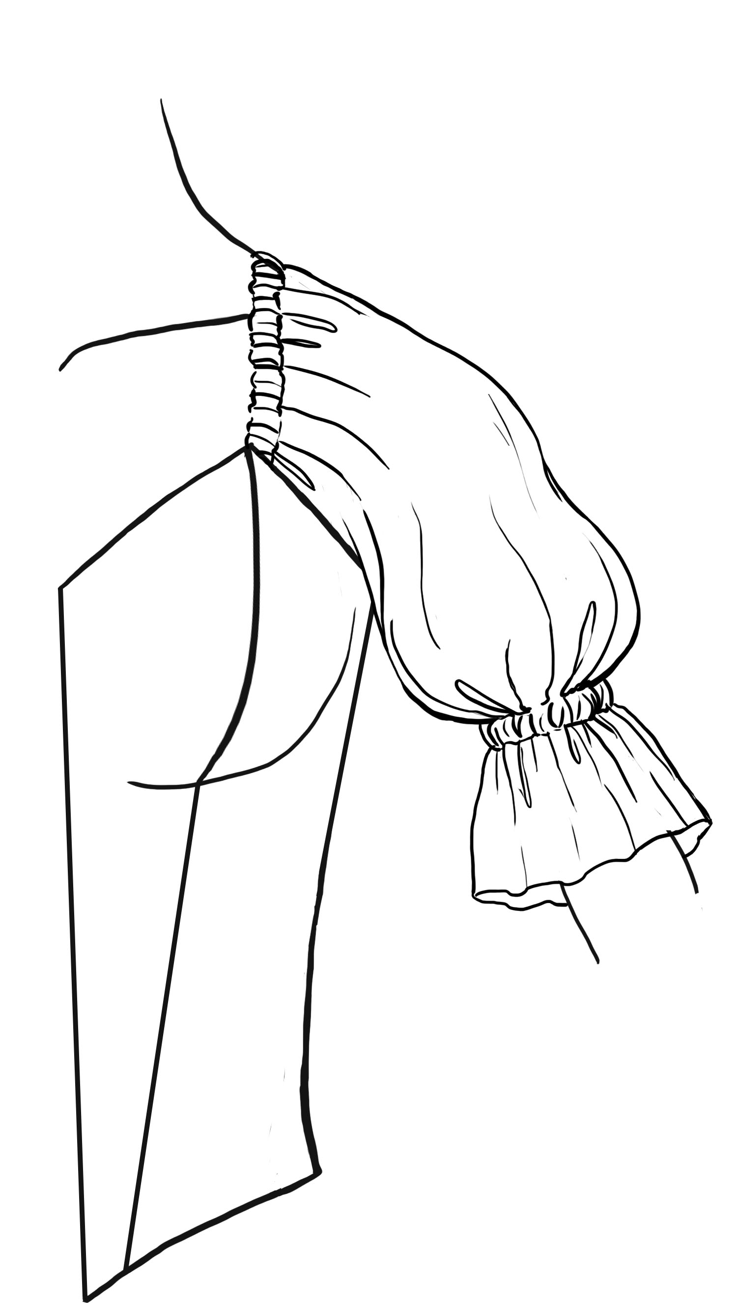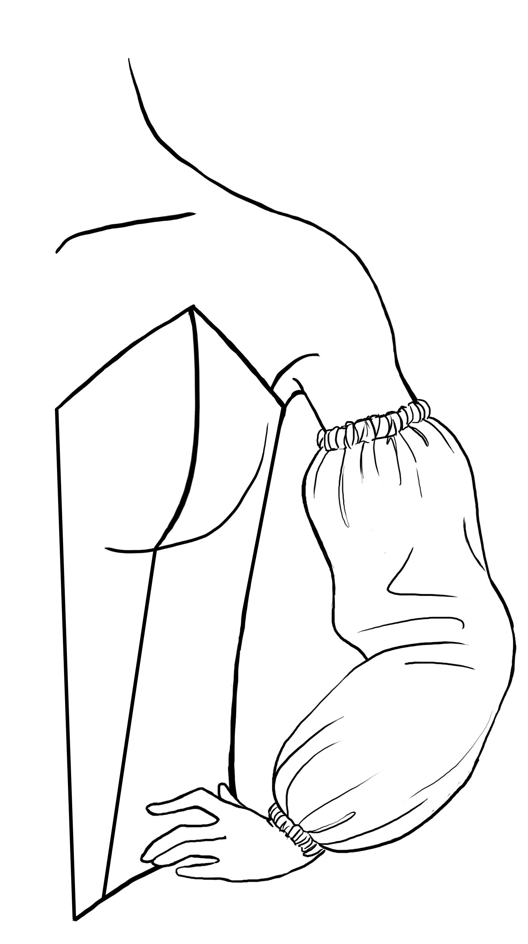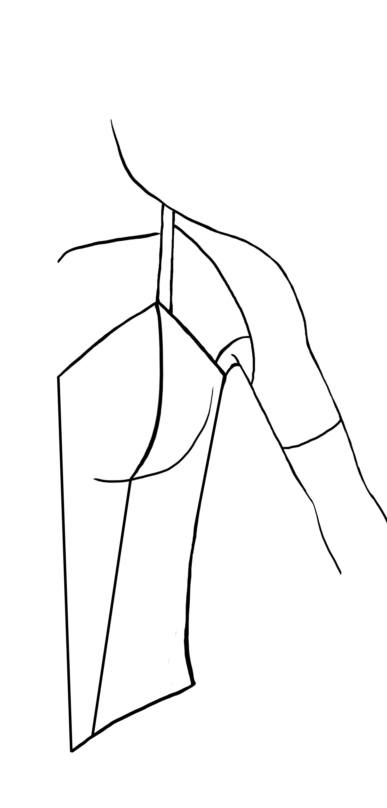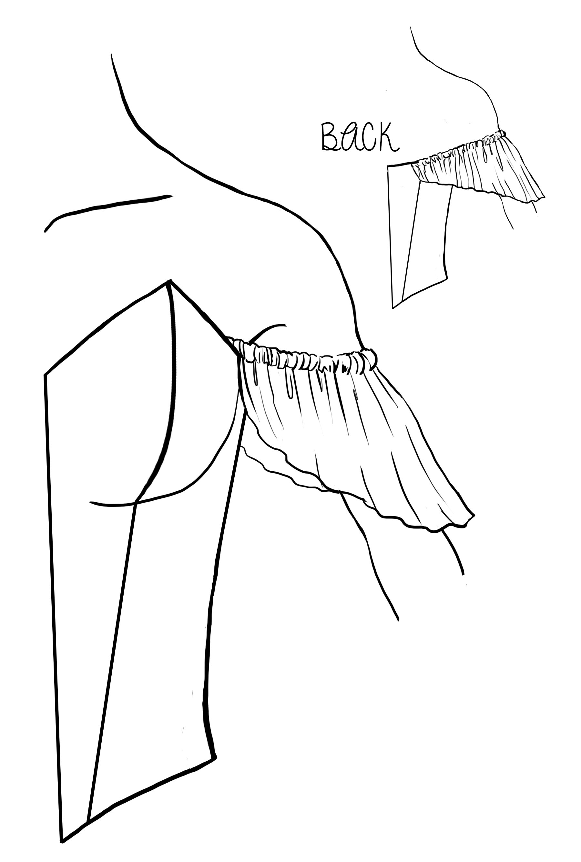
Attached Attached Long Puff Souffel Flutter
Puff $45.00 w/ Ruffle $50.00 $40.00 $30.00 $35.00

Wings

These wings are constructed of tulle stitched on to millinery wire.
They can be stitched, snapped or tied to your bodice. (Hardware not included).
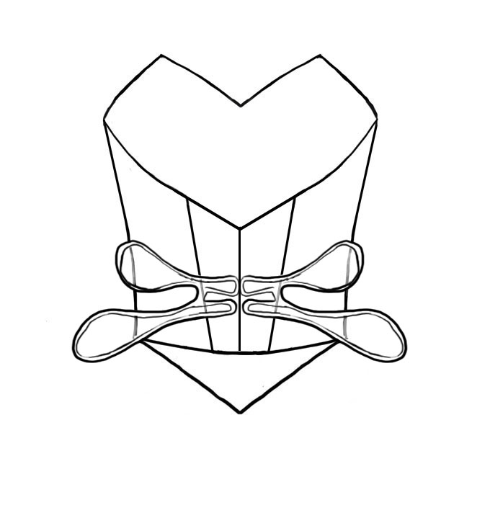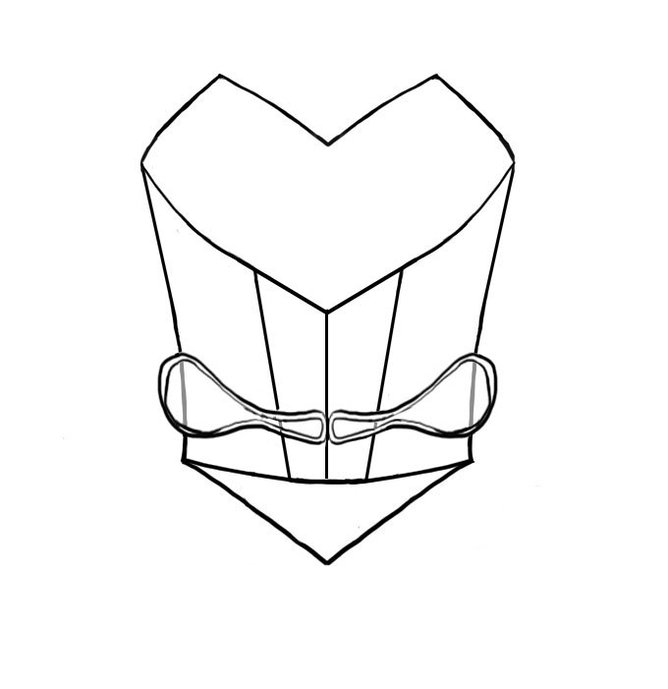
Double Wings Single wings
$85.00 $55.00

Tutu Etoile Revised 07/19 Prices are subject to change Pg.11

Head Pieces

Our headpieces displayed below can be created to match your custom designed tutu. We have created these drawings to display silhouette suggestions. Each headpiece design can be constructed with any combination of materials such as; Beads, Rhinestones, Appliqués, Feathers or Foliage. They are very lightweight and durable. Included for security are combs and/or horsehair to bobby pin into your hair. If you like aspects from one headpiece and want to blend them with another contact us, we will create it for you.
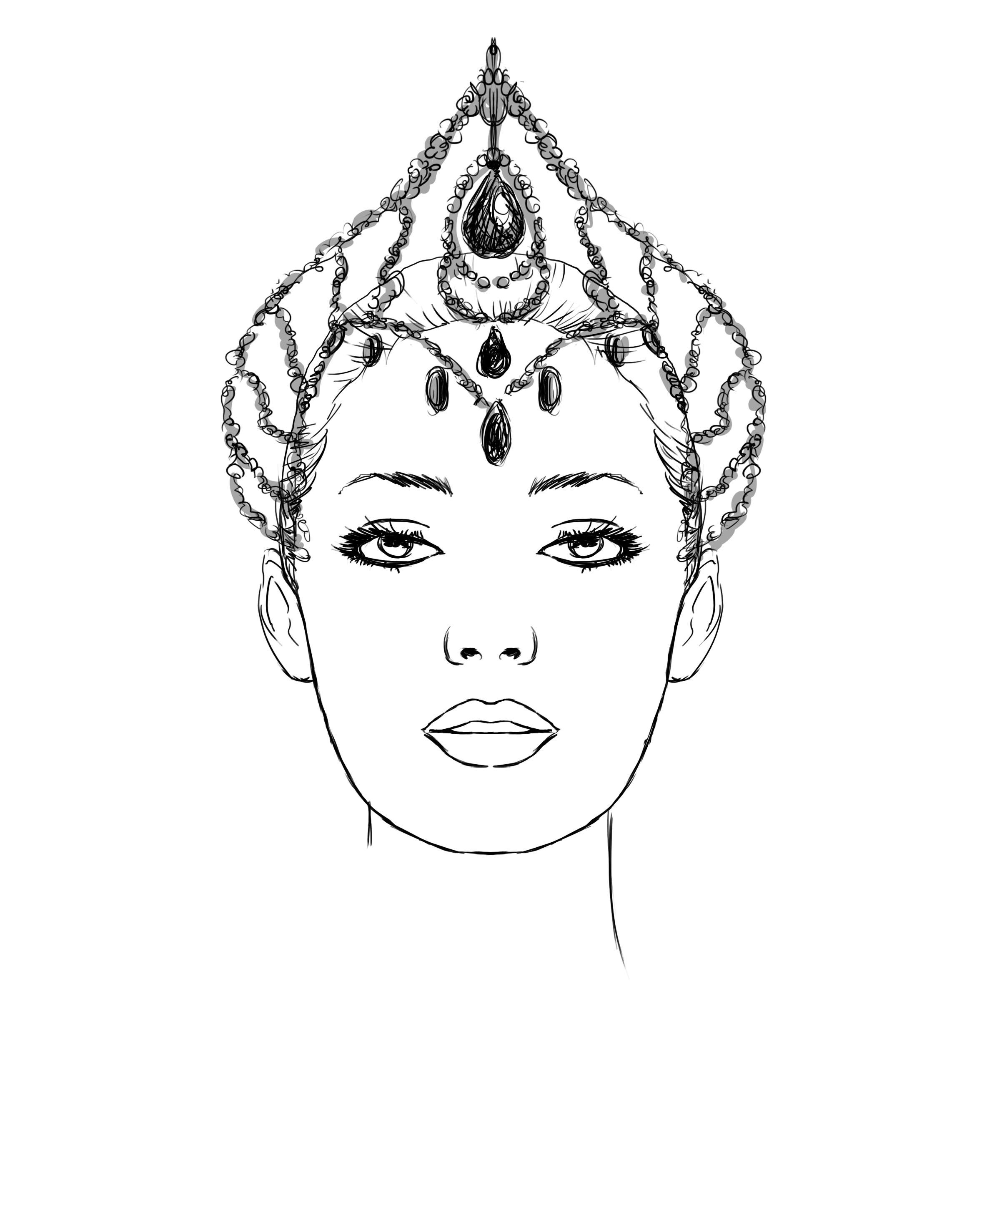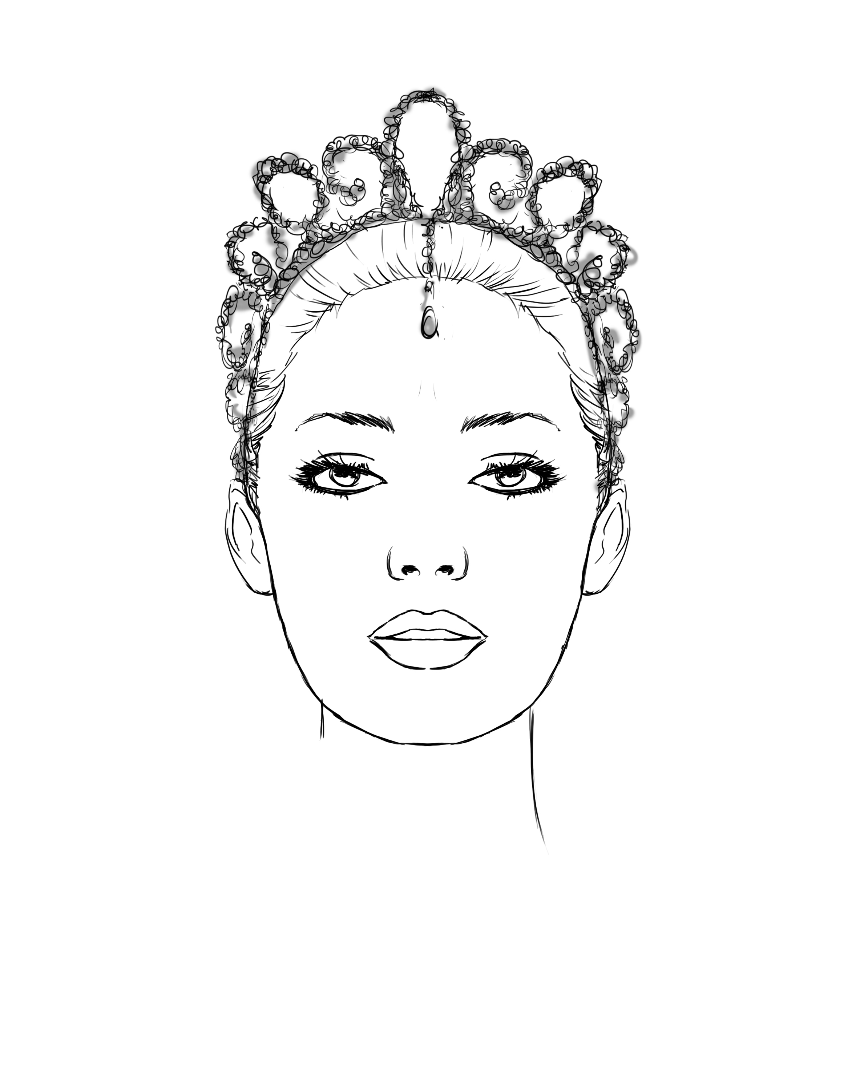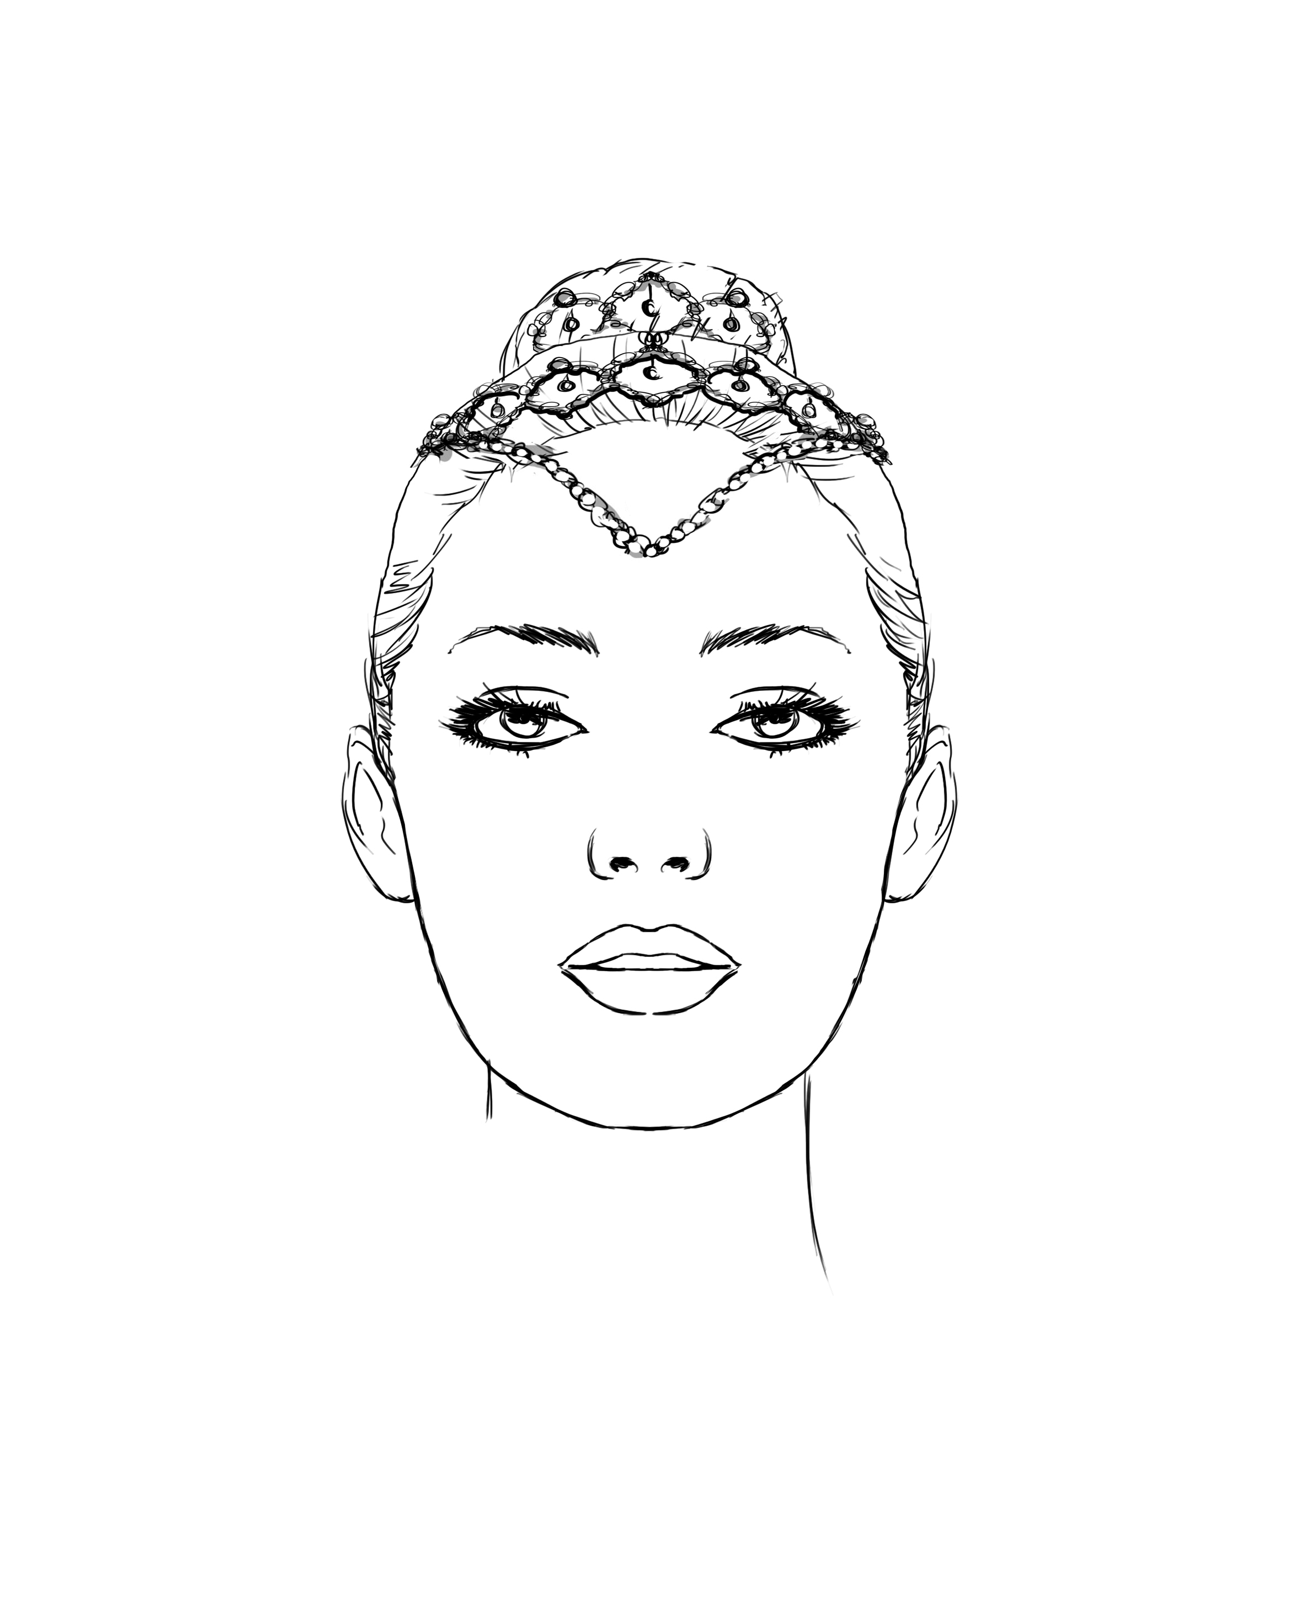
La Bayadere/ Gamzatti 1 $350.00 La Bayadere/ Gamzatti 2 $300.00 Esmerelda $245.00

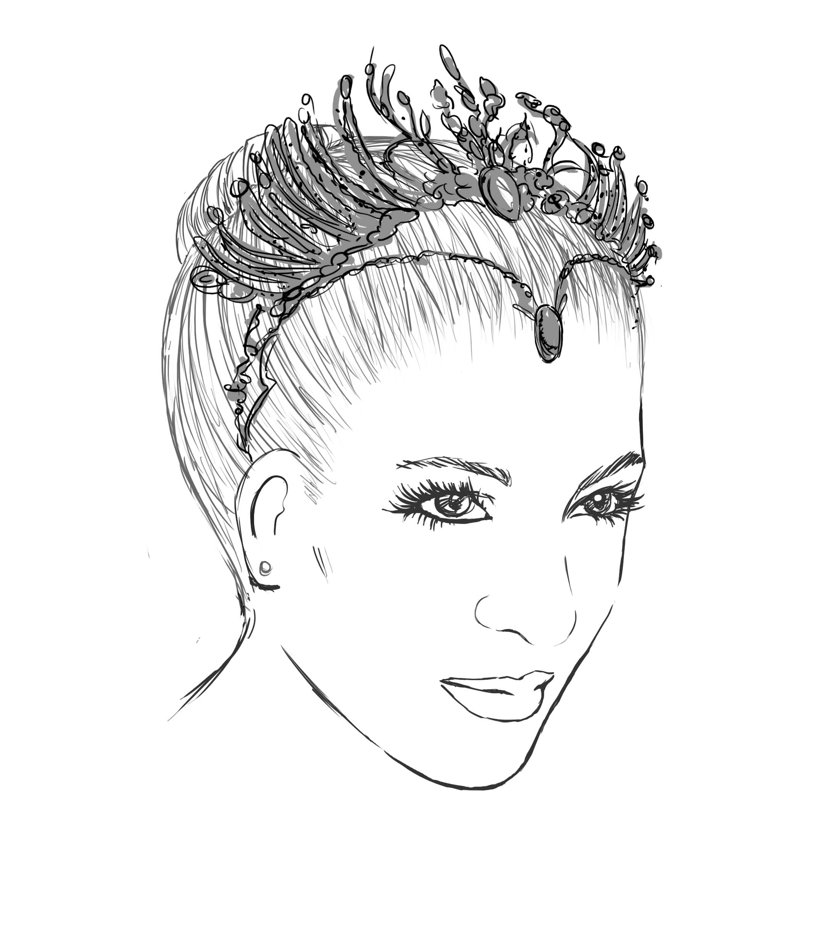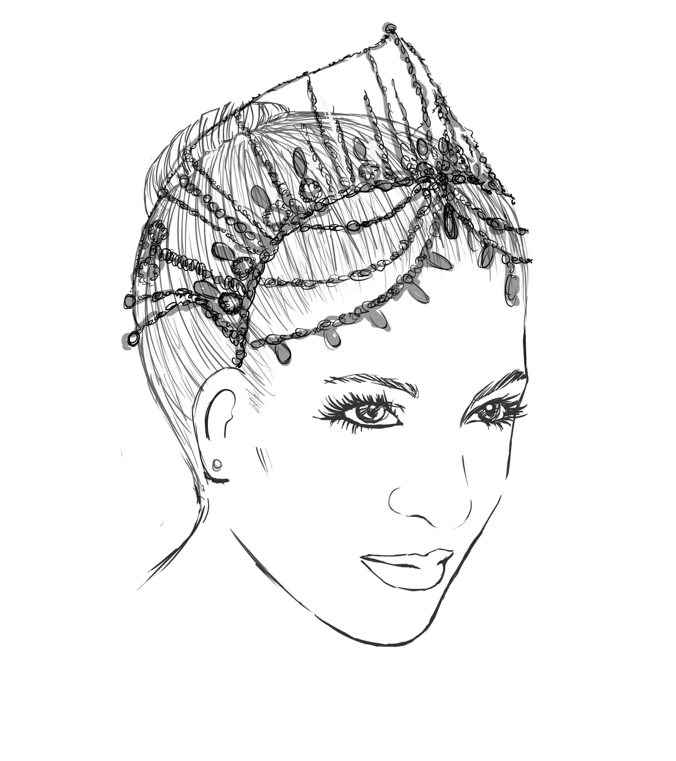
Odile $350.00 Pharaoh’s Daughter $350.00

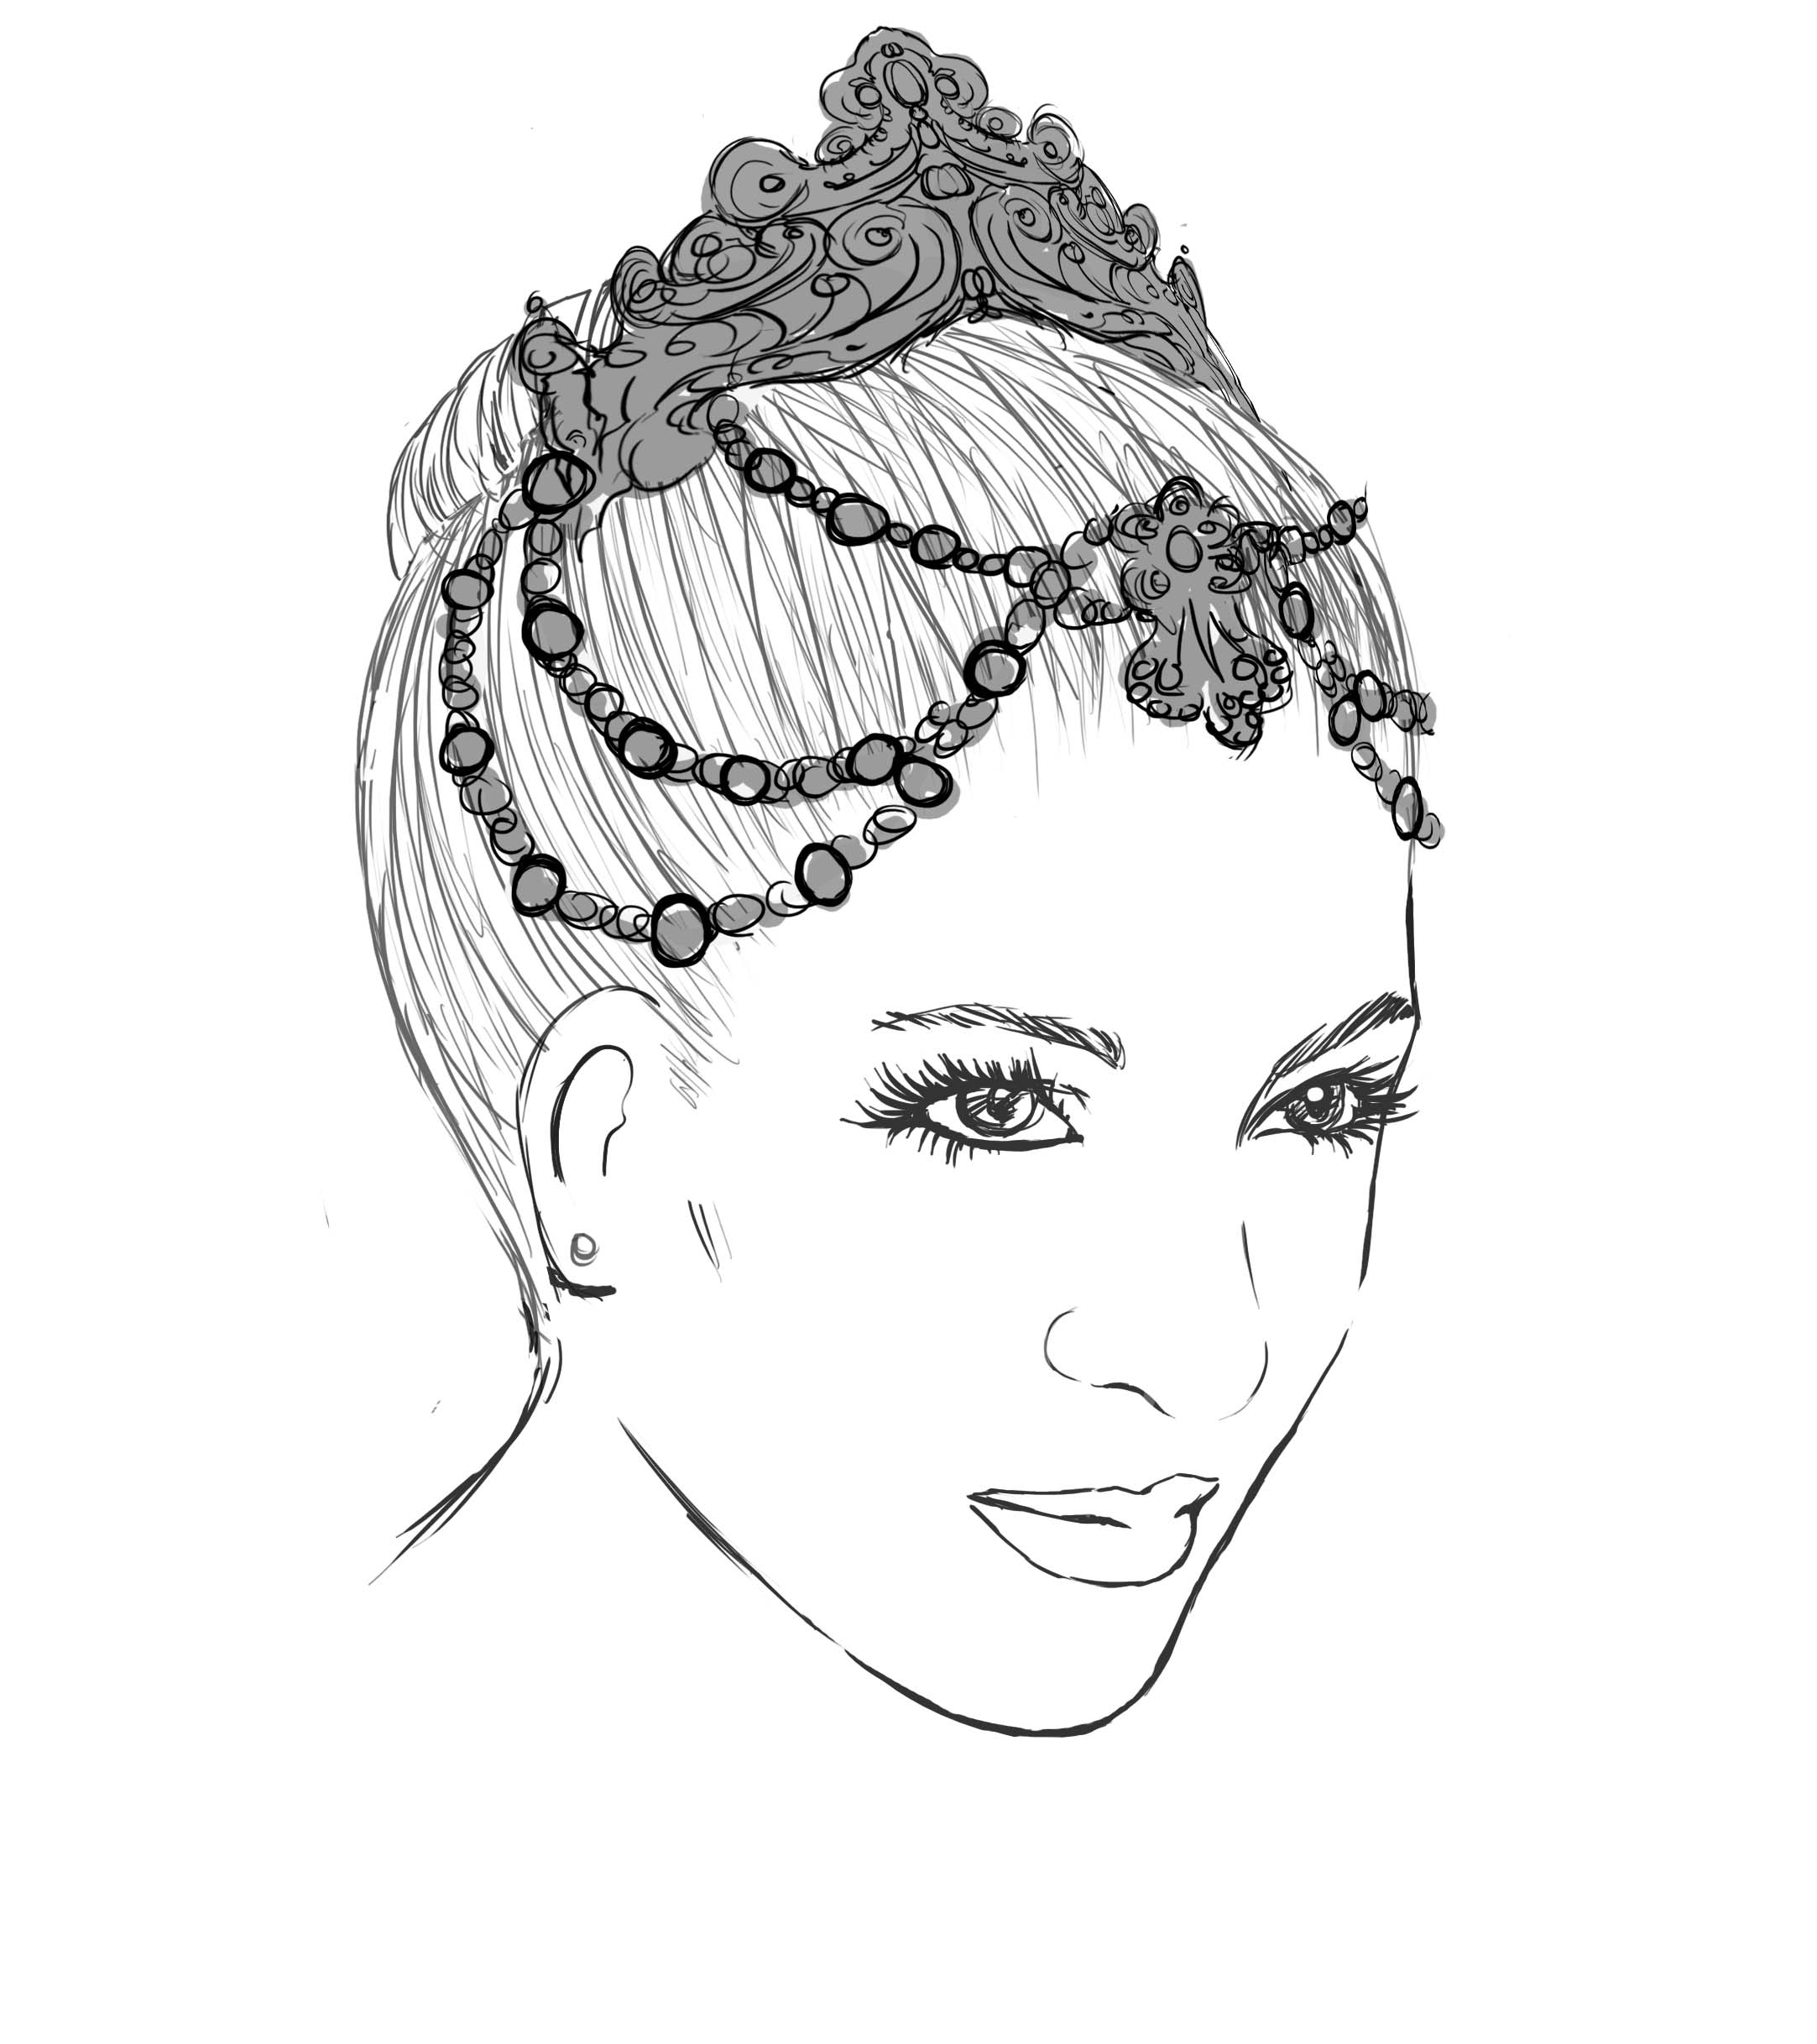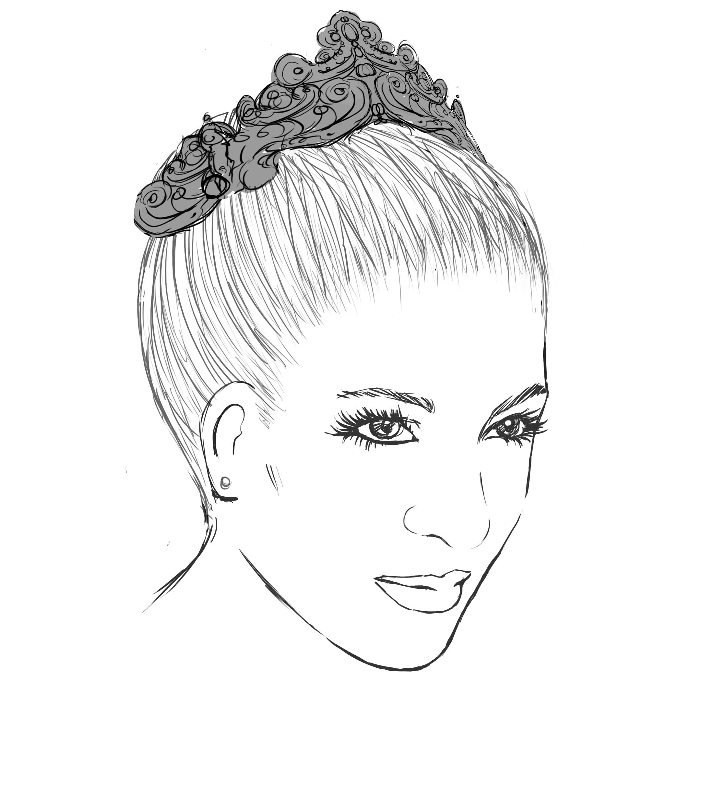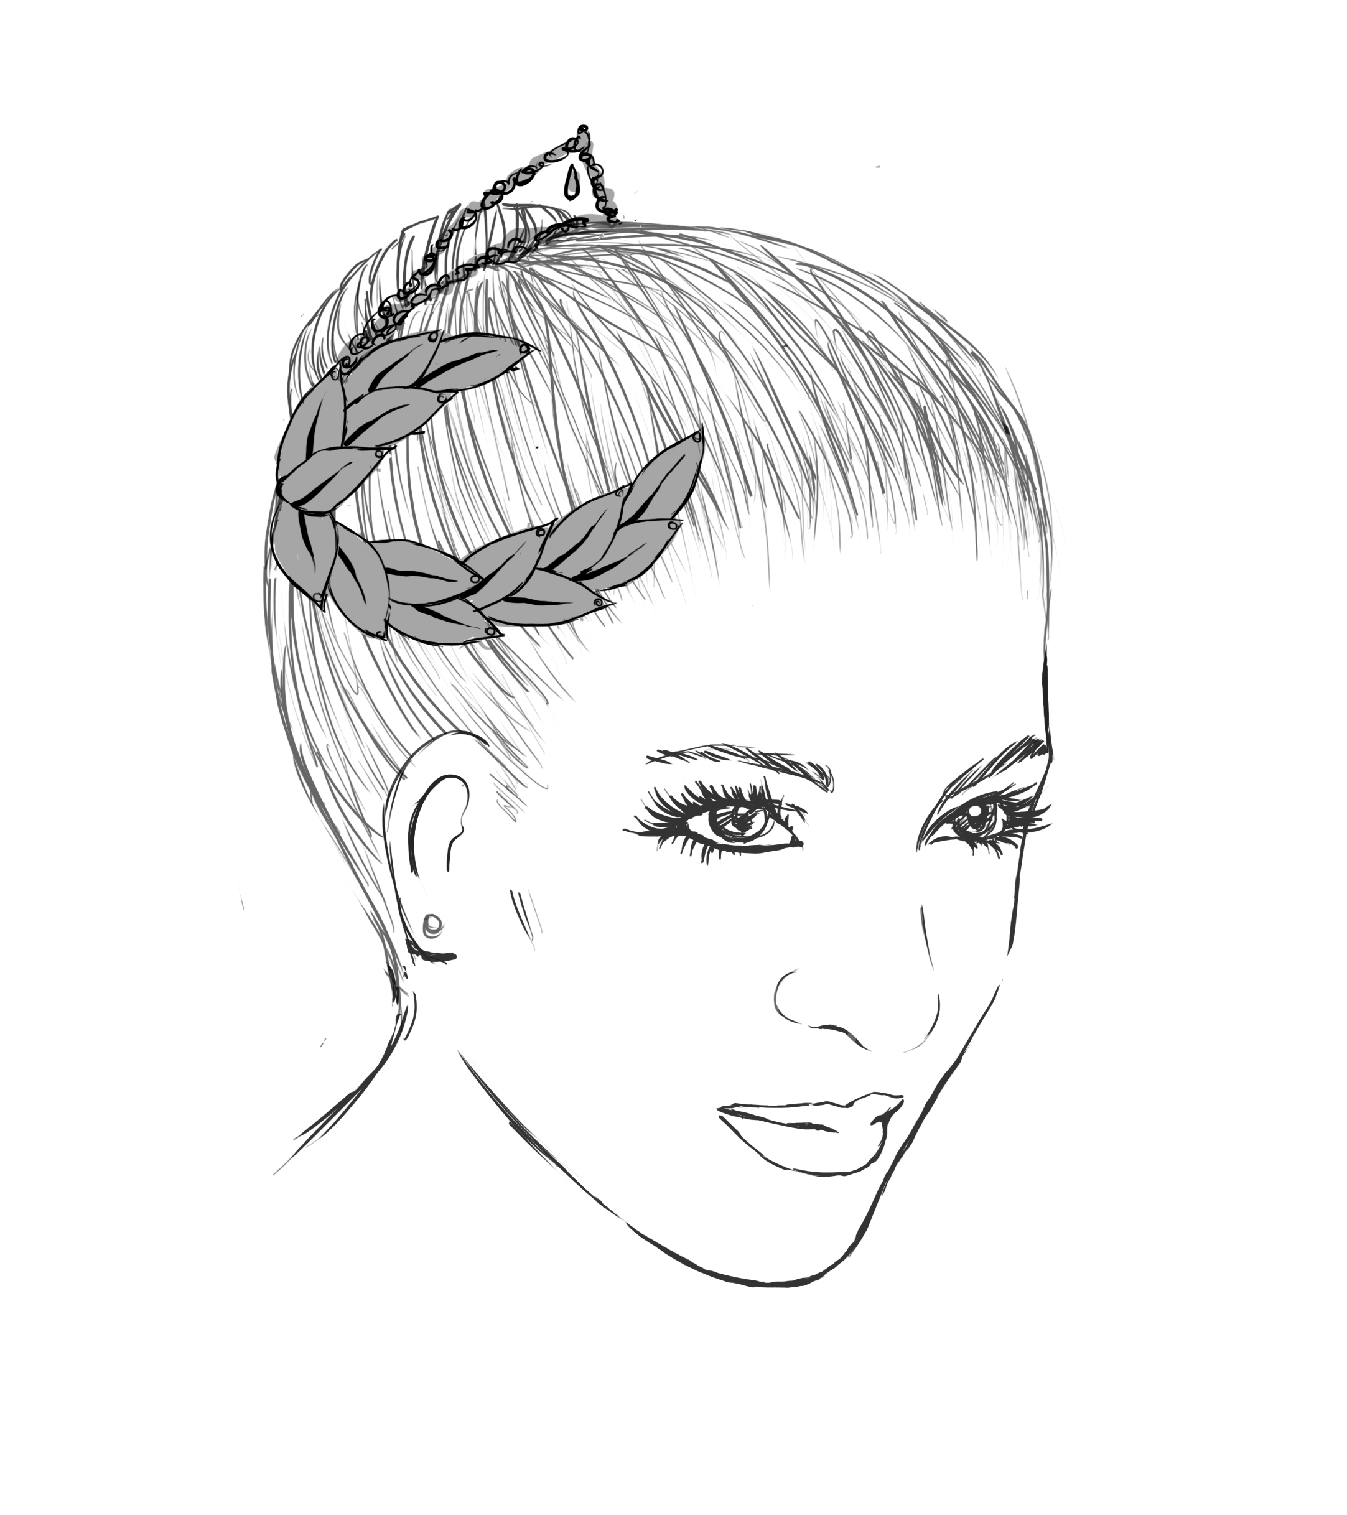
Raymonda $275.00 Satanella $145.00 Diane and Acteon $175.00

Tutu Etoile Revised 07/19 Prices are subject to change Pg. 12

Head Pieces cont.

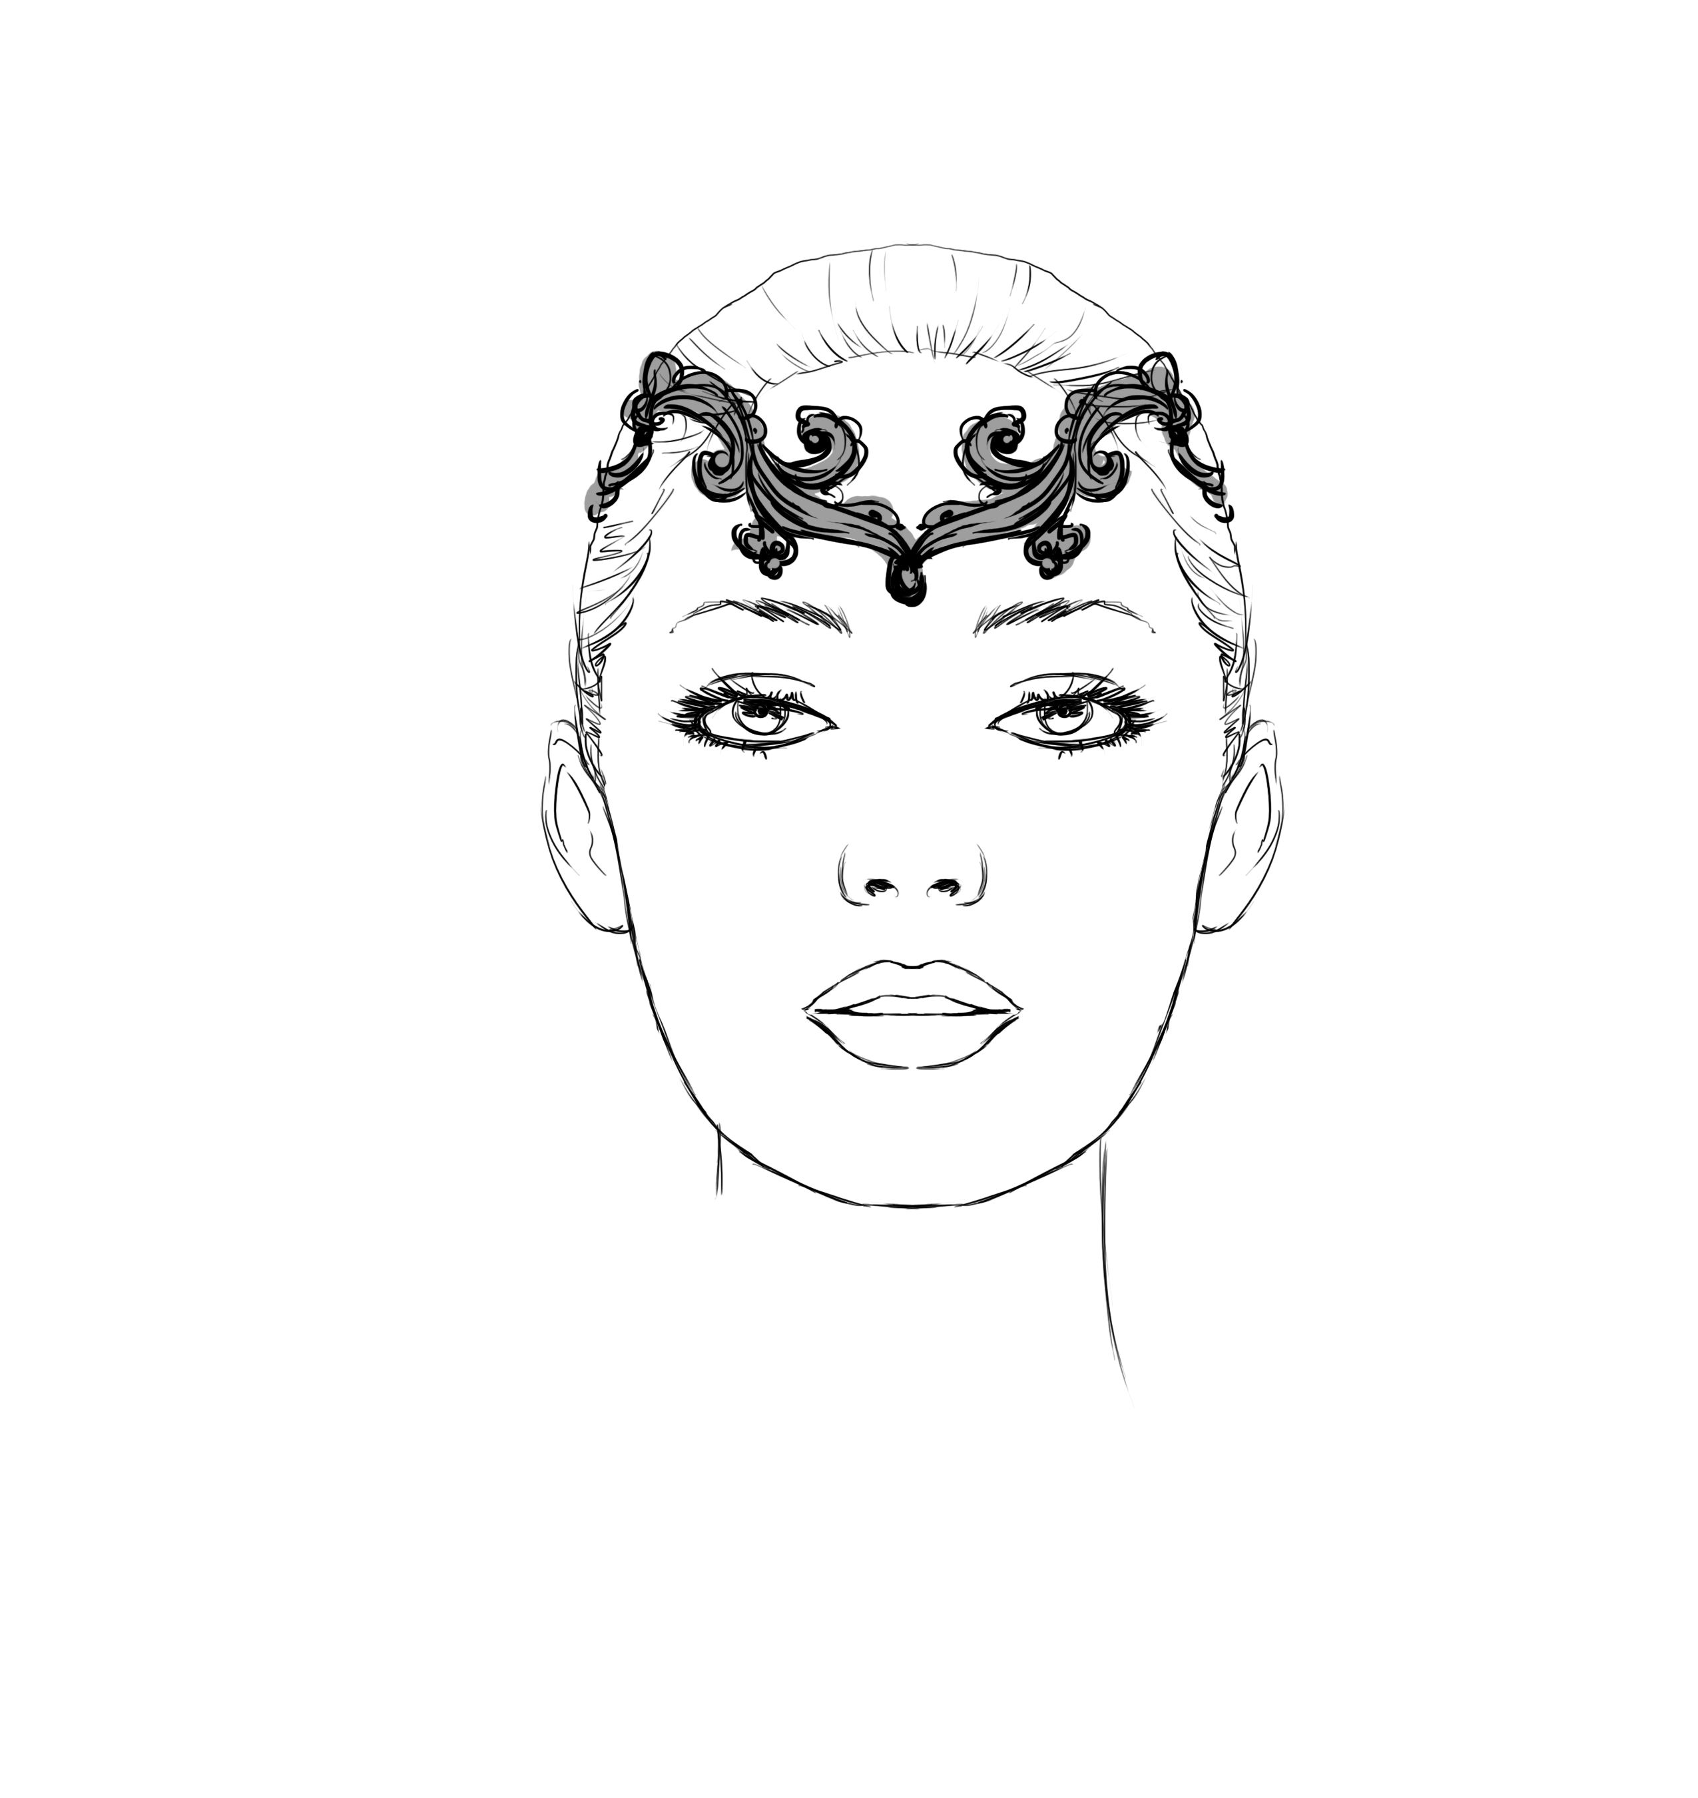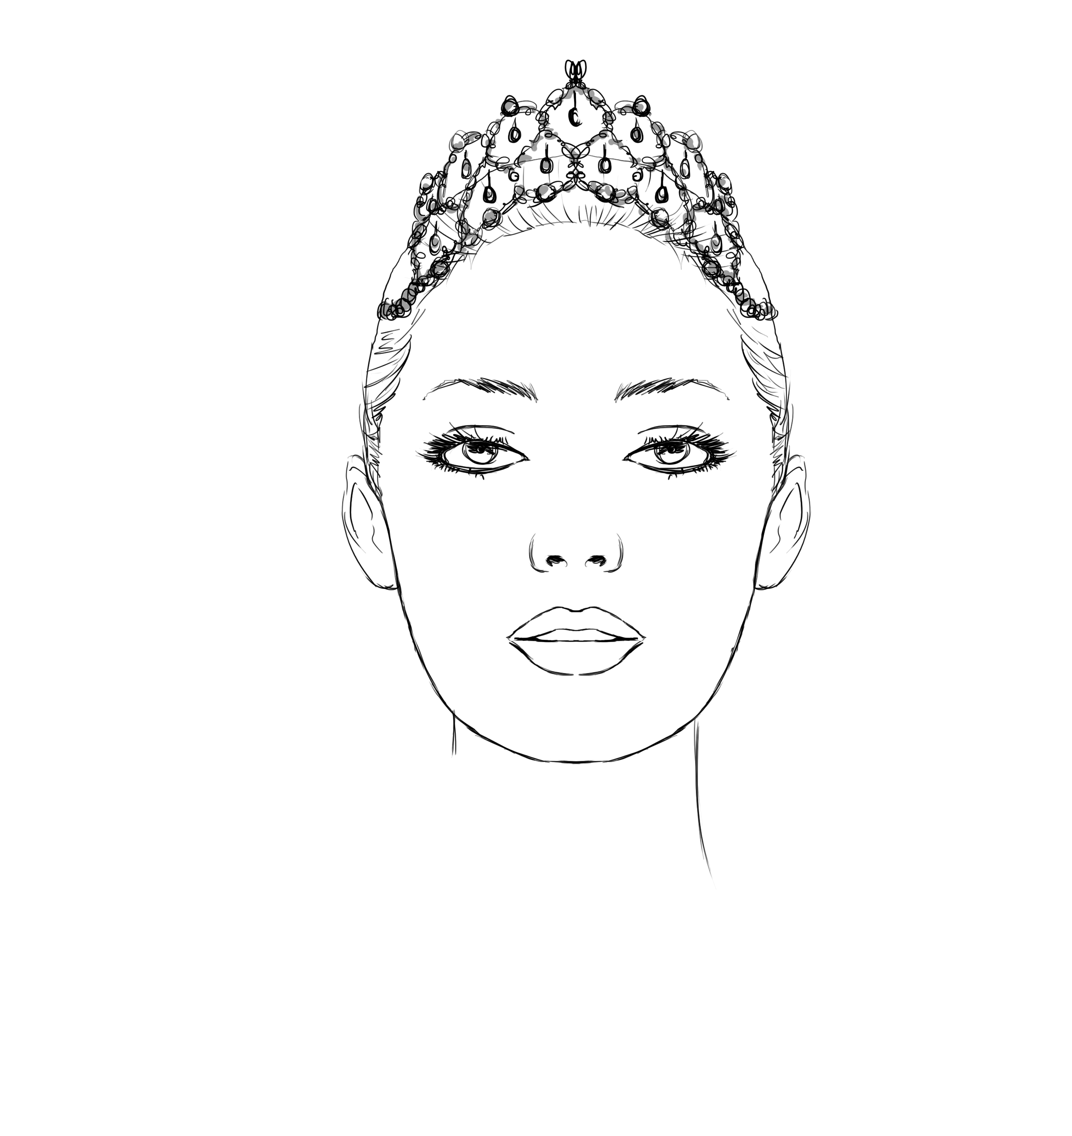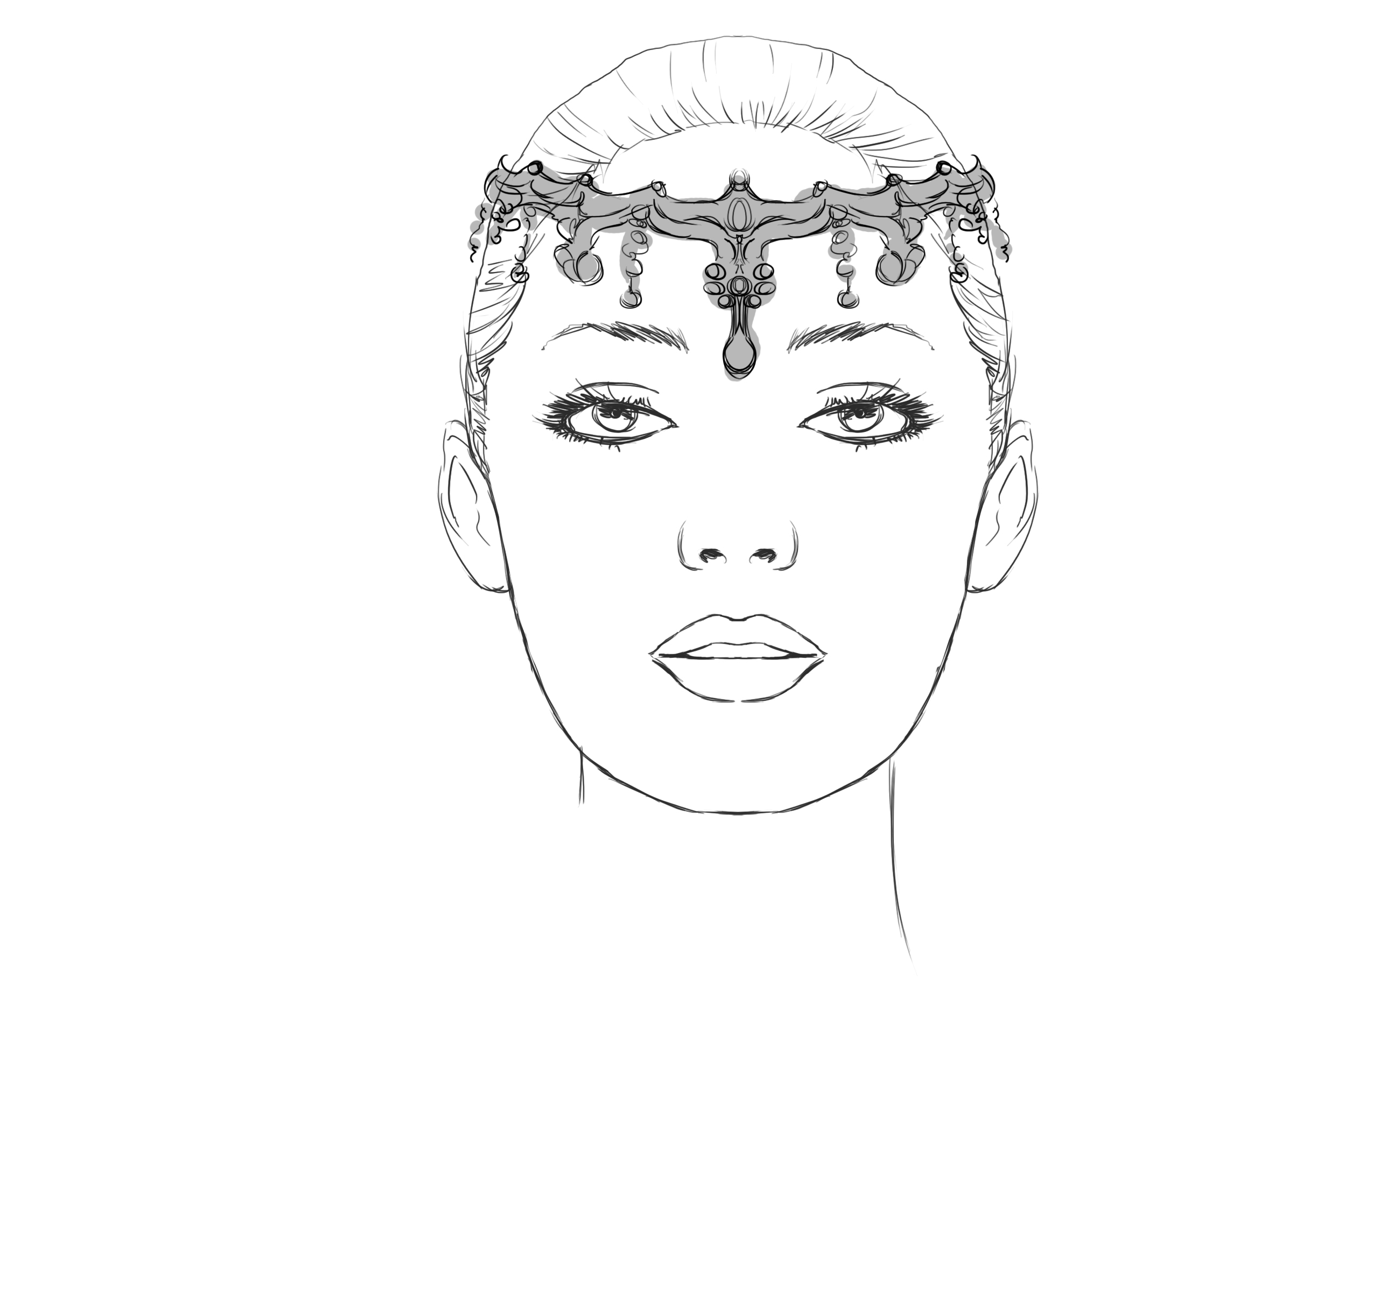
Arabian or La Bayadere $145.00 Coppelia Wedding $230.00 Gamzatti $160.00
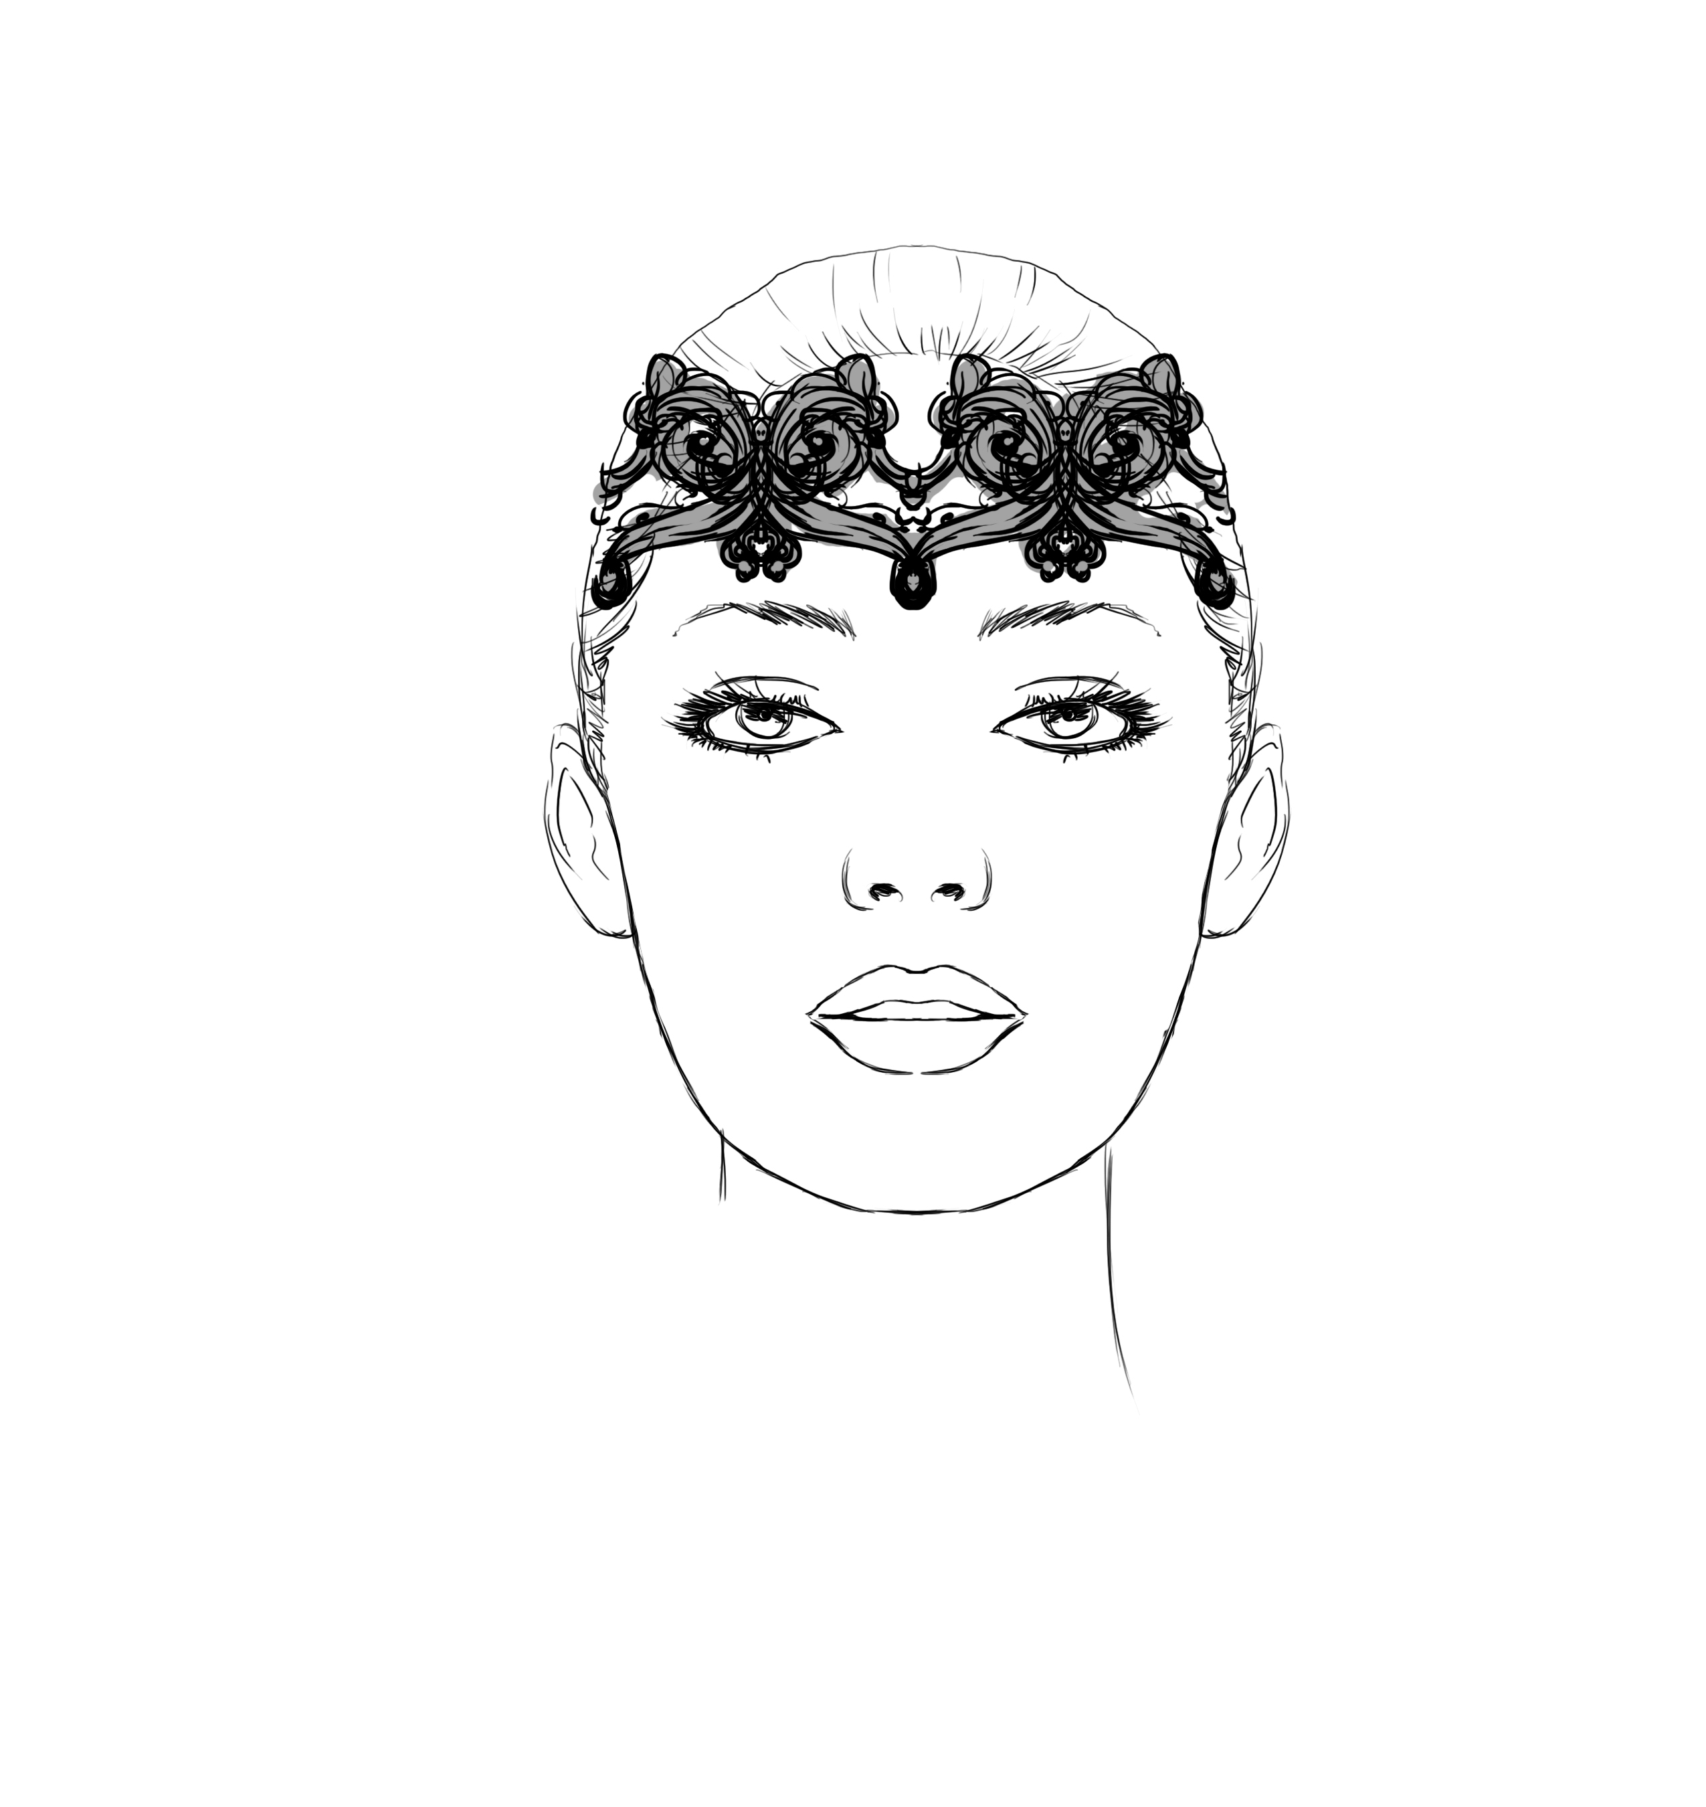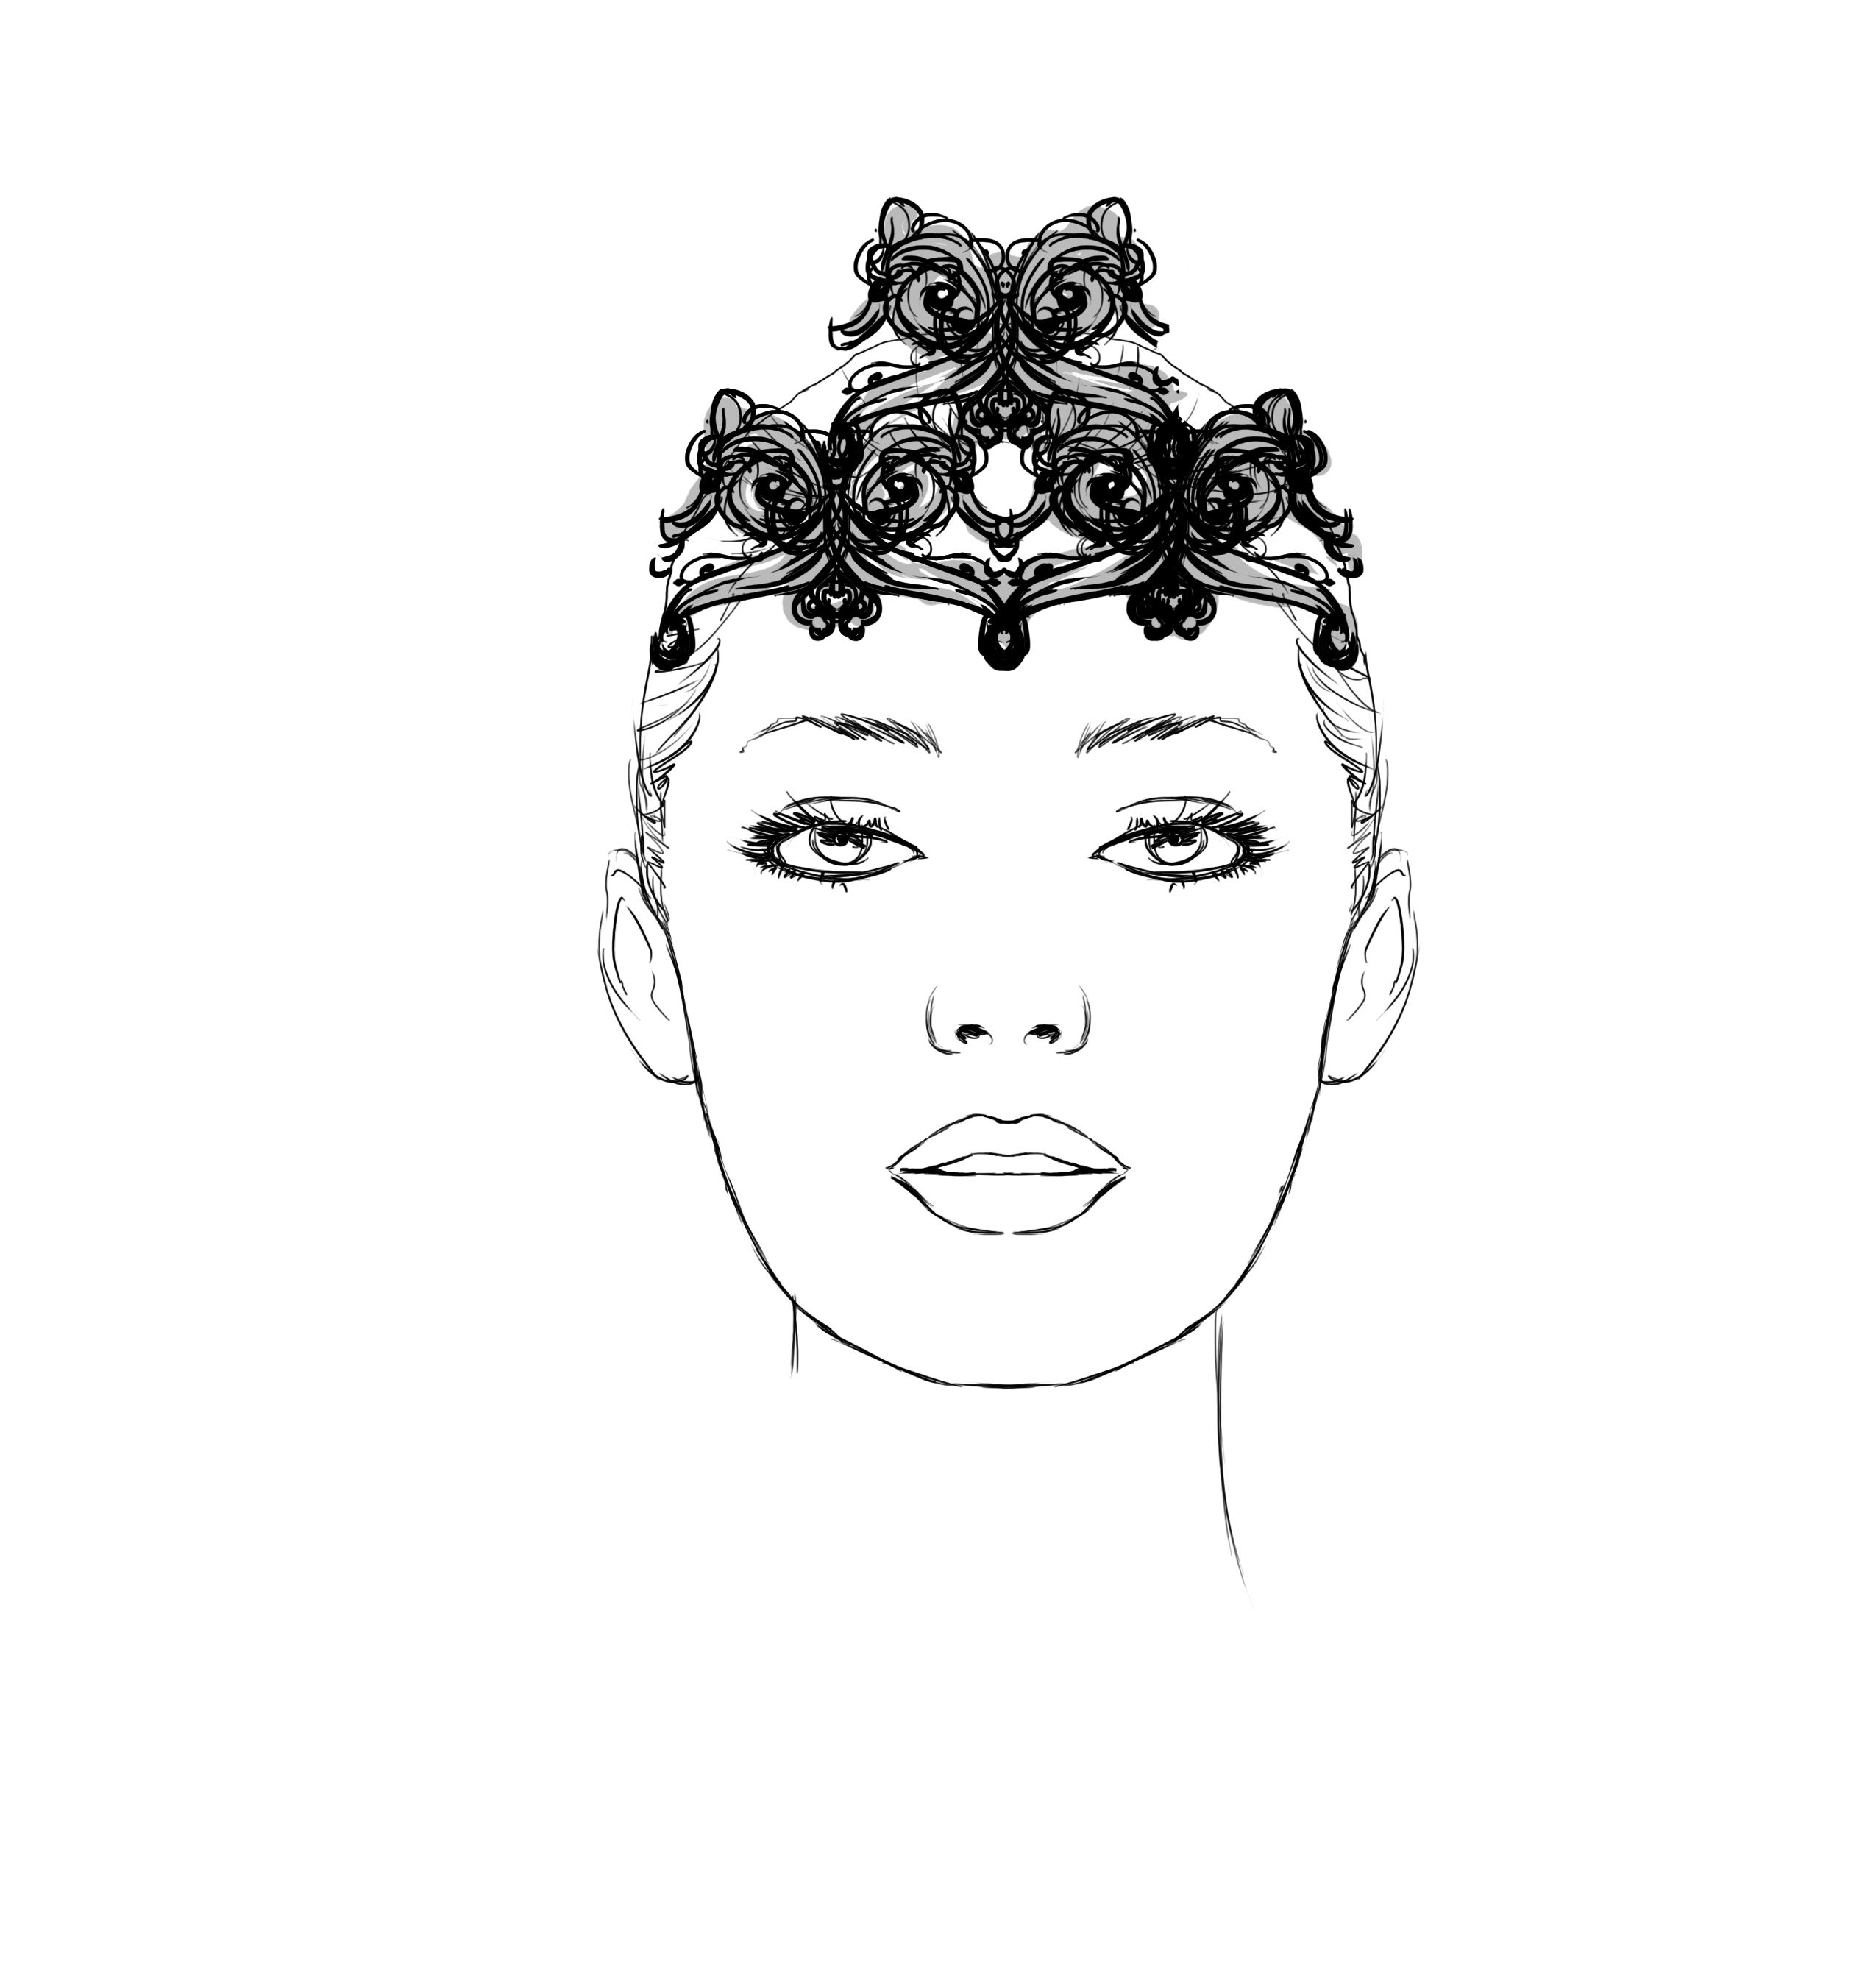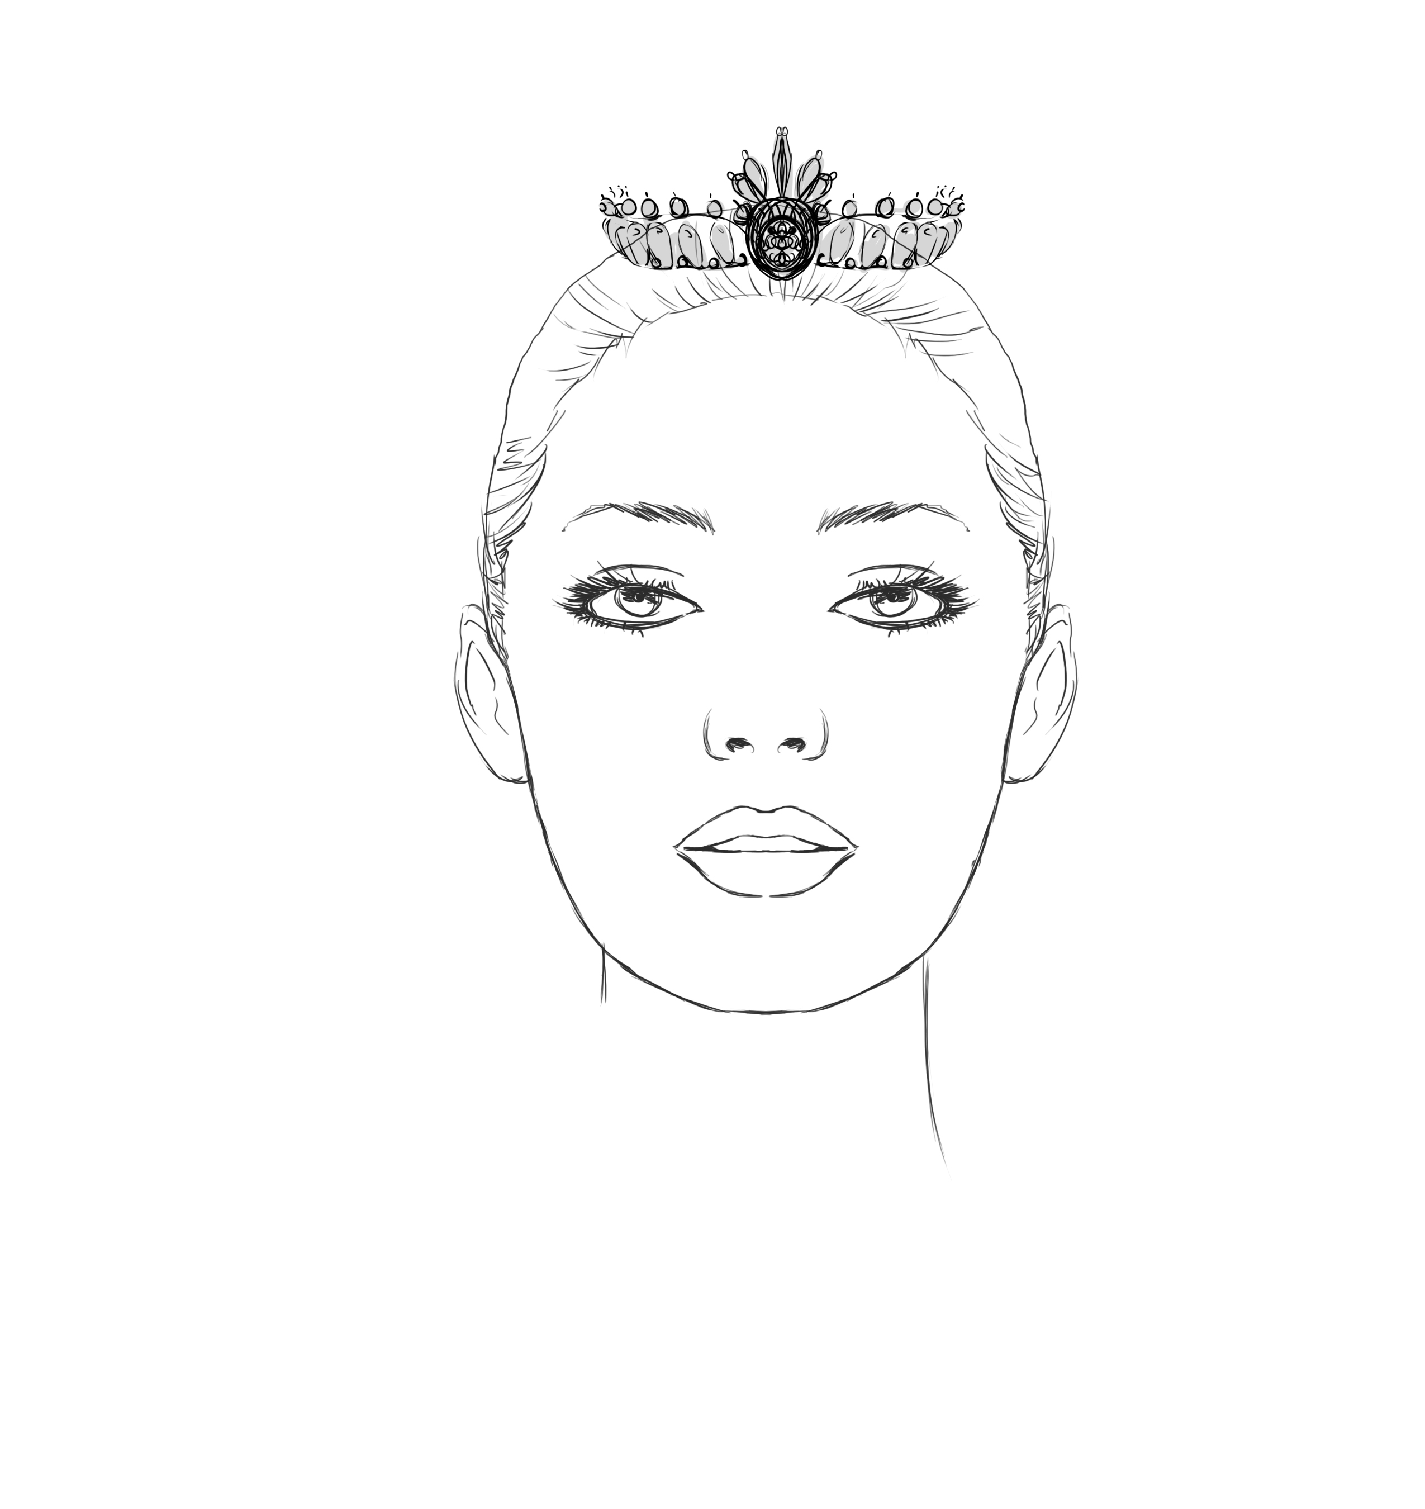
Le Corsaire $165.00 Lilac Fairy $250.00 Pearl Crown $165.00

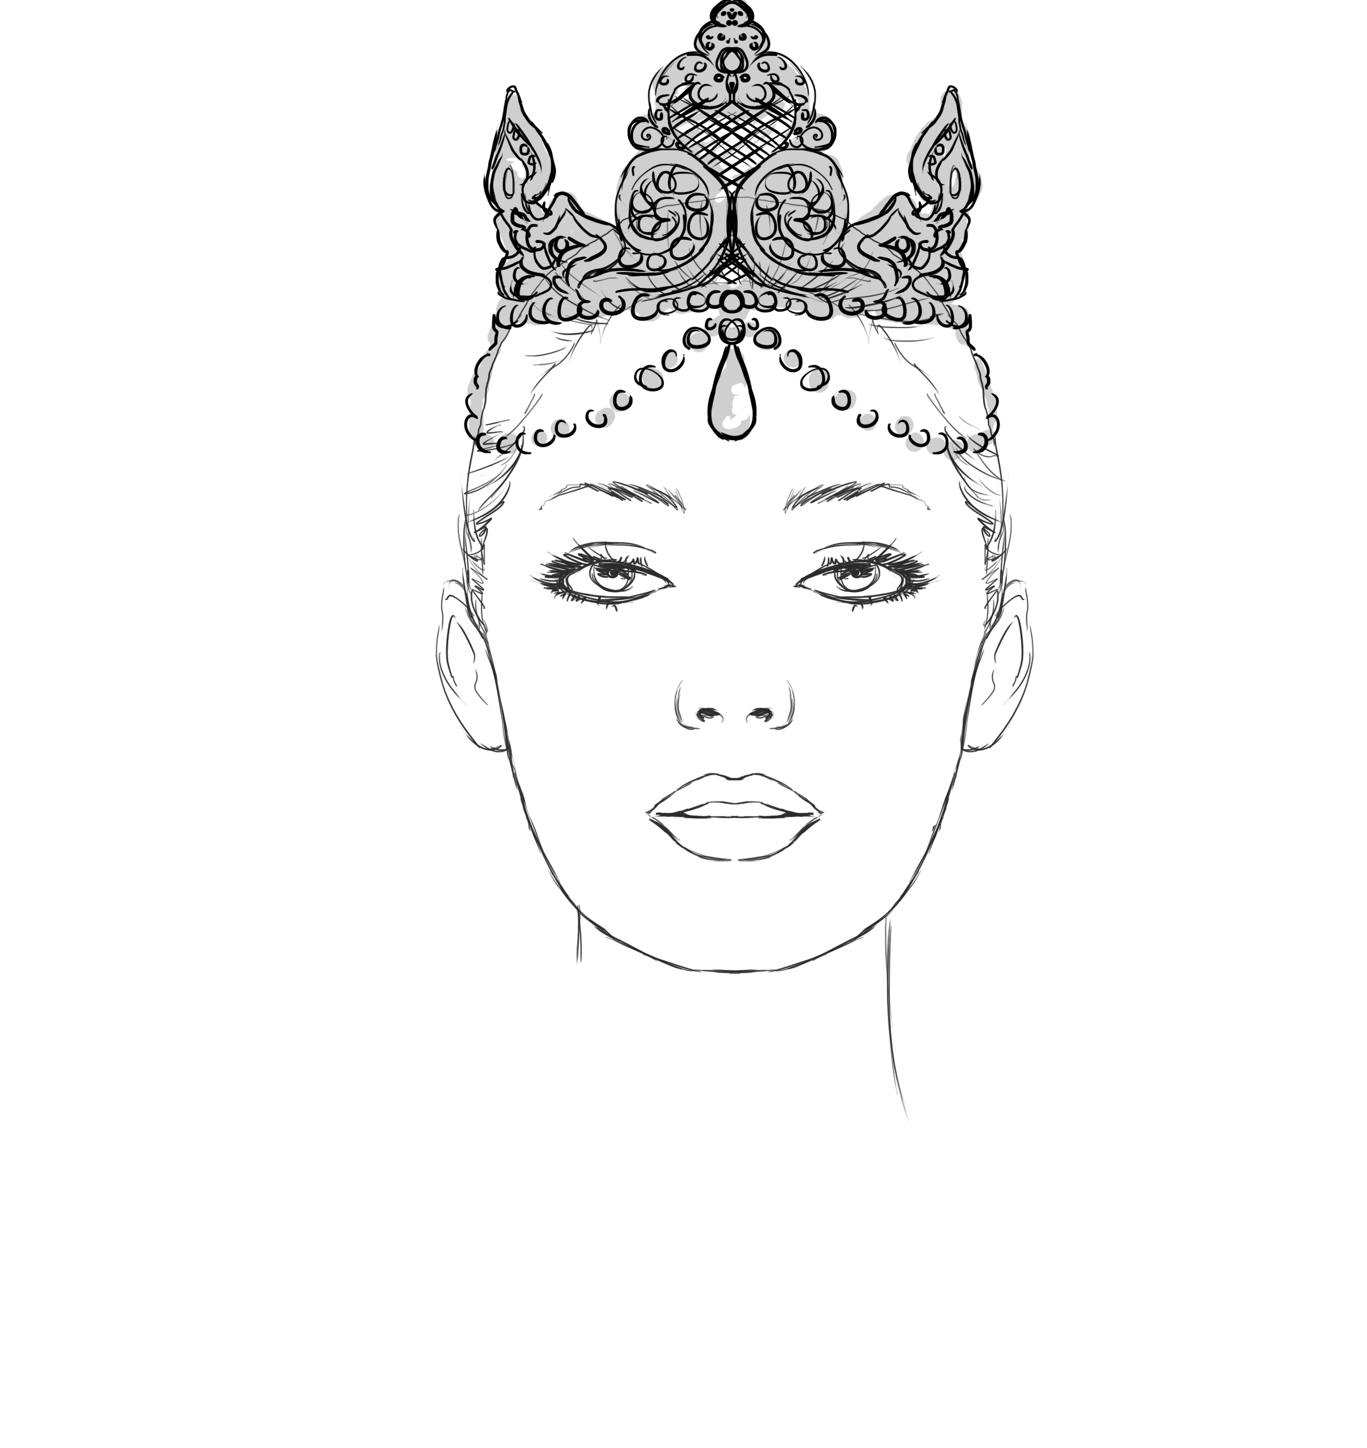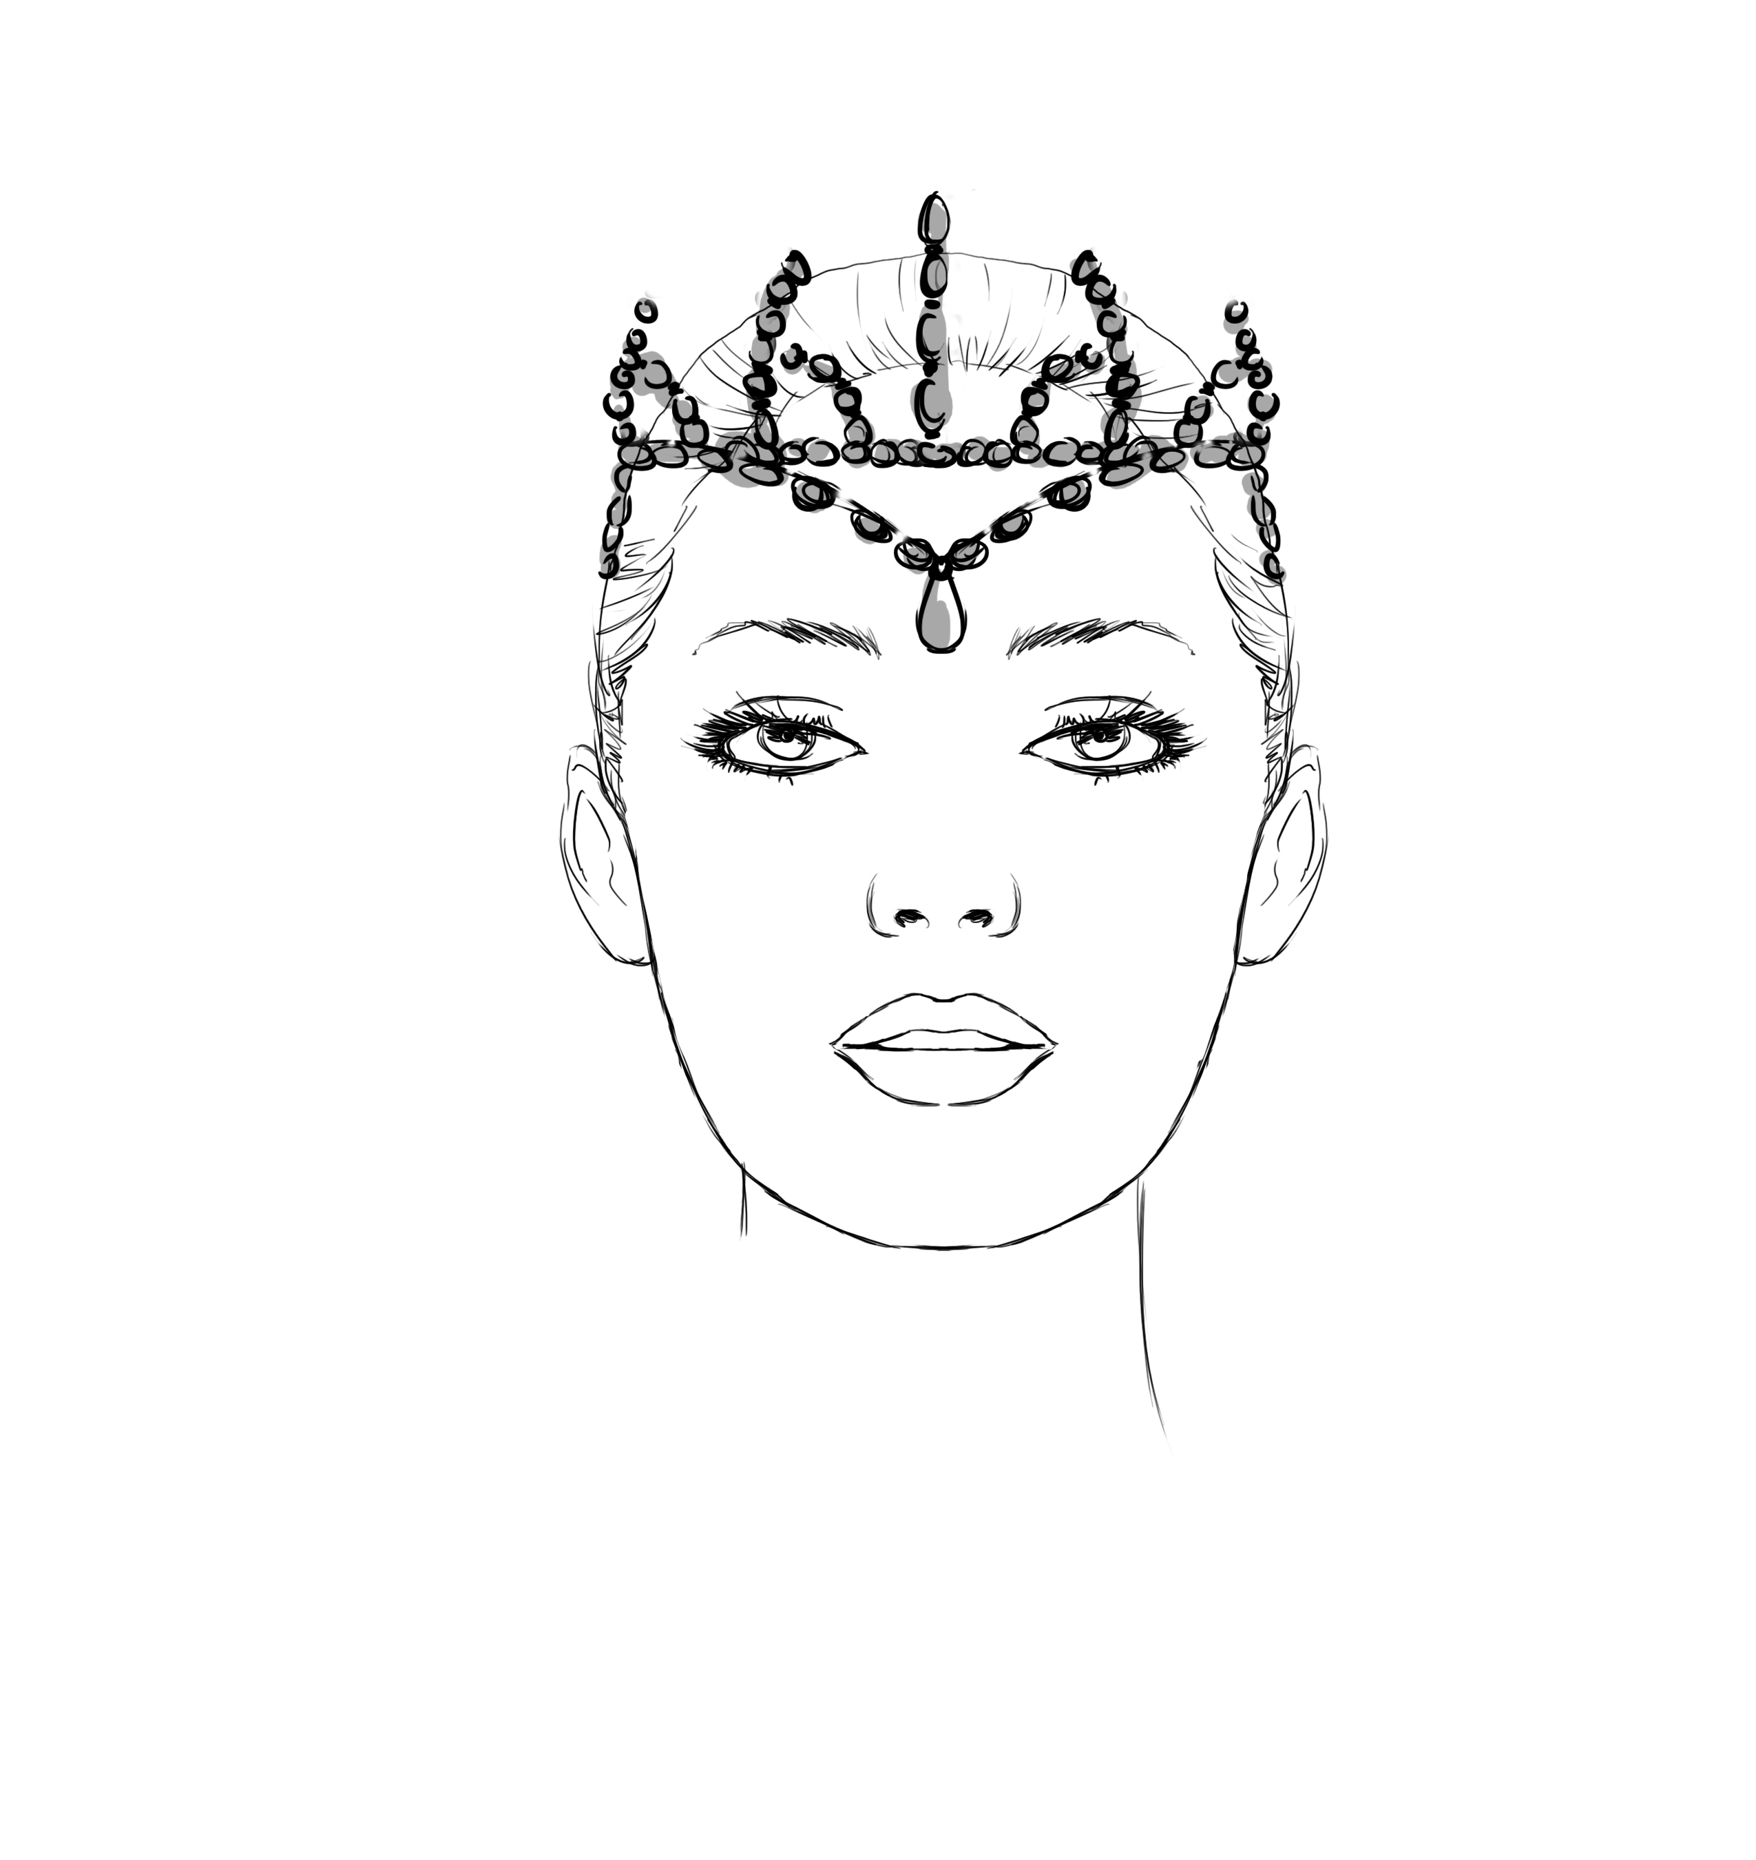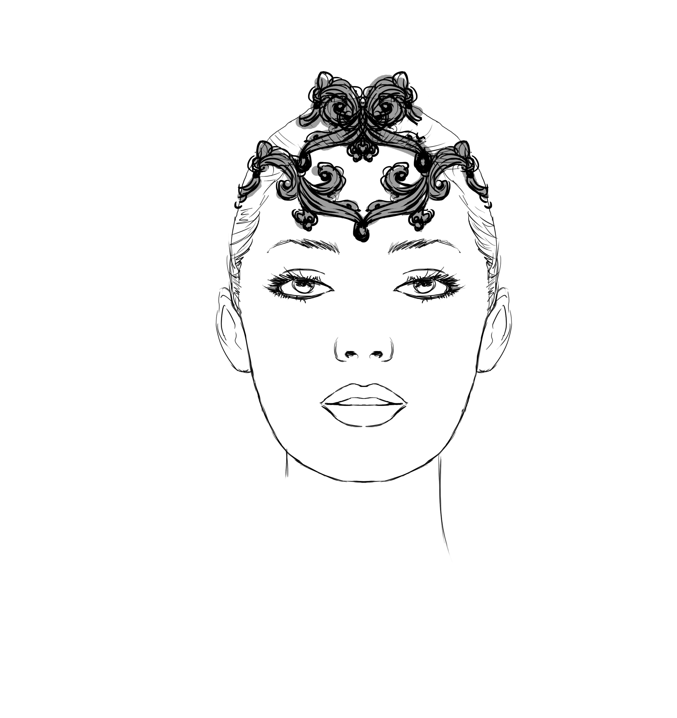
Russian Crown $250.00 Snow $165.00 Sugar Plum $165.00

Tutu Etoile Revised 07/19 Prices are subject to change Pg. 13

Head Pieces cont.
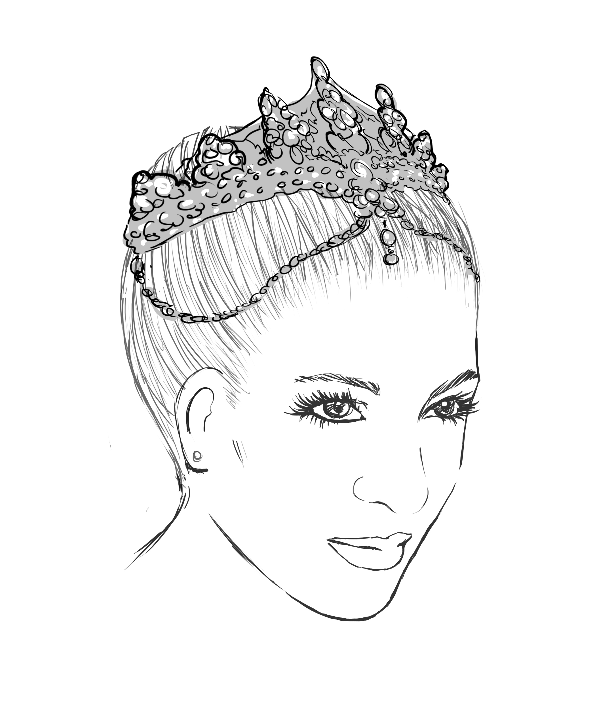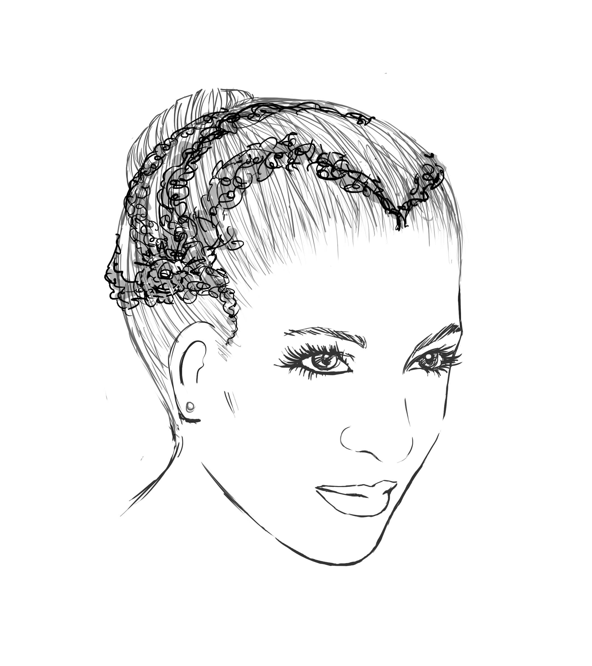
Le Corsaire/ Odealisque $250.00 The Talisman or Raymonda $230.00
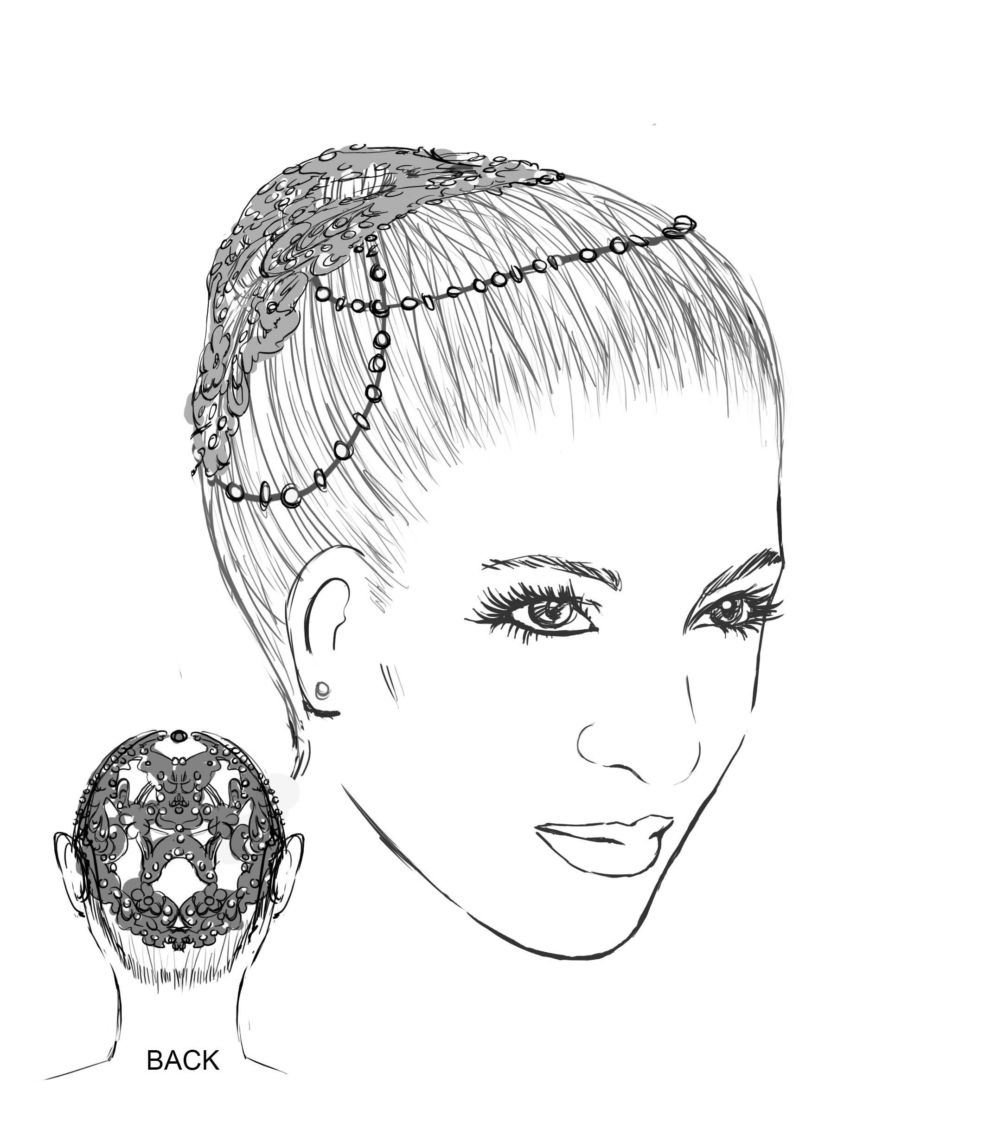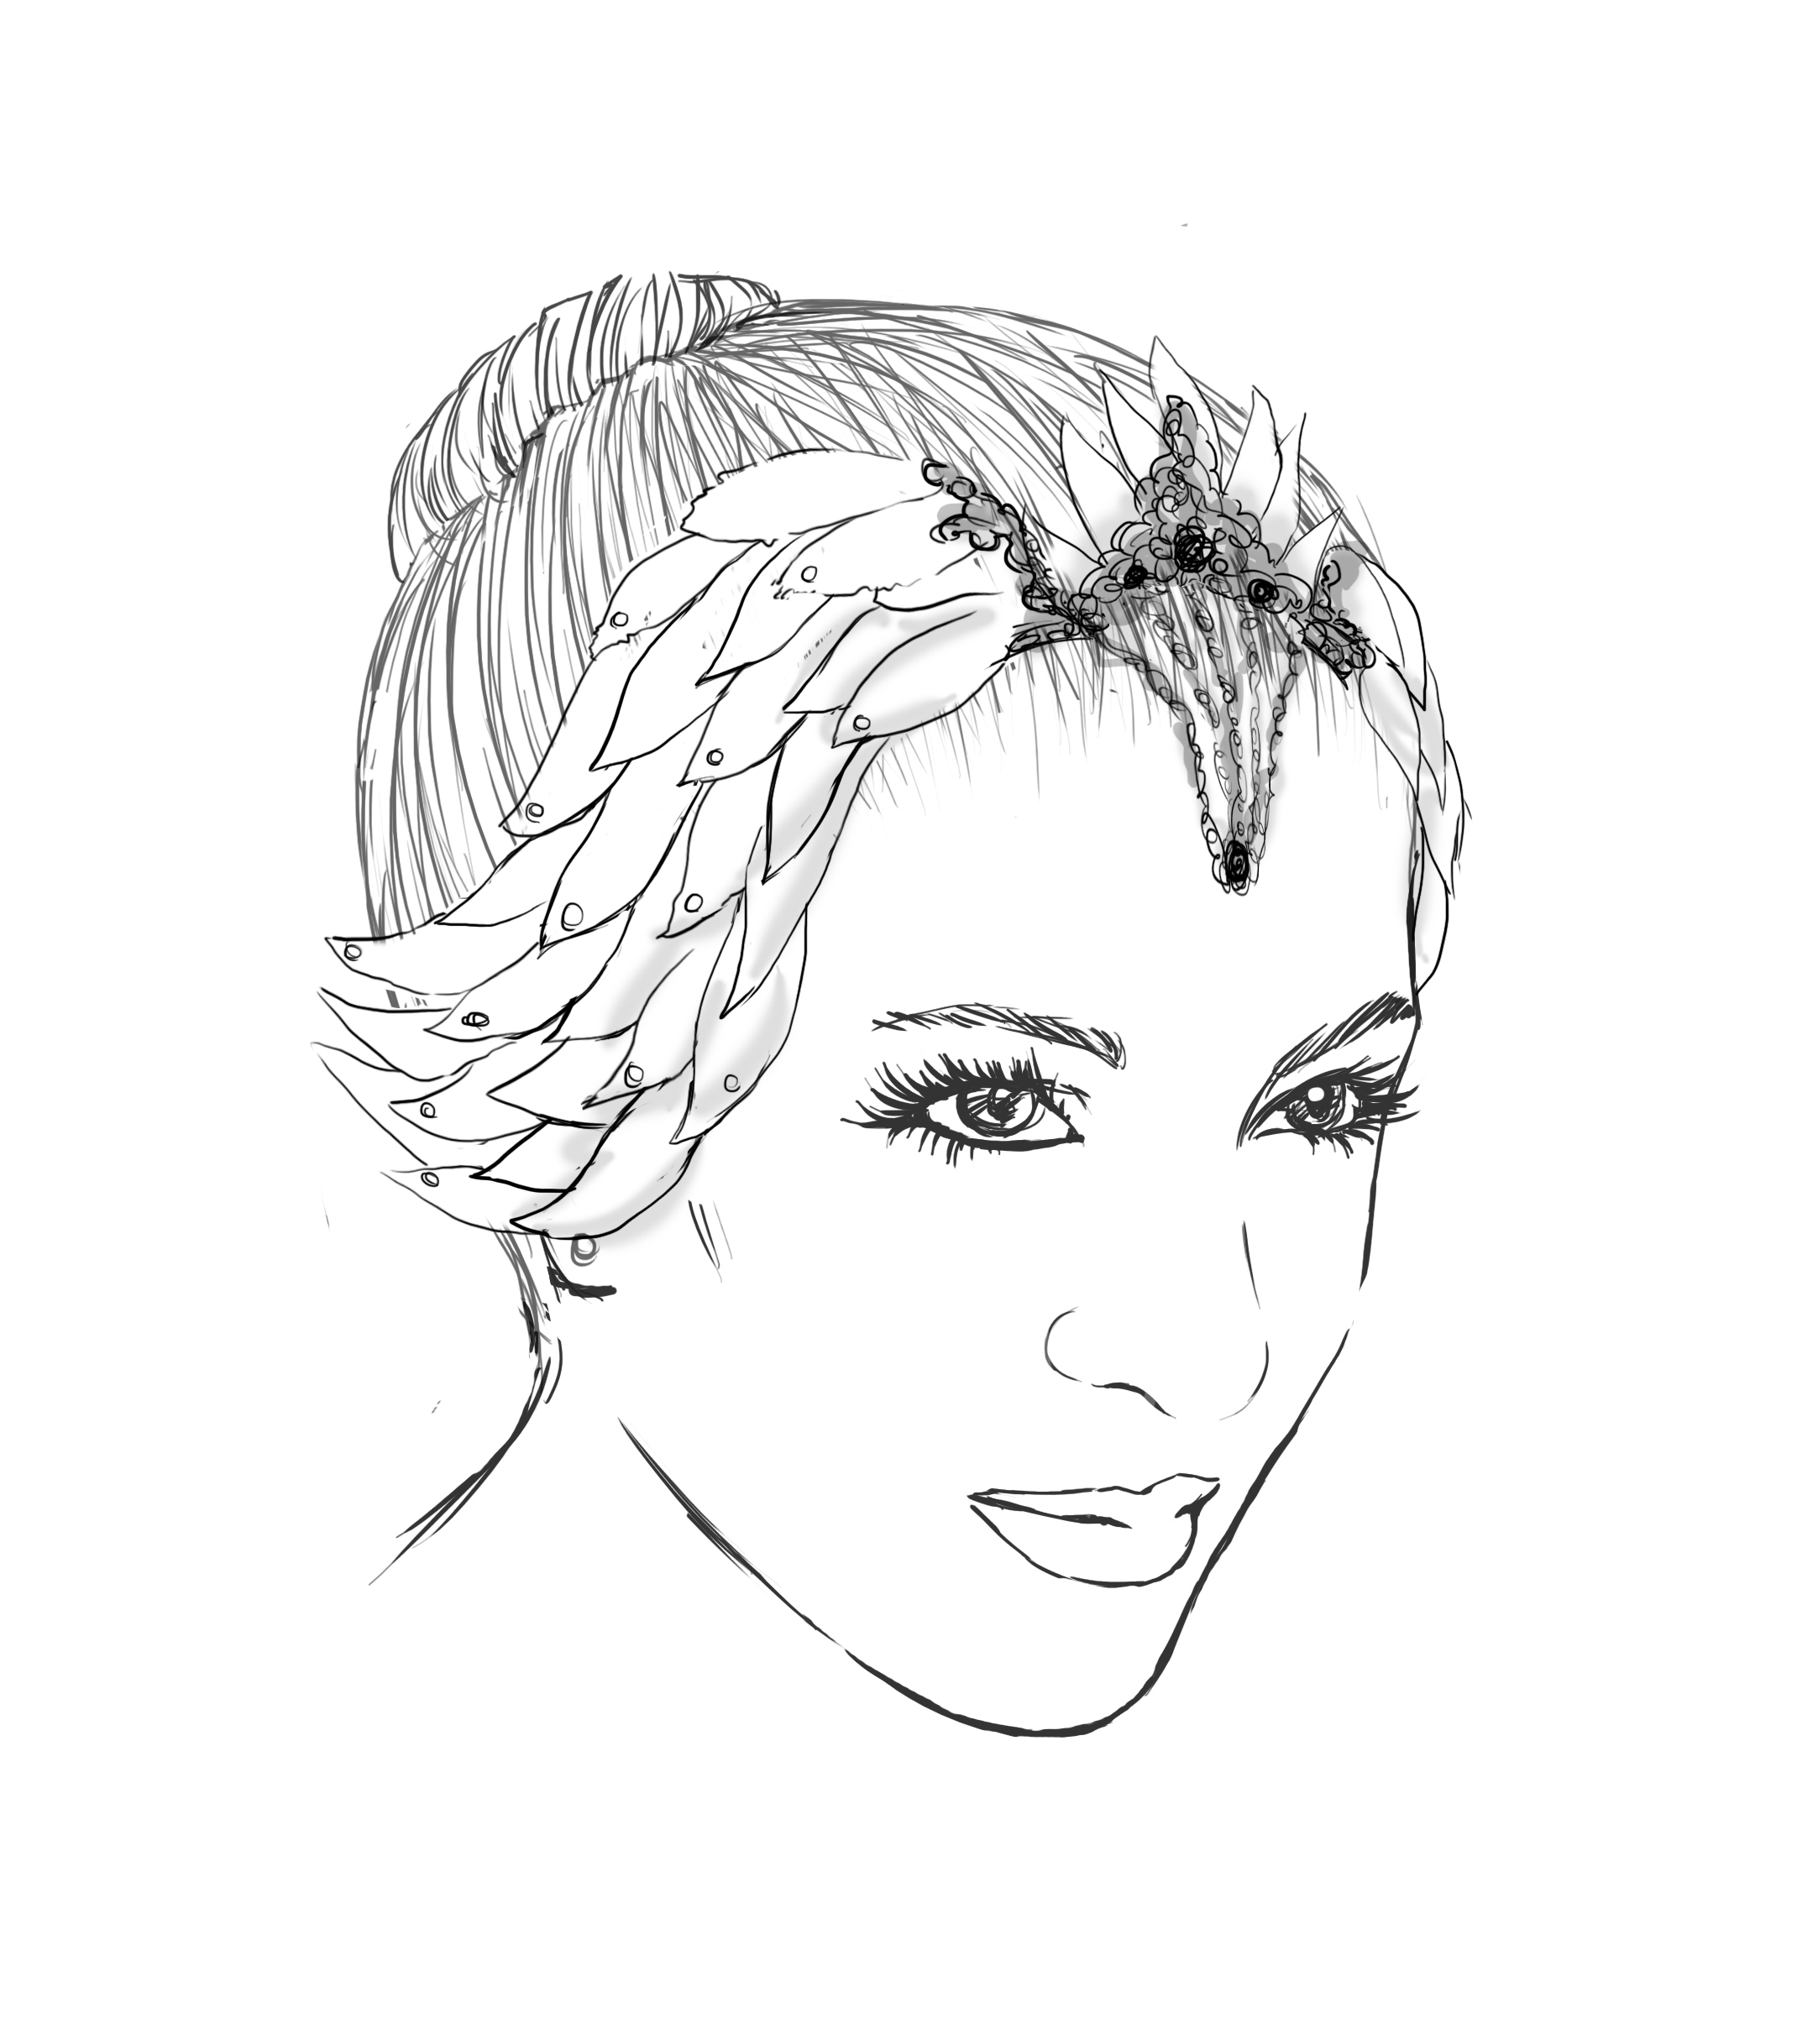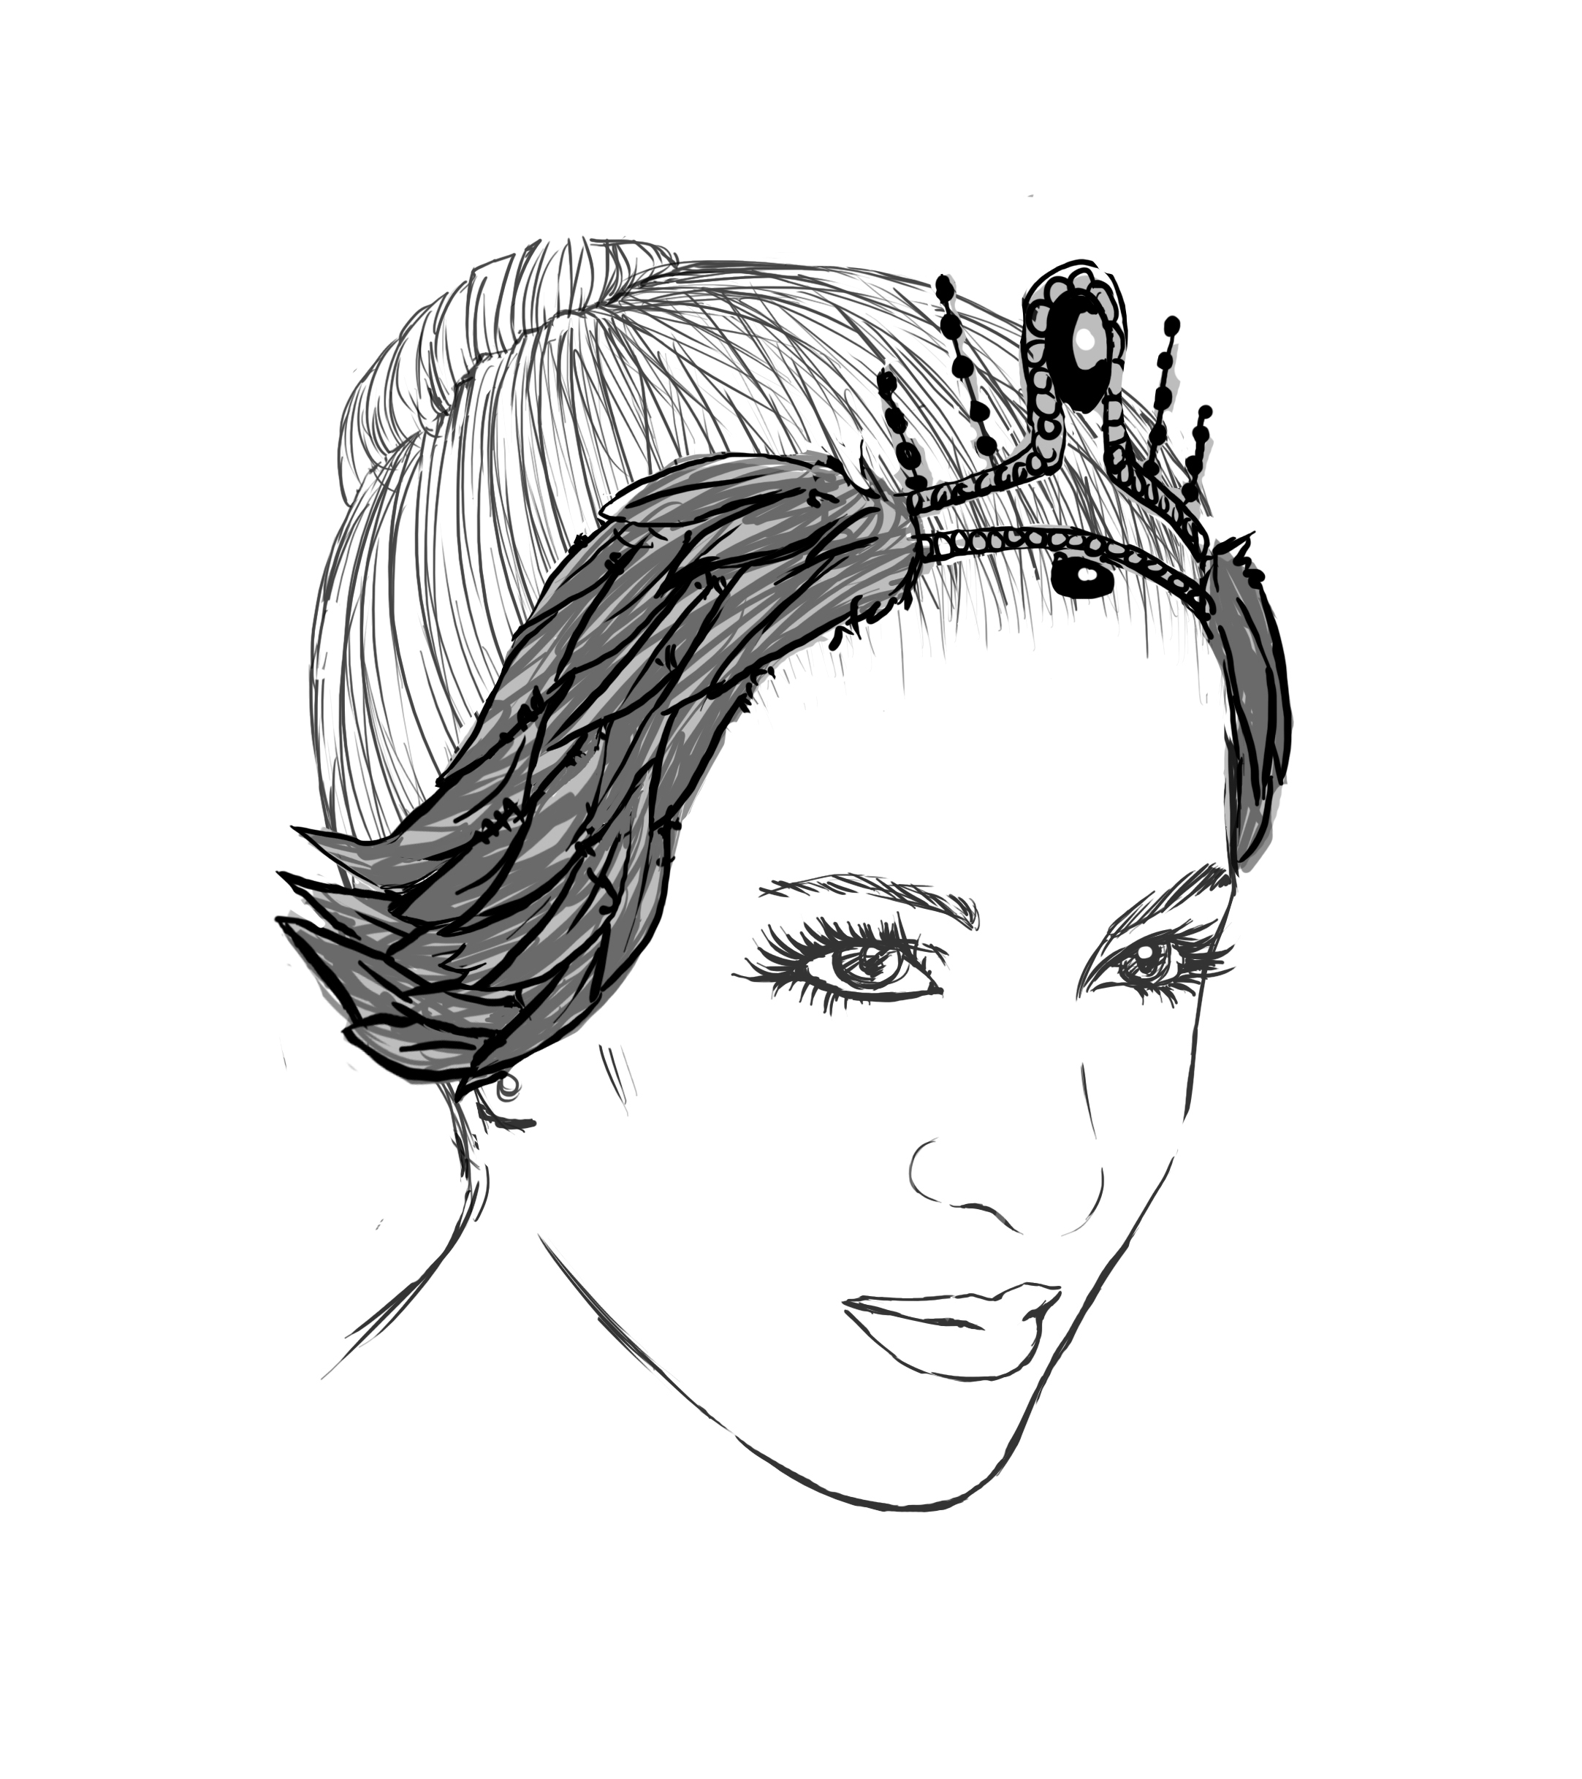

Swan Lake Pas de Troix $250.00 Odette w/organza feathers $215.00 Odile w/feathers$215.00
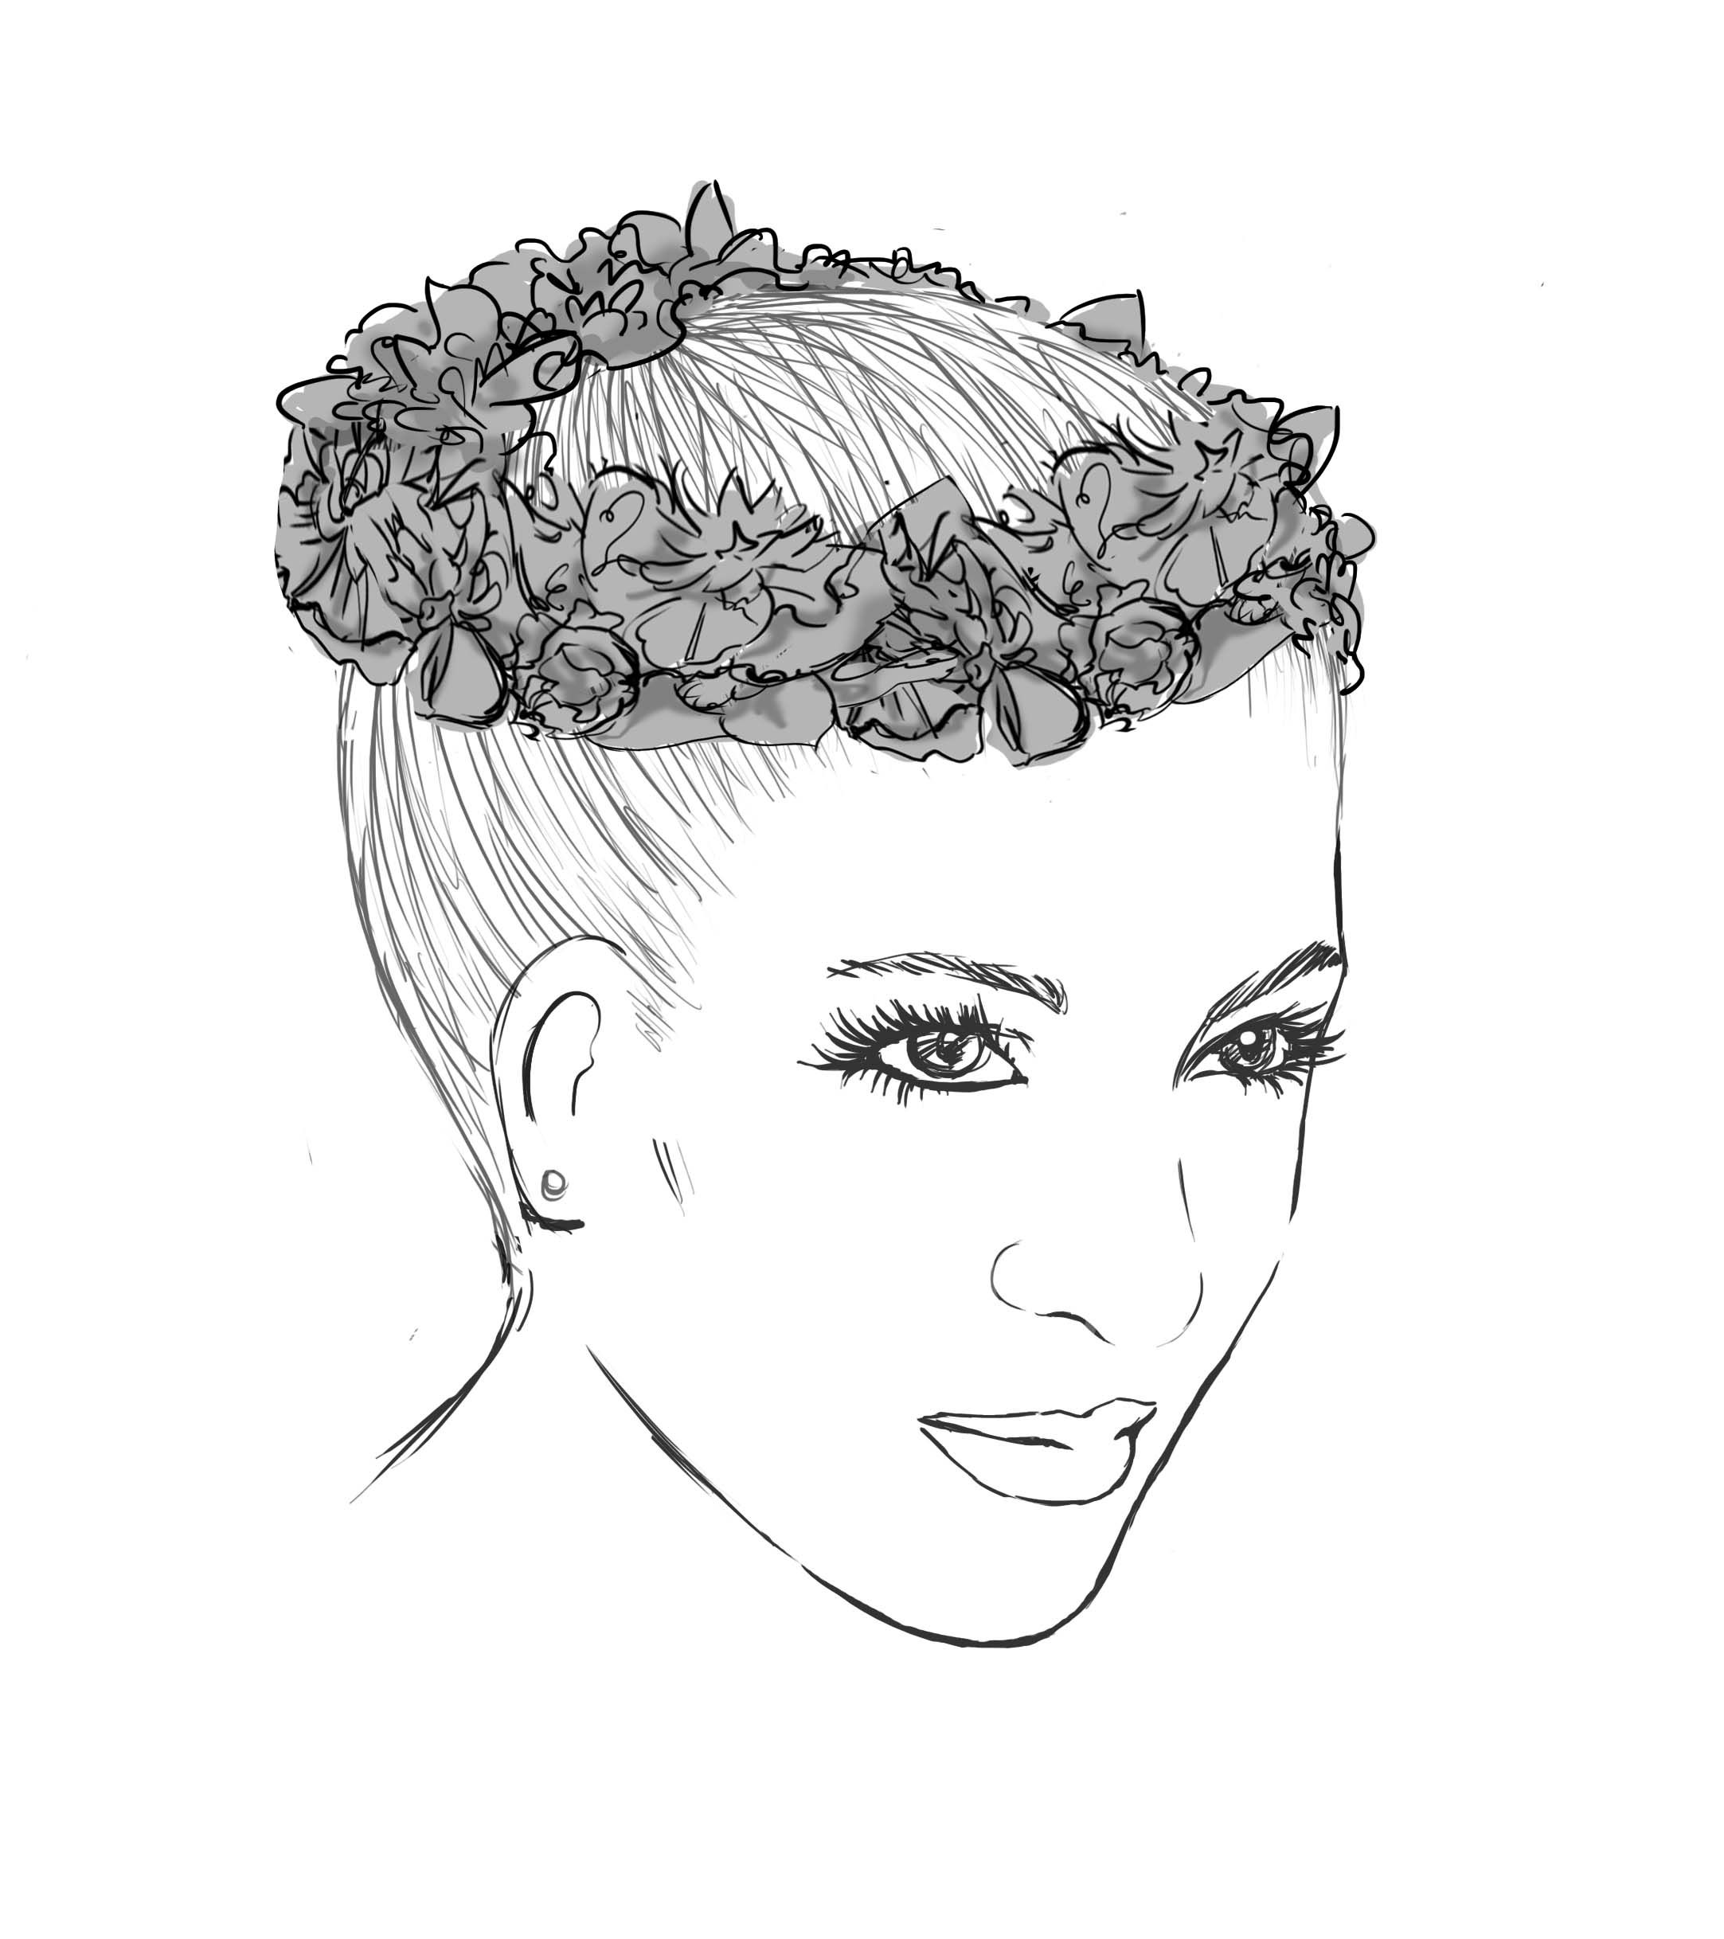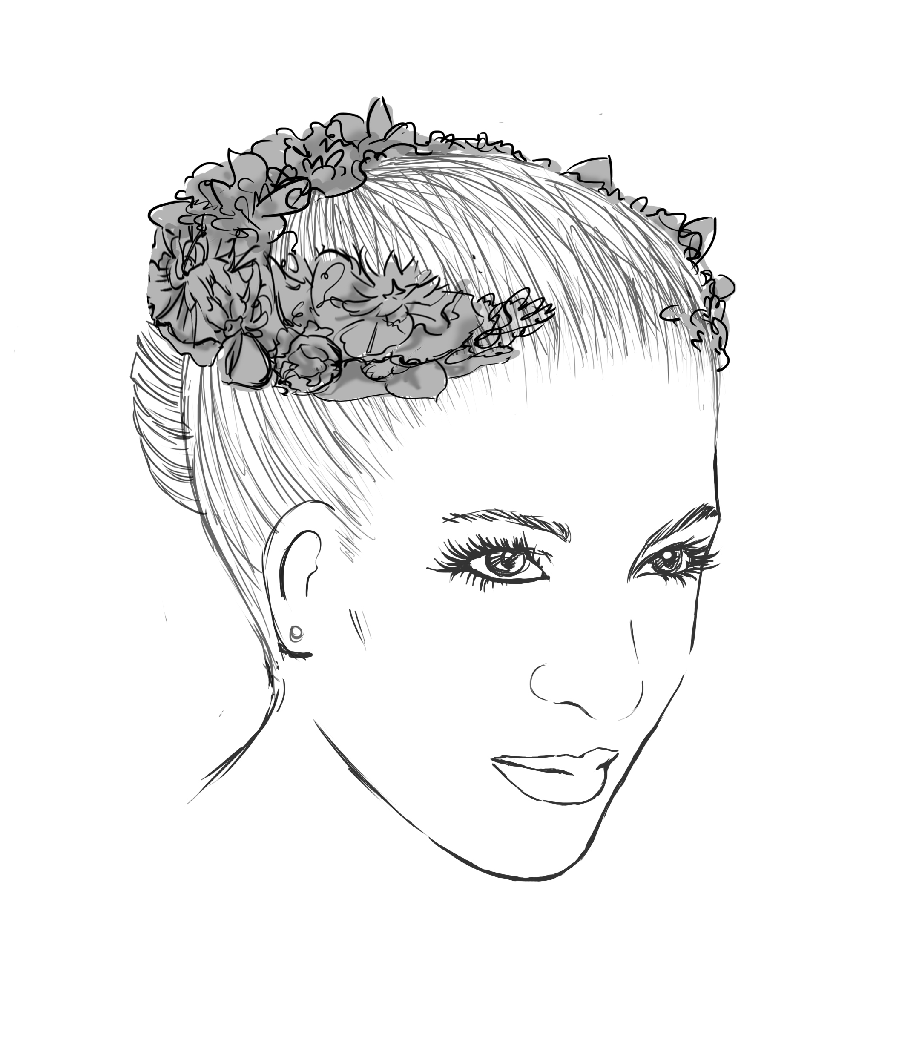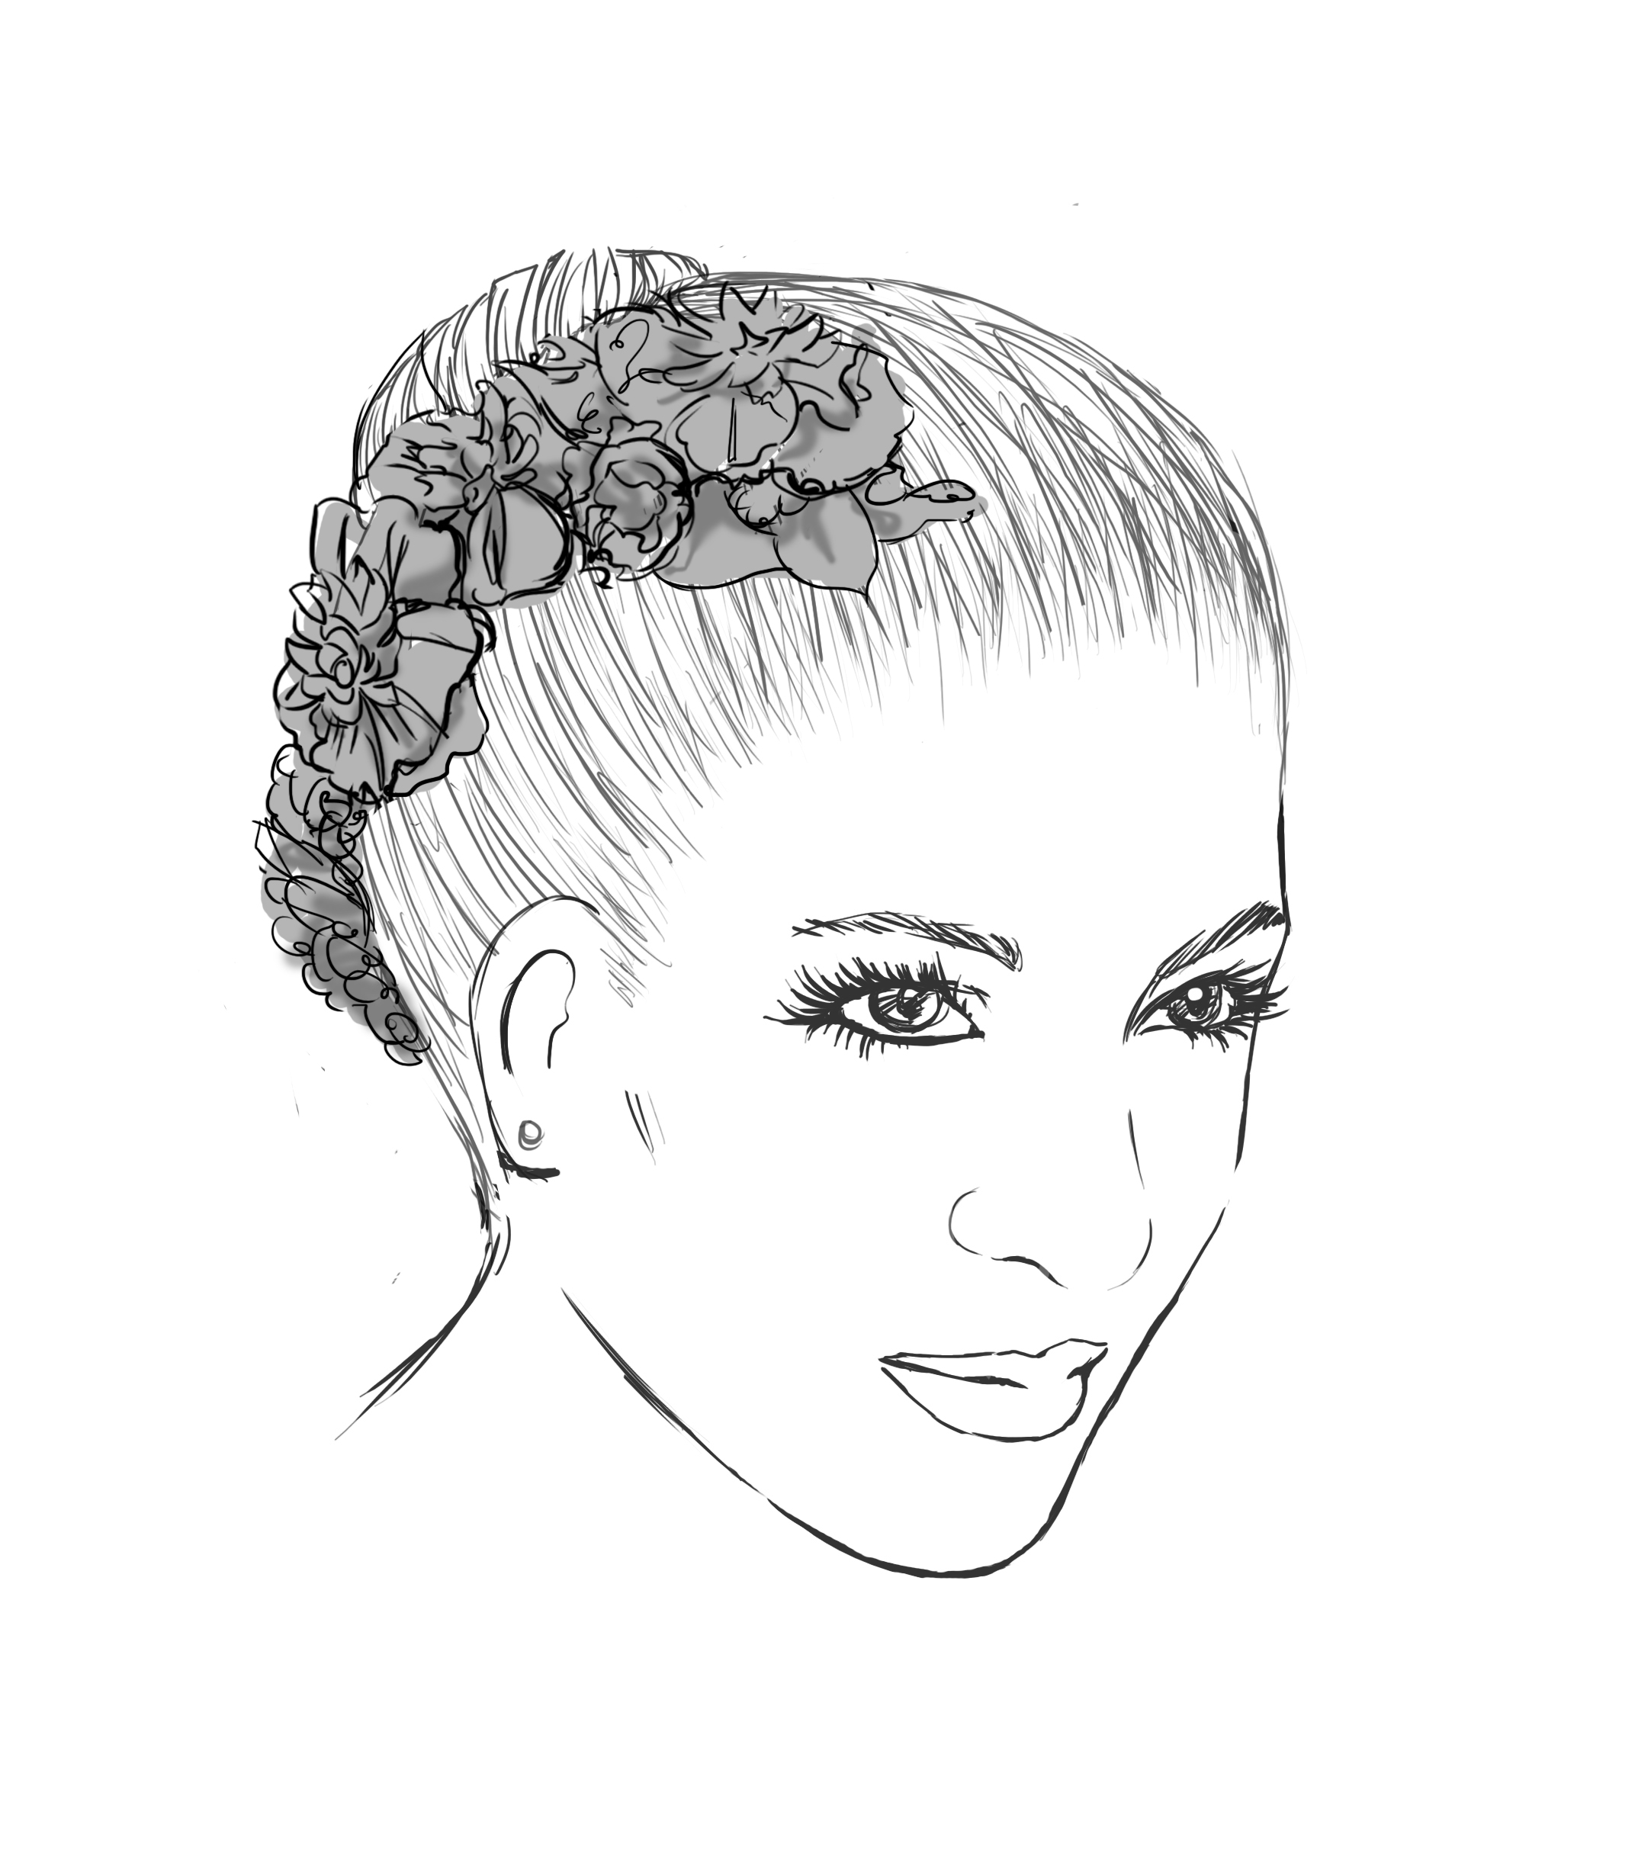
Pas de Quatre $135.00 Giselle/ Willis $115.00 Kitri $65.00
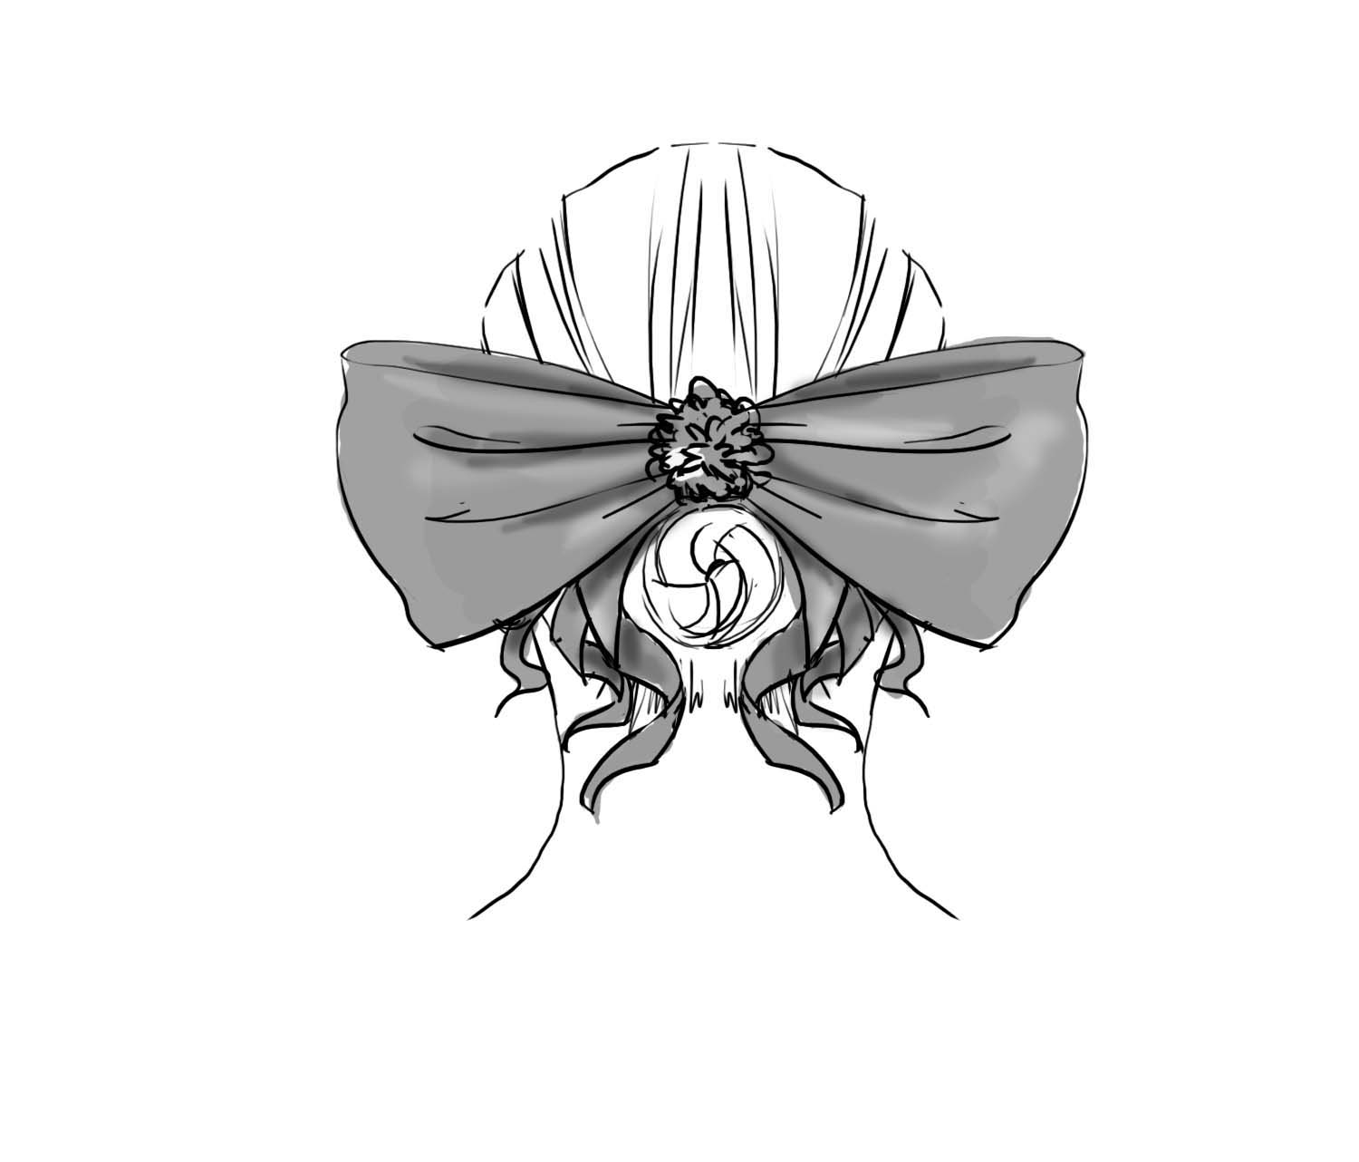
Fairy Doll $35.00 Coppelia/ Swanhilda $70.00

Tutu Etoile Revised 07/19 Prices are subject to change Pg. 14

Order Information

All orders must be placed by email or snail-mail and include the order form, worksheet and measurement chart(s). All orders are processed on a first come, first served basis. All payments may be made by check or credit card via PayPal. When placing your order, a minimum deposit of 50% is required with the remaining balance received before your order is shipped or payment in full is accepted. Please allow approximately 2-8 weeks delivery depending upon the size of your order. Please call for current delivery date’s as we may be able to ship earlier than noted.

No changes or cancellations will be permitted once your order is received. As your costumes are custom made, no returns will be accepted. Tutu Etoile stands behind the manufacture of their products under normal wear. In the event of situations beyond our control, Tutu Etoile will not be held responsible for any damages and/or cancellations beyond the moneys paid by the purchaser to Tutu Etoile.

**** Discounts ****

5-10 costumes receive 5%
11 or more costumes receive 10%
1. Discounts apply to undecorated costumes listed on our catalog.
Costumes must be ordered in the same style and color. Custom options are
not included.
2. Approximate delivery time is 2 - 8 weeks (based on the size of your order) from the
time your completed order is received. If we are able to deliver your costumes earlier, we will
honor the discount.

3. All discounted orders are to be paid in full at the time the order is placed.

4. The order form, worksheet and measurement chart/s must be completed
when placing your order. Orders will not be put in to our queue until we
receive your completed order.

Tutu Etoile Revised 07/19 Prices are subject to change Pg. 15

